Clarity for Learning
Standard KY.1.OA.1 Use addition and subtraction within 20 to solve word problems involving situations of adding to, taking from, putting together, taking apart and comparing, with unknowns in all positions.
Concepts (Nouns)  addition word problems within 20  subtraction word problems within 20  unknowns  all positions |  | Skills (Verbs)  add to  take from  put together  take apart  compare
Learning Progressions
Prerequisite Skills:
- Structure to 5
- Combine and partition within 10
- Add and subtract within 20 with materials
- Solve addition and subtraction word problems within 10

Grade Level Skills:
- Solve all types of word problems within 20 using hands-on materials (counters, bead-strings, blocks, etc.) to represent the problem.
- Solve all types of word problems within 20 using drawings, number lines, hundreds boards, etc. to represent the problem.
- Solve all types of word problems within 20 using equations with unknowns to represent the problem.
- Solve word problems involving situations of adding to, taking from, putting together, taking apart and comparing, with unknowns in all positions.
See Table 1 Appendix A below.

Clarifications:
- Students flexibly model or represent addition and subtraction situations or context problems (involving sums and differences up to 20). See Table 1 in Appendix below:
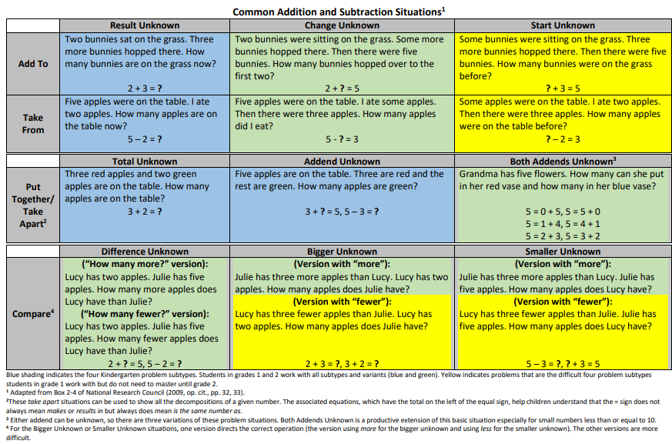
- Note: Drawings need not show detail, but accurately represent the quantities involved in the task.

KY.K.OA.2→ KY.1.OA.1→KY.2.OA.1
KY.1.OA.1→KY.1.MD.4
Learning Intentions (I am learning to...) |  | Success Criteria (I know I’m successful when...)
Solve word problems. |  | - I can determine when I need to add or subtract to solve a word problem.  - I can model the story and solve a problem situation up to 20 verbally or with materials.  - I can model the story and solve a problem situation up to 20 by drawing or writing an equation to represent the situation.

