Clarity for Learning
Standard KY.K.OA.2 Solve addition and subtraction word problems and add and subtract within 10 by using objects or drawings to represent the problem.
Concepts (Nouns)  addition word problems  subtraction word problems  objects  drawings |  | Skills (Verbs)  add within 10  subtract within 10  represent meaning of story
Learning Progressions
Prerequisite Skills:
- One to One Correspondence
- Cardinality
- Count objects to 10

Grade Level Skills:
- Solve add to-results unknown word problems within 10 using objects or drawings.
- Solve take from-result unknown word problems within 10 using objects or drawings.
- Solve put together/take apart-total unknown word problems within 10 using objects or drawings.
- Solve put together/take apart-addend unknown word problems within 10 using objects or drawings.
See Table 1 Appendix A below.

Clarifications:
Students flexibly model or represent addition and subtraction situations or context problems (involving sums and differences up to 10). See Table 1 in Appendix A inserted below:
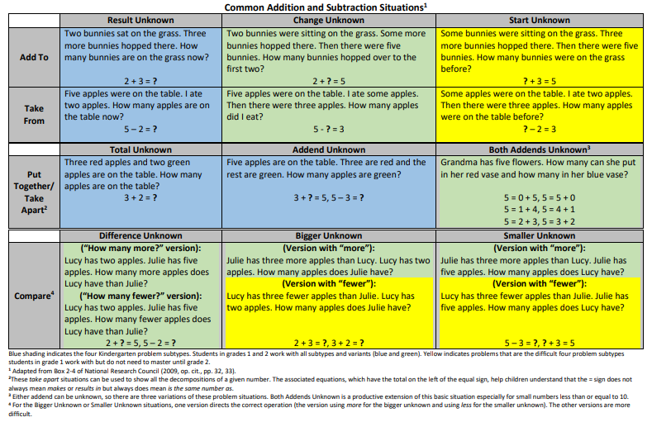
Note: Drawings need not show detail but accurately represent the quantities involved in the task.
KY.K.OA.2→KY.1.OA.1

Learning Intentions (I am learning to...) |  | Success Criteria (I know I’m successful when...)
Solve word problems by modeling the story with objects or pictures. |  | - I can model the story and solve the problem using up to 5 objects.  - I can model the story and solve a problem up to 5 by drawing.  - I can model the story and solve the problem using up to 10 objects.  - I can model the story and solve a problem up to 10 by drawing.

