Clarity for Learning
Standard KY.2.NBT.1 Understand that the three digits of a three-digit number represent amounts of hundreds, tens and ones. Understand the following as special cases:
a. 100 can be thought of as a bundle of ten tens — called a “hundred.”
b. The numbers 100, 200, 300, 400, 500, 600, 700, 800, 900 refer to one, two, three, four, five, six, seven, eight, or nine hundreds (and 0 tens and 0 ones).
Concepts (Nouns)  three digits of a three-digit number  amounts of hundreds, tens, and one  100 can be thought of as a bundle of ten tens - called a hundred  100 refers to one hundred with 0 tens and 0 ones | Skills (Verbs)  understand  represent  thought  refer
Learning Progressions
Prerequisite:
- Understand place value of two-digit numbers
- Use hands-on materials to count to 100 by 1s, 5s, and 10s
- Use a hundreds board to count to 100 by 1s, 5s, and 10s
- Represent two-digit numbers with bundles and sticks

Grade Level Skills:
- Use hands-on materials to represent ones, tens and hundreds (single stickers, sticker strips, sheets of stickers).
- Understand that 100 can be seen one hundred, as ten tens, and as 100 ones.
- Understand that 3-digit numbers represent amounts of hundreds, tens and ones.
- Represent 3-digit numbers in multiple ways (stickers, drawings, expanded notation, etc.)

Clarifications:
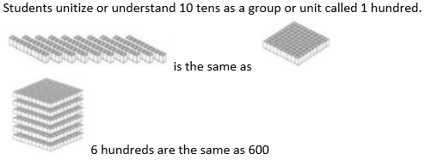
KY.1.NBT.2→KY.2.NBT.1→KY.3.NBT.1

Learning Intentions (I am learning to...) | Success Criteria (I know I’m successful when...)
Represent place value with hundreds, tens and ones. | - I can use a place value model to represent and compare 3-digit numbers as hundreds, tens and ones.  - I can represent 3-digit numbers using expanded form.  - I can represent a 3-digit number in multiple ways.

