Help Sheet

Temporary Teacher Login:  - My.amplify.com  - Select “LOGIN WITH AMPLIFY”  - UN: t1.fayette20201@demo.tryamplify.net  - PW: Amplify1-fayette20201  - At the top right corner, select LAUNCH PROGRAMS  - If your grade level is not displayed, select the arrow to the right of it and select it from the drop box. | Regular Login:  - Amplify.com  - Select “Login”  - Scroll down to Amplify Science  - Select “Log in with google”  - Select your school email address  I will let you know when this is accessible.
These links are where students can access someone READING ALOUD the texts!  Kindergarten, Unit 1  https://www.youtube.com/watch?list=PLm_xeUJV-0tQAZUi3ohjWCNAgUEoXKZ4o&v=GGALAJ9B2fk&feature=emb_title  Grade 1, Unit 1  https://www.youtube.com/playlist?list=PLm_xeUJV-0tSzTc7UrCGwA07gTMN  Grade 2, Unit 1  https://www.youtube.com/playlist?list=PLm_xeUJV-0tTm2sXKKK5bbl4O5sRrw29i  Grade 3, Unit 1  https://www.youtube.com/playlist?list=PLm_xeUJV-0tRzeLwn0FeGRdBEDnBep_G9  Grade 4, Unit 1  https://www.youtube.com/playlist?list=PLm_xeUJV-0tT-YdoYnvmkFXftHdZfMH7e  Grade 5, Unit 1  https://www.youtube.com/playlist?list=PLm_xeUJV-0tSuzxDnlTz9pMQM7qlnsAsX | Student Access to Amplify Resources  (including Simulations, Practice Tools, and Student Digital Books)  - Learning.amplify.com  - select “Login with Amplify”  - UN: ampsci123  - PW: ampsci123  Spanish version  - UN: ampsci123sp  - PW: ampsci123sp  Here is an Amplify link that walks students through this login process.  Accessing Amplify Student Apps in Grades K through 5

Remote Learning Resources
To find the remote learning resources, first login and get to your grade’s homepage.

2. Click the “stack of pancakes”

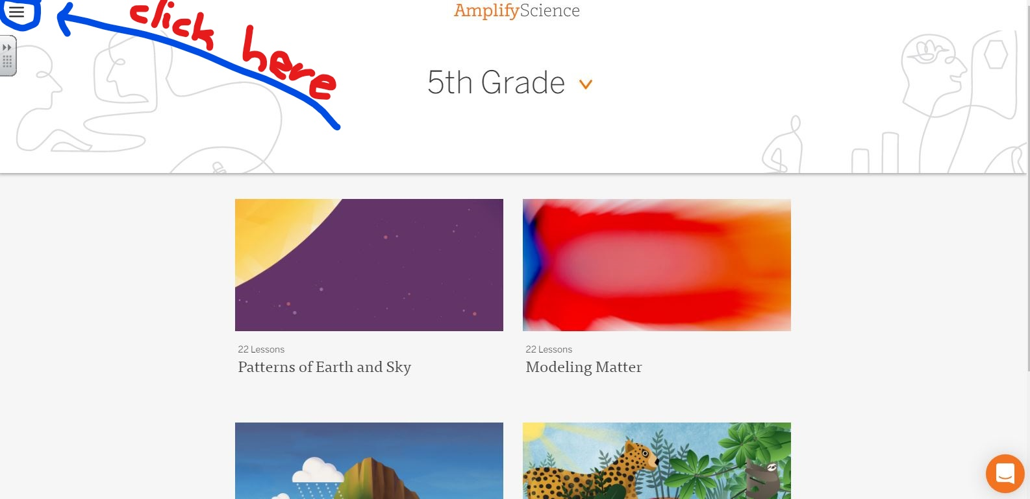

3. You will see tools and apps, but scroll to almost the bottom and click on PROGRAM HUB.

4. Click “I am a Teacher”

5. Click on Remote learning: Amplify Science@Home as seen below.
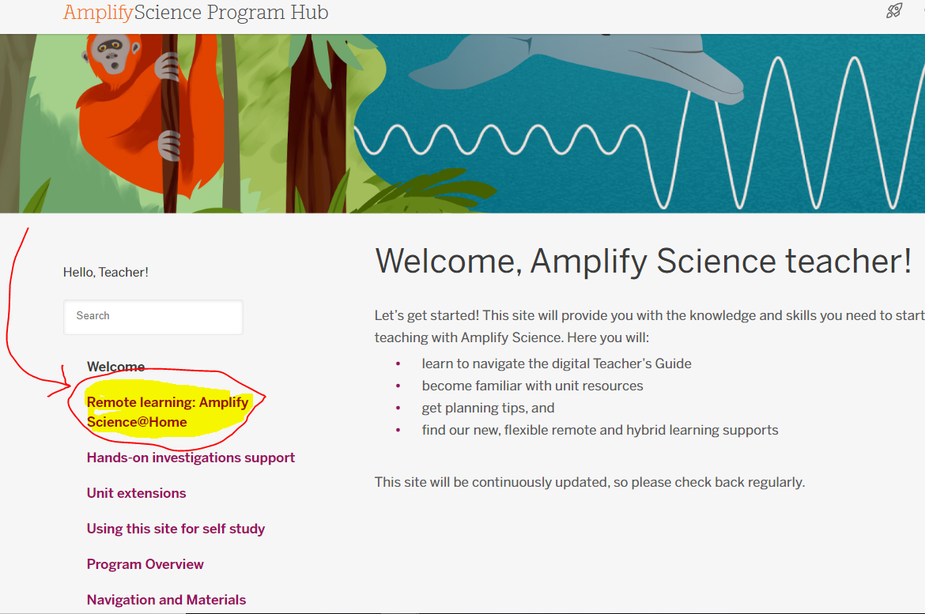

There are TWO OPTIONS for @home lessons
DO NOT ASSIGN BOTH!
(All of these resources are on the Remote Learning@home page)

Option 1:  @Home Video playlists  These video lessons cover the unit in its entirety.  @Home Video playlists  Note: Spanish videos will be added August 20th  - Science Notebook or just paper and pencil  *YOU MAY WANT TO ASSIGN A FEW OF THE PAGES FROM THE INVESTIGATION NOTEBOOK….ESP THE ONES THAT HAVE PHOTOGRAPHS TO REFER TO.  Instructions:  - The @Home Videos are another option, different from the @Home Units. The lessons listed below (on the website) correspond with the lessons in the full version of Amplify Science. Each lesson is linked to a playlist of recorded versions of the activities that make up that lesson, which you can share with your students. | Option 2:  @Home Unit resources  These are MODIFIED versions of the Units and the @Home sheets were modified to go along with these slides. If you don’t have as much time for science, you may want to go along with THIS OPTION.  - Teacher Overview  - Family Overview  - Note: Spanish will be added for this and all student materials August 20  - @Home Slides compilation  - @Home Packet compilation  - @Home Student Sheets  - Note: Student Sheets are required when using Slides  *YOU MAY WANT TO ASSIGN A VIDEO HERE AND THERE TO USE SOME SEGMENTS OF THE VIDEOS TO SUPPLEMENT THE SLIDES.  Instructions:  - If you intend to utilize mainly digital materials with students: Open and make a copy of the Google Slides linked in the “Digital option” column of the table below (on the website). Next, open the “Student Sheets” linked above, make a copy (if using Google Doc), and send BOTH the @Home Slides and Student sheets to students.

