Progress Builds and the Assessment System
Participant Pages to Accompany the Part 1 Video
Open the Progress Build document. Complete this graphic organizer to internalize the ideas and reflect on how the levels are connected.
- Fill in PB levels with visual representations and text that will help you remember key ideas at each level.
- What new learning occurs between each level? Add that to the bubble.
- How does a level 4 understanding help students answer the Unit Question and figure out the Unit Phenomenon?
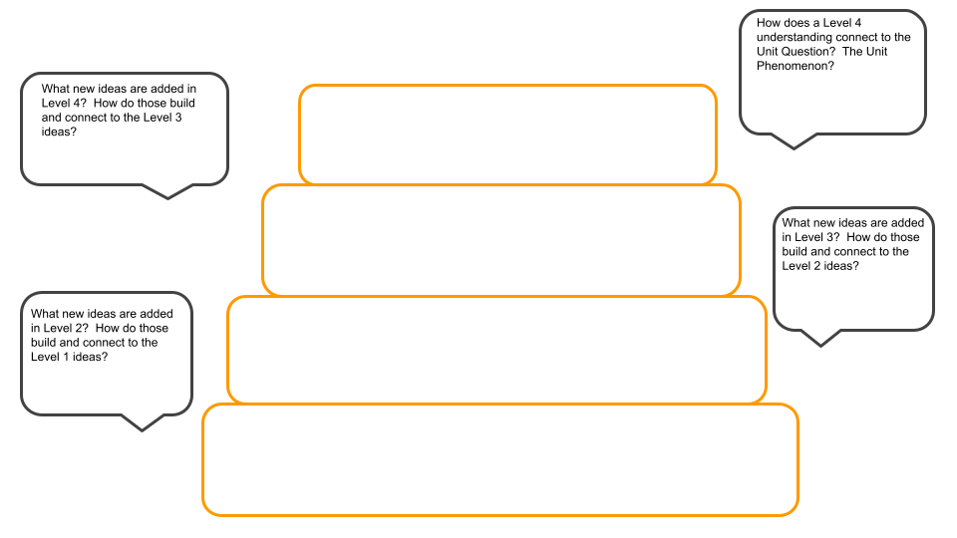

Notes on the Progress Build

Critical Juncture Assessments - Video Part 2

Where is it located? | Assess what understanding? | What do students do in this assessment? | Tailor instruction in what way?

On The Fly Assessments leading up to Critical Juncture 1

Where is it located? | Look for? | Now what?

On The Fly Assessments leading up to Critical Juncture 2

Where is it located? | Look for? | Now what?

On The Fly Assessments leading up to Critical Juncture 3

Where is it located? | Look for? | Now what?

On The Fly Assessments leading up to Critical Juncture 4

Where is it located? | Look for? | Now What?

Chapter Self Assessments (Optional)

Where is it located? | What is it reflecting upon?

