Novice High (NH) Benchmark Assessment
(8th grade, End of semester 2)
(High School, End of semester 2)

The FCPS Secondary World Language (WL) Unit Frameworks provide a roadmap for content while also identifying targeted proficiency goals. For middle schools offering level one as an approved high school credit course, benchmark assessments aligned to the district curriculum are expected to be administered two times per year, at the end of semesters one and two.
When to assess?
Benchmark proficiency checks will occur near the end of each semester and end of for grades 7, 8, and Level 1 in high school (see table below). These time periods reflect the anticipated proficiency jumps for students as reflected in the FCPS Level One WL Unit Frameworks and At-A-Glance document.
Table- Benchmark Testing Schedule and Test to Use
(For approved level one courses being offered at the middle school level for high school credit and all level one WL courses at the high school level).
 | Middle School  7th Grade | Middle SChool  8th Grade | High School  Level One
End of 1st  semester | NL/M Benchmark assessment | NM/H Benchmark assessment | NM Benchmark assessment
End of 2nd semester | NM Benchmark assessment | NH Benchmark assessment | NH Benchmark assessment

Data analysis is completed at the school level with the purpose of informing instruction and learning. Data will be shared with the district level as determined by district leadership.
Which modes of communication to assess?
The Interpersonal Speaking/Listening (teacher speaking with student) and Presentational Writing modes of communication are assessed. Chinese and Japanese may choose to only assess Interpersonal Speaking at this time.
Which KY Academic Standards (KAS) for WL and FCPS Secondary Level One curricular content are assessed?

Assessed Mode of Communication | Assessed KAS for WL | Assessed FCPS Level One Content
Interpersonal Speaking | NH.C.2.IS/IL/IW.Q1  Exchange Information and Ideas  I can request and provide information by asking and answering practice and some original questions on familiar and everyday topics, using simple sentences most of the time.  NH.C.2.IS/IL/IW.Q3  Preferences and Opinions  I can express, ask about, and react to preferences, feelings, or opinions on familiar topics, using simple sentences most of the time and asking questions to keep the conversation on topic. | In addition to spiraled content-  Unit 5: Let’s Explore!  (B) About Your Community  Unit 6: Let’s Take A Trip!  (C) About Your Travels
Presentational Writing | NH.C.3.PW/PS.Q1  Narrate  I can present personal information about my life and activities, using simple sentences most of the time.  NH.C.3.PW/PS.Q3  Inform or Describe  I can present on familiar and everyday topics, using simple sentences most of the time. | In addition to spiraled content-  Unit 5: Let’s Explore!  (B) About Your Community  Unit 6: Let’s Take A Trip!  (C) About Your Travels

How to begin?
Prior to assessing, teachers are encouraged to read the Benchmark Proficiency Expectations (see below) for Novice High (NH) and the Benchmark Guide (see below). Teachers will use the FCPS NH Interpersonal Benchmark Assessment (see below) to converse one-on-one with each student. Plan for 4-5 minutes per student for the Interpersonal Speaking.
The Benchmark Guide for Interpersonal Communication provides samples of anticipated student responses and suggested tips for eliciting responses from students. Reviewing this document may provide support regarding language expectations.

How to score?
For each Part of the Interpersonal assessment, a student's demonstrated language will either Meets or Does Not Meet the benchmark expectation. Once completed, a student who has earned a score of Meets for each Part of the assessment, will have earned a Yes for the Interpersonal benchmark proficiency level. A student who has earned one or more Does Not Meet ratings will earn a No score for Interpersonal.

For the Presentational Writing assessment, a student's demonstrated language must score Meets in each component: Function (addressing overall purpose), Context (including content from each guiding question), Text Type (containing sentences), and Language Control (being comprehensible to you, a sympathetic reader). A student earning Meets in each component will earn a Yes for that benchmark proficiency level in Writing. A student who has earned one or more Does Not Meet, will earn a No score for Writing.
Below is a review of the proficiency expectations for Novice High.

Description of Novice High Language
Functions | -I begin to take part in a conversation and exchange information.  -I begin to ask/answer questions beyond memorized ones.
Context, Content | -I begin to interact in some informal situations.  -I exchange information about myself and begin to understand and converse about topics including my activities and immediate environment.
Text Type | -I identify/describe with memorized phrases and created sentences.  -I begin to use/understand separate sentences.
Language Control | -Because of my grammar, word order/choice, and or pronunciation, I am generally understood by someone used to non-native language users.  -I sometimes need time, cues, and or repetition. I begin to self-correct.

What is included in this assessment packet?

Page(s) | Description | For Teacher or Student
1-4 | Overview of benchmark assessment and procedures | Teacher
5 | Interpersonal Speaking Assessment and Rubric | Teacher
6 | Description of Interpersonal Speaking Assessment | Student
7-8 | Interpersonal Benchmark Guide with Sample Answers and Prompts | Teacher
9 | Presentational Writing Prompt with Pre-Writing Space | Student
10 | Presentational Writing Response Page | Student
11 | Presentational Writing Rubric | Teacher

FCPS World Language Benchmark Assessment: Novice High
Interpersonal Speaking/Listening

Student Name:__________________________ Class:______________

Teacher prompt | Meets | Does not meet
Part A: Greeting
"Hello, how are you?"
Part B: Home and Community
"Where do you live?"
"What/How is it like?"
"What can you do in Lexington?"
Part C: Travel
"Where do you visit?"
"What do you do there?"
"What is the weather like there?"
Part D: Farewell
"Goodbye!"

Benchmark Score Demonstrated (Circle One): Yes No

Interpersonal Speaking/Listening
Novice Mid/High Proficiency Benchmark Check

Interpersonal Speaking
Standards:

Exchange Information and Ideas: I can request and provide information by asking and answering a few simple questions on very familiar and everyday topics, using a mixture of practiced or memorized words, phrases, and simple sentences.

Narrate: I can present personal information about my life and activities, using simple sentences most of the time.
Interpersonal Assessment:

Instructions: You will have a brief conversation with your teacher in the target language. You will be asked multiple questions on things you have studied. Use sentences to respond to the questions and include as much information as you can. The language proficiency target for this speaking assessment is Novice High. Below is a description of what that language level might look like.

Description of Novice High Language
Functions | -I begin to take part in a conversation and exchange information.  -I begin to ask/answer questions beyond memorized ones.
Context, Content | -I begin to interact in some informal situations.  -I exchange information about myself and begin to understand and converse about topics including my activities and immediate environment.
Text Type | -I list/name/identify with words and memorized phrases.  -I begin to use/understand separate sentences.
Language Control | -Because of my grammar, word order/choice, and or pronunciation, I am generally understood by someone used to non-native language users.  -I sometimes need time, cues, and or repetition. I begin to self-correct.

FCPS World Language Benchmark Guide
Novice High (8th grade)
For Novice High language use, providing visuals, gestures, and language frames in your sentences are acceptable techniques.
Teacher Questions | Eliciting Techniques for NH  (use if needed) | Possible Student Responses
Part A: Greeting
"Hello, how are you?" | - Elicitation should not be needed. | “Hello. I’m fine.”  Responses may be varied.
Part B: Home and Community
"Where do you live?" | - (Prompt for expansion)  - "What is that near?"  - "And what else?" | “I live in Lexington.”  “I live in an apartment.”  “I live near Fayette Mall.”
"What/How is it like?" | - (Prompt for expansion)  - "What else is in Lexington?"  - “How many rooms are in your house?”  - "And what else?" | Student must give a short description. Examples may vary.  For example, "Lexington is big. There is a big mall. Lexington does not have a zoo."
"What can you do in Lexington?" | - (Prompt with non-examples)  - “I know you can’t go to the beach in Lexington, but what can you do?” | “In Lexington you can go to the Horse Park, watch a movie, hang out at the mall.”
Part C: Travel
"Where do you want to visit?" | - (Model and repeat)  - “I want to visit Costa Rica. Where do you want to visit?” | “I want to visit China.”  “France”
"What do you do there?" | - (Model and repeat)  - “In Costa Rica I swim and mountain climb.  - What do you do in China?” | “In China I eat steamed dumplings. I also take pictures of the Great Wall.
"What is the weather like there?" | - (Prompt for expansion)  - “Is it hot or cold” | “In France, it is hot in the summer.”
Part D: Farewells
"Goodbye!" | - Elicitation should not be needed. | Bye.  Goodbye.

Presentational Writing
Novice High Proficiency Benchmark Check

You have been chosen as the “student of the week” for your school and the school wants to tell all about you on its social media page. Write about yourself by sharing the following details:
- Section 1- Profile photo: A quick sketch of yourself.
- Section 2- Biographical information: Your name, where you are from, and how old you are.
- Sections 3, 4, 5- Hometown: For each post, include a quick sketch. Below each sketch, include information in the target language. Be sure to talk about where you live (house/apt OR the city), what your town is like, what you can do in your town.
- Sections 6, 7, 8- Travels: For each post about where you would like to travel, include a quick sketch. Below the sketch, include information in the target language. Be sure to talk about where you visit, what the weather is like, and what you can do while you are there.
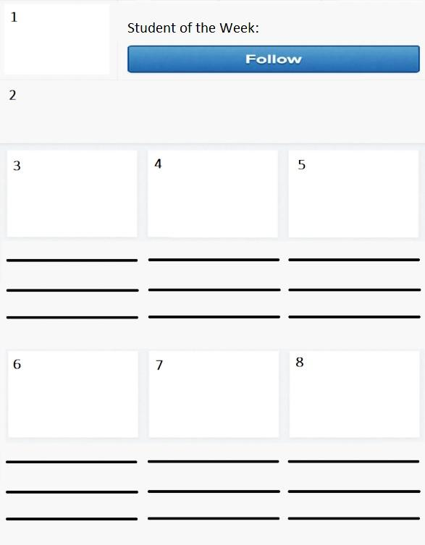

Presentational Writing
Novice High Proficiency Benchmark Check

Student name: ____________________________ Class: _____________
 |  | Meets | Does not meet
Functions | Student writes about self, immediate environment, and begins to provide description.
Content/Context | Student writes about self and immediate environment, such as home, community, and activities. Able to use highly predictable vocabulary and begins to use high frequency idiomatic expressions.
Text Type | Student writes using formulaic sentences and sometimes creates with language expressing original thoughts. Able to produce unrehearsed language. Able to write discrete sentences and possibly a string of sentences.
Language Control | Meaning is mostly understandable, but some may require a sympathetic reader.

Benchmark Score Demonstrated (Circle One): Yes No

