Math 3rd Grade Benchmark Assessment 1
3.OA.1, 3.OA.2, 3.OA.3, 3.NBT.1, 3.NBT.2, 3.MD.5, 3.MD.6, 3.G.1
# | Standard | Question
1 | 3.OA.1 | Choose the model that represents the following expression.  6 x 3 =  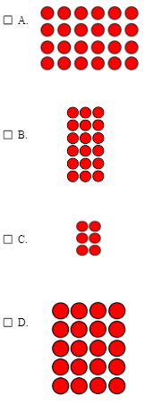
2 | 3.OA.1 | Which expression equals 2 x 3?  - 2 + 2  - 2 + 2 + 2  - 2 + 3  - 2 + 2 + 2 + 2 + 2 + 2
3 | 3.OA.2 | Santiago has 21 pieces of candy that he brought home from a birthday party. He wants to eat the same number of candy pieces each day for 7 days. Which of these shows how Santiago could split up the candy for each day?  Choose all that are correct.  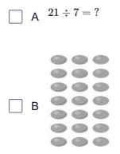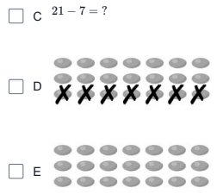
4 | 3.OA.2 | Which two questions can be answered correctly by finding 27 ÷ 9?  - A. If 27 students are placed into 9 equal-sized groups, how many students are in each group?  - B. If 9 rulers are stored in one box, how many boxes are needed to store 27 rulers?  - C. If each of the 27 chapters in a book is 9 pages long, how many pages long is the book?  - D. If 9 pencils were taken from a pack of 27, how many pencils are left?
5 | 3.OA.2 | You have 32 cookies. You want to put 8 cookies in each box. Which picture shows how many boxes you will use?  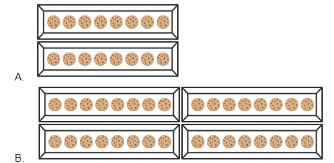  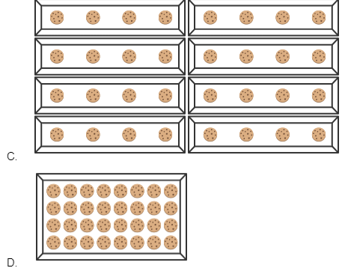
6 | 3.OA.3 | Dwayne ate 5 blueberries each day. He ate blueberries for 2 days.  Which could be used to find b, the number of blueberries Dwayne ate?  - 2 x 5 = b  - 2 ÷ 5 = b  - 2 - 5 = b  - 2 + 5 =
7 | 3.OA.3 | Jessie writes this on his whiteboard.  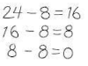  What problem is Jessie trying to solve?  - 24 ÷ 8 =  - 24 ÷ 6 =  - 24 - 16 =  - 24 x 3 =
8 | 3.OA.3 | Minh needs to put 9 basketballs in each bin to clean up after practice. There are 45 basketballs. Which equations can you use to find how many bins Minh can fill?  - A. 45 x 5 = ⬜  - B. 45 ÷⬜ = 9  - C. 45 ÷ 9 = ⬜  - D. 45 ÷ ⬜= 8  - E. 9 ÷ 45 = ⬜
9 | 3.NBT.1 | Which numbers equal 170 when rounded to the nearest ten? Choose all that apply.  - A. 173  - B. 177  - C. 168  - D. 163  - E. 165
10 | 3.NBT.1 | Jada's teacher asked her to round 1,783 to the nearest ten. Select the number line that would BEST help Jada solve this problem.  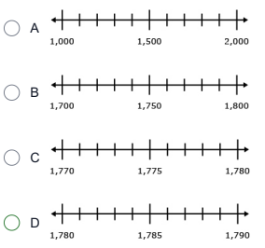
11 | 3.NBT.1 | Tyrese worked at a video game store. There was a big sale for four days. His boss wanted to know which day of the big sale the most people bought video games. He was asked to round these numbers to the nearest hundred.  435 488 450 472  Which of these numbers would Tyrese round to 400?  - 435  - 488  - 450  - 472
12 | 3.NBT.2 | During a number talk, Ms. Carroll’s students were breaking apart numbers to add 430 + 380. Which option could the students could use to solve the problem?  - 4 + 3 + 3 + 8 + 0 + 0  - 430 + 400  - 380 + 20 + 400  - 400 + 300 + 80 + 20 + 10
13 | 3.NBT.2 | Solve.  84 + 67 =  - 141  - 151  - 171  - 251
14 | 3.NBT.2 | What unknown number makes this equation true?  584 + 38 = 600 + □  - 12  - 13  - 22  - 24
15 | 3.MD.5 | Mr. Nolan wants to put new tiles on his rectangular kitchen floor. He has chosen tiles that are 1 square foot each. Which measurement should Mr. Nolan use to determine the number of tiles needed to cover the floor?  - the area of the floor  - the perimeter of the floor  - the width of the floor  - the length of the floor
16 | 3.MD.5 | Max wants to plant grass in his garden, seen below.  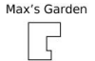  Max wants to find the area of his garden so he knows how much  grass he needs to buy to cover it. Which of these shows how Max  can find the area of his garden?  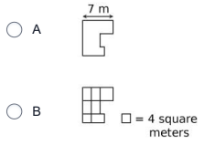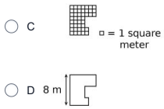
17 | 3.MD.6 | What is the area of the shape shown?  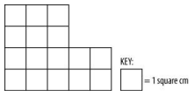  - 12 square centimeters  - 16 square centimeters  - 18 square centimeters  - 20 square centimeters
18 | 3.MD.6 | John made this shape out of blocks.  Which shapes have the same area as John's shape? Choose all that are correct.  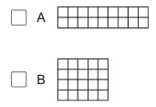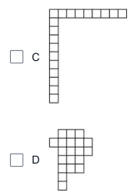
19 | 3.G.1 | Look at the polygons. Which polygons are quadrilaterals? Pick THREE that are correct.  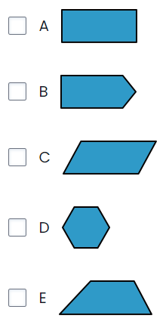
20 | 3.G.1 | Ben is using tiles like the one shown below to cover a stepping stone. Name the shape he created.  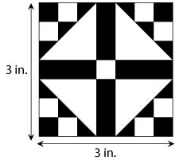  - Square  - Rectangle  - Triangle  - Rhombus
21 | 3.G.1 | Sasha and Max each have a group of shapes, seen below.  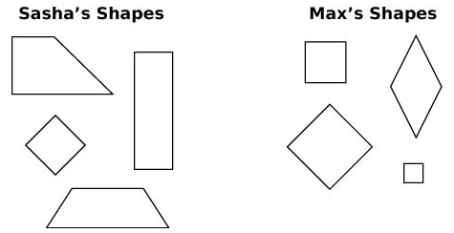  Look at Shape 1.  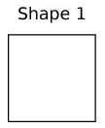  In which group does Shape 1 belong and why?  - Shape 1 belongs in both groups because all sides are the same length.  - Shape 1 only belongs in Max’s group because it is a rhombus.  - Shape 1 belongs in both groups because it is a quadrilateral and a rhombus.  - Shape 1 belongs in Sasha’s group because it is a quadrilateral.

Answer Key
1 | 3.OA.1 | B |  | 12 | 3.NBT.2 | D
2 | 3.OA.1 | B |  | 13 | 3.NBT.2 | B
3 | 3.OA.2 | A, B, E |  | 14 | 3.NBT.2 | C
4 | 3.OA.2 | A, B |  | 15 | 3.MD.5 | A
5 | 3.OA.2 | B |  | 16 | 3.MD.5 | C
6 | 3.OA.3 | A |  | 17 | 3.MD.6 | B
7 | 3.OA.3 | A |  | 18 | 3.MD.6 | B, D
8 | 3.OA.3 | B, C |  | 19 | 3.G.1 | A, C, E
9 | 3.NBT.1 | A, C, E |  | 20 | 3.G.1 | A
10 | 3.NBT.1 | D |  | 21 | 3.G.1 | C
11 | 3.NBT.1 | A

