Math 3rd Grade Benchmark Assessment 2
3.OA.3, 3.OA.7, 3.MD.7, 3.OA.4, 3.OA.6, 3.OA.8
# | Standard | Question
1 | 3.OA.8 | Bodin has 85 baseball cards. He buys 2 packets of baseball cards. Each packet has 7 cards. How many total baseball cards does Bodin have?  - 71 cards  - 87 cards  - 94 cards  - 99 cards
2 | 3.MD.7 | Which area models can be used to show the value of the expression (4×2) + (4×3)? Select two correct answers.  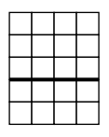  - A.  - B.  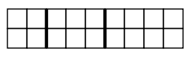  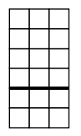  - C.  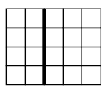  - D.  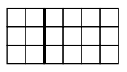  - E.
3 | 3.OA.6 | An equation with a missing number is shown.  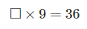  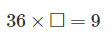  Which equation has the same missing number?  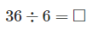  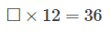  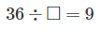
4 | 3.OA.8 | Timothy has 3 boxes of books. There are 45 books in all. Two of the boxes have 12 books each. Which equation can be used to find the total number of books, b, in the third box?  - 12 + 45 ÷ 3 = b  - 12 - 45 ÷ 3 = b  - 2 × 12 - b = 45  - 2 × 12 + b = 45
5 | 3.OA.3  3.OA.7 | There were 63 students on a trip to a local camp. The students were divided into 7 equal groups. Which equation can be use to find the number of students in each group? How many students were in each group?  - 7 + s = 63; 56 students in each group  - 63 - s = 7; 56 students in each group  - 63 + 7 = s; 70 students in each group  - 63 ÷ 7 = s; 9 students in each group
6 | 3.OA.4 | Which number will make the number sentence true?  40 = 4 ×⁤ 𞻱  - 8  - 9  - 10  - 40
7 | 3.MD.7 | What is the area of the figure in square units?  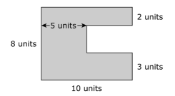  - 28 units  - 46 units  - 65 units  - 90 units
8 | 3.OA.7 | Which expression can be used to find 7 × 6? Choose all that apply.  - A. (7×4) + (7×2)  - B. (2×6) + (5×6)  - C. (5×6) + (1×6)  - D. (7×2) + (7×5)  - E. (7×3) + (7×3)
9 | 3.OA.6 | To solve 24 ÷ n = 6, which of the following equations could help you?  - n + 6 = 24  - 24 × 6 = n  - 6 × n = 24  - 24 - 6 = n
10 | 3.OA.3 | Sara is making 14 cookies. She has 98 chocolate chips and wants to use the same amount of chocolate chips on each cookie. Which diagram shows how to find the number of chocolate chips that Sara should put on each cookie?  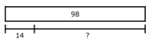  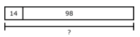  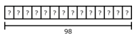  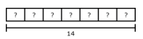
11 | 3.OA.4 | What unknown number makes the equation true?  8 = 8 ÷ 𞸃  - 64  - 16  - 1  - 56
12 | 3.OA.6 | The third graders were playing kickball at recess. There are 20 students that need to be put into 2 teams. Choose TWO equations that could be used to find how many players will be on each team.  - A. 20 × 2 = s  - B. 20 - 2 = s  - C. 2 x s = 20  - D. 20 ÷ 2 = s  - E. 20 + 2 = s
13 | 3.MD.7 | The front of the school has a square window with an area of 9 square feet. Which could be the measurement of each side of the window?  - 4 feet  - 3 feet  - 5 feet  - 81 feet
14 | 3.OA.8 | Kylie helped her grandfather clean out his basement. He paid her $3 for each box she filled up. Kylie filled 7 boxes.  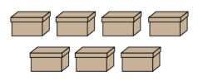  She put the money she earned in her piggy bank and then counted how much was in the piggy bank. She had $66 total.  Which equation can be solved to find how much money was in Kylie’s piggy bank before her grandfather paid her (n)?  - 66 + 3 × 7 = n  - n + 3 + 7 = 66  - n + 3 × 7 = 66  - n × 3 × 7 = 66
15 | 3.OA.3,  3.OA.7 | Jose, Sam, Nikki, and Zack each have 9 markers. How many markers do they have altogether?  - 13 markers  - 36 markers  - 27 markers  - 4 markers
16 | 3.OA.4 | Which number will make the number sentence true?  5 = ☐ ÷ 3  - 15  - 2  - 8  - 45

Answer Key

# | Standard | Answer | # | Standard | Answer
1 | 3.OA.8 | D | 11 | 3.OA.4 | A
2 | 3.MD.7 | A, D | 12 | 3.OA.6 | C, D
3 | 3.OA.6 | D | 13 | 3.MD.7 | B
4 | 3.OA.8 | D | 14 | 3.OA.8 | C
5 | 3.OA.3, 3.OA.7 | D | 15 | 3.OA.3, 3.OA.7 | B
6 | 3.OA.4 | C | 16 | 3.OA.4 | A
7 | 3.MD.7 | C
8 | 3.OA.7 | A, B, E
9 | 3.OA.6 | C
10 | 3.OA.3 | C

