Math 4th Grade Benchmark Assessment 2
Standards: 4.NF.1, 4.NF.2, 4.NF.3, 4.NF.4, 4.NF.5, 4.NF.6, 4.NF.7
# | Standard | Question
1 | 4.NF.1 | Which of the following fractions is NOT equivalent to $\frac{1}{2}$ ?  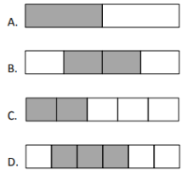
2 | 4.NF.1 | Which of the following fractions are equivalent to the model below? Choose all that apply.  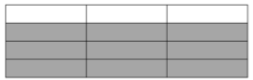  - A. $\frac{2}{3}$  - B. $\frac{3}{4}$  - C. $\frac{6}{8}$  - D. $\frac{10}{12}$
3 | 4.NF.2 | Look at the fraction strips below. Use them to answer the question.  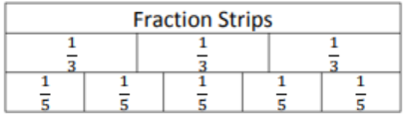  Which statement is true?  - $\frac{1}{5}$> $\frac{1}{3}$  - $\frac{2}{5}$ < $\frac{1}{3}$  - $\frac{3}{5}$ < $\frac{2}{3}$  - $\frac{4}{5}$ < $\frac{2}{3}$
4 | 4.NF.2 | Which fraction below is GREATER THAN the model?  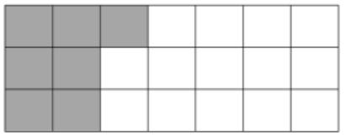  - $\frac{1}{2}$  - $\frac{1}{3}$  - $\frac{1}{4}$  - $\frac{1}{5}$
5 | 4.NF.2 | Amir shaded $\frac{2}{3}$ of a circle red. Marissa shaded $\frac{1}{4}$ of the same circle yellow. Which correctly compares the fractions of the circle that Amir and Marissa shaded?  - $\frac{2}{3}$ > $\frac{1}{4}$  - $\frac{2}{3}$ < $\frac{1}{4}$  - $\frac{2}{3}$ + $\frac{1}{4}$  - $\frac{2}{3}$ = $\frac{1}{4}$
6 | 4.NF.3 | Which equation below best represents this model?    =  - $\frac{5}{4}$ = $\frac{1}{4}$ x $\frac{1}{4}$ x$\frac{1}{4}$ x $\frac{1}{4}$ x $\frac{1}{4}$  - $\frac{5}{4}$ = 5 x $\frac{1}{4}$  - $\frac{2}{3}$ = $\frac{1}{4}$  - $\frac{2}{3}$ = $\frac{1}{4}$
7 | 4.NF.3 | Which of the following shows a correct way to decompose the fraction $\frac{7}{8}$?  - $\frac{6}{7}$ + $\frac{1}{1}$  - $\frac{8}{8}$ - 1  - $\frac{2}{8}$ + $\frac{2}{8}$ + $\frac{2}{8}$ + $\frac{1}{8}$  - $\frac{9}{8}$ - $\frac{2}{8}$ - $\frac{1}{8}$
8 | 4.NF.3 | Jason runs on a racecourse that is 3$\frac{5}{8}$ miles long. He has run 1$\frac{1}{8}$ miles. How many more miles must Jason run to reach the end of the racecourse?  - 1$\frac{4}{8}$  - 2$\frac{2}{8}$  - 2$\frac{4}{8}$  - 3
9 | 4.NF.4 | What whole number multiplied by $\frac{1}{4}$ would have a product of $\frac{5}{4}$?  - 1  - 4  - 5  - 2
10 | 4.NF.4 | Which expression will have the same product as 4 x $\frac{2}{5}$?  - 8 x $\frac{1}{5}$  - 8 x $\frac{2}{5}$  - 4 x $\frac{1}{5}$  - 4 x $\frac{2}{10}$
11 | 4.NF.4 | Ms. McCoy was baking cookies for the fourth grade classes. The recipe required $\frac{3}{4}$ of a cup of chocolate chips for each batch. Ms. McCoy needed to make 5 batches. How many cups of chocolate chips did Ms. McCoy use?  - 3$\frac{3}{4}$ cups  - 5$\frac{3}{4}$ cups  - $\frac{8}{4}$ cups  - $\frac{15}{20}$ cups
12 | 4.NF.5 & 4.NF.6 | Today at school, $\frac{3}{10}$ of Jody’s class bought a hot lunch and $\frac{40}{100}$ bought a sandwich. What fraction, in decimal form, of Jody’s class bought a hot lunch or a sandwich for lunch today?  - 0.01  - 0.1  - 0.7  - 0.07
13 | 4.NF.5 & 4.NF.6 | Which of the follow is the same as 0.95?  - 9 +$\frac{5}{10}$  - $\frac{9}{10}$ + $\frac{5}{10}$  - $\frac{9}{10}$ + $\frac{5}{100}$  - 9 + $\frac{5}{100}$
14 | 4.NF.5 & 4.NF.6 | Which fraction and decimal pair does the X represent on the number line below?  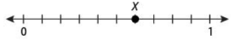  - $\frac{6}{100}$ and 0.06  - $\frac{6}{10}$and 0.6  - $\frac{6}{100}$ and 0.6  - $\frac{6}{10}$ and 0.06
15 | 4.NF.7 | Which statement correctly compares the models?  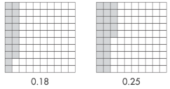  - 0.18 = 0.25  - 0.25 < 0.18  - 0.25 > 0.18  - 0.18 > 0.25
16 | 4.NF.7 | Look at the inequality shown below.  5.07 > ___  Which values will correctly complete the inequality?  Choose the TWO correct answers  - A. 5.02  - B. 5.4  - C. 5.09  - D. 5.1  - E. 5.05  - F. 5.07

Answer Key
# | Standard | Answer | # | Standard | Answer
1 | 4.NF.1 | C | 9 | 4.NF.4 | C
2 | 4.NF.1 | B, C | 10 | 4.NF.4 | A
3 | 4.NF.2 | C | 11 | 4.NF.4 | A
4 | 4.NF.2 | A | 12 | 4.NF.5 & 4.NF.6 | C
5 | 4.NF.2 | A | 13 | 4.NF.5 & 4.NF.6 | C
6 | 4.NF.3 | B | 14 | 4.NF.5 & 4.NF.6 | B
7 | 4.NF.3 | C | 15 | 4.NF.7 | C
8 | 4.NF.3 | C | 16 | 4.NF.7 | A, E

