Math 5th Grade Benchmark Assessment 1
5.NBT.1, 5.NBT.2, 5.NBT.3, 5.NBT.4, 5.NBT.5, 5.NBT.6, 5.NBT.7, 5.MD.4, 5.MD.5
# | Standard | Question
1 | 5.NBT.1 | Select the numbers where the digit in the hundreds place $\frac{1}{10}$ of the value of the digit in the thousands place.  - 8,856  - 6,855  - 5,568  - 5,656  - 8,556
2 | 5.NBT.1 | If the 9 in 506,092 is moved two places to the right, how does the value of the 9 change?  A The 9 is 1/100 of its original value.  B The 9 is 1/10 of its original value.  C The 9 has the same value.  D The 9 is 10 times its original value.
3 | 5.NBT.2 | Choose all the expressions that are equal to 6 x ${10}^{3}$.  - 6 x 100  - 6 x 1,000  - 6 x 10,000  - 6 x 10 x 10 x 10  - 6 x 10 x 10 x 10 x 10
4 | 5.NBT.2 | In which equation will d = ${10}^{2}$ make the equation true?  - 386.2 ÷ d = 3.862  - 4,963.6 ÷ d = 4.9636  - 5.8 ÷ d = 0.58  - 153 ÷ d = 0.153
5 | 5.NBT.3 | Choose all the comparisons that are true.  - 4.15 > 4.051  - 1.054 > 1.45  - 5.14 < 5.041  - 5.104 < 5.41  - 5.014 < 5.41
6 | 5.NBT.3 | A national park has eighty thousand, nine-hundred twenty-three and eighty-six hundredths acres of land. Which shows this in standard form?  - 80,923.086  - 80,923.68  - 80,923.806  - 80,923.86
7 | 5.NBT.4 | Which two numbers round to 15.5 when rounded to the nearest tenth?  - 15.04  - 15.55  - 15.508  - 15.445  - 15.0  - 15.49
8 | 5.NBT.4 | Nancy placed 78.089 on the number line. Which of the following numbers is closest to 78.089?  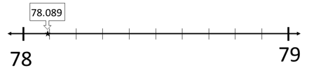  A 78  B 78.08  C 78.09  D 78.1
9 | 5.NBT.5 | Shauntel builds widgets at a factory. She makes exactly 258 widgets  each day. At the end of 27 days, how many widgets has she made at  the factory?  A 285 widgets  B 2,322 widgets  C 6,866 widgets  D 6,966 widgets
10 | 5.NBT.5 | There are 60 minutes in an hour and a day has 24 hours. How many minutes are there in a day?  A 1,240  B 1,440  C 12,240  D 14,400
11 | 5.NBT.5 | Mr. Hoover bought 15 bags of candy.  ● 8 of the bags had 27 pieces of candy each.  ● 7 of the bags had 132 pieces of candy each.  How many pieces of candy did Mr. Hoover buy?  A 363  B 1,140  C 1,272  D 2,196
12 | 5.NBT.6 | Anyta has several packs of stickers that she does not want anymore.  She has 84 animal stickers, 92 star stickers, 141 emoji stickers, and 27 rainbow stickers. She wants to give an equal number of stickers to each of her 4 younger sisters.  How many stickers should she give to each sister?  A 76  B 85  C 86  D 344
13 | 5.NBT.6 | A large math event was held for 5th grade students in Kentucky.  54 different schools sent students to the event.  Each school sent 28 students.  Students were placed into teams with 12 students on each team.  How many teams were formed?  A 18,144  B 1,512  C 126  D 7
14 | 5.NBT.7 | Each shaded area in the grids below represents a decimal.  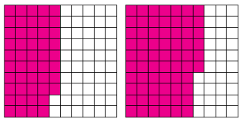  What is the sum of the decimals?  - 0.94  - 0.48  - 0.66  - 1.14
15 | 5.NBT.7 | Oliver buys 0.75 kilograms of grapes. He eats 0.17 kilograms of grapes. Oliver draws this model to ding how many kilograms of grapes are remaining.  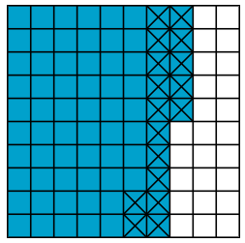  Which equation does Oliver’s model represent?  - 1.0 - 0.75 = 0.25  - 1.0 - 0.17 = 0.83  - 0.75 - 0.17 = 0.58  - 0.75 - 0.25 = 0.50
16 | 5.NBT.7 | Bailey wants to find 0.4 × 0.9.  Which of the following grids models the problem?  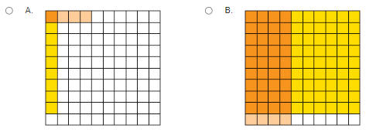  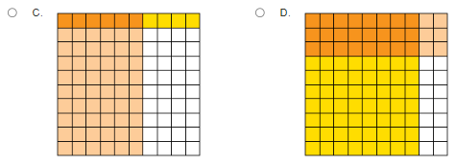
17 | 5.MD.4 | Both of the models shown are made up of 1-inch cubes. Which statement about these models is true?  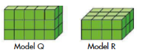  A. Model Q has 15 cubic units.  B. Model R has 24 cubic units.  C. Model Q has fewer cubic units than Model R.  D. Model R has 8 cubic units.
18 | 5.MD.4 | What is the volume of this figure?  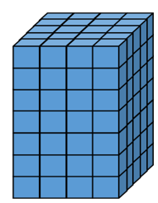  A 16 cubic units  B 83 cubic units  C 140 cubic units  D 150 cubic units
19 | 5.MD.5 | The volume of a juice box is 24 cubic units. A juice box company wants to design a new juice box that holds the same volume. Which of the following could be possible dimensions for the new design? Choose all that apply.  - A. 3 units x 4 units x 2 units  - B. 12 units x 12 units x 1 unit  - C. 12 units x 2 units x 1 unit  - D. 2 units x 2 units x 6 units  - E. 5 units x 4 units x 4 units
20 | 5.MD.5 | A student finds the volume of a right rectangular prism using cubic unit blocks, as shown.  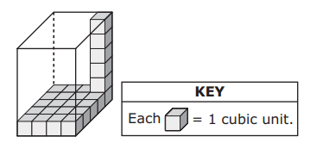  Which expression can be used to find the total number of cubic unit blocks the student needs to completely fill the prism?  A. 4 + 5 x 6  B. 5 x 4 x 6  C. 8 x 4 x 5  D. 10 + 8 x 6

Answer Key

# | Standard | Answer | # | Standard | Answer
1 | 5.NBT.1 | 8,856  5,568 | 11 | 5.NBT.5 | B 1,140
2 | 5.NBT.1 | A. The 9 is 1/100 of its original value. | 12 | 5.NBT.6 | C 86
3 | 5.NBT.2 | 6 x 1,000  6 x 10 x 10 x 10 | 13 | 5.NBT.6 | C 126
4 | 5.NBT.2 | A.386.2 ÷ d = 3.862 | 14 | 5.NBT.7 | D. 1.14
5 | 5.NBT.3 | 4.15 > 4.051  5.104 < 5.41  5.014 < 5.41 | 15 | 5.NBT.7 | C. 0.75 - 0.17 = 0.58
6 | 5.NBT.3 | D. 80,923.86 | 16 | 5.NBT.7 | B
7 | 5.NBT.4 | 15.508  15.49 | 17 | 5.MD.4 | B. Model R has 24 cubic units
8 | 5.NBT.4 | A 78 | 18 | 5.MD.4 | C 140 cubic units
9 | 5.NBT.5 | D 6,966 widgets | 19 | 5.MD.5 | A. 3 units x 4 units x 2 units  C. 12 units x 2 units x 1 unit  D. 2 units x 2 units x 6 units
10 | 5.NBT.5 | B 1,440 | 20 | 5.MD.5 | B. 5 x 4 x 6

