3rd Grade Standard Benchmark Assessment 1
Standards
RL.3.3  RL.3.6  RL.3.7 | RI.3.2  RI.3.3  RI.3.6  RI.3.7  RI.3.9 |  | L.3.1  L.3.2  L.3.4
Passage # 1
Brown Bear and the Honey Tree

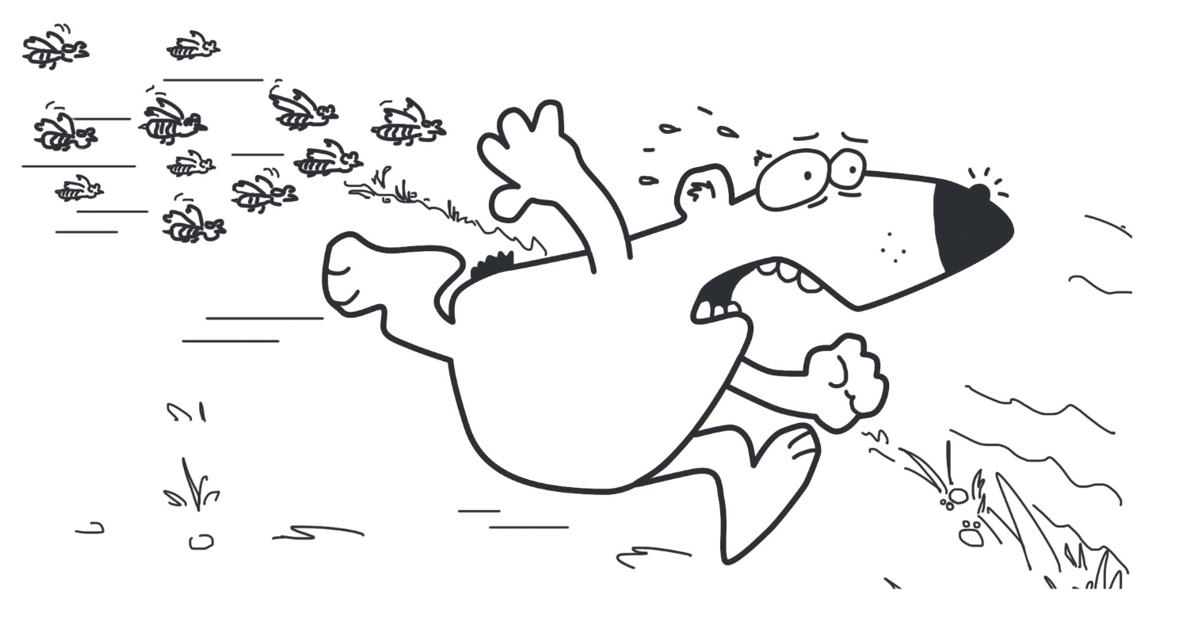
1 Brown Bear was wandering along a path in the forest one day. He was
searching for blueberries and nuts. He stopped at a patch full of ripe,
round berries and ate his fill. Moving on, he nearly tripped over the trunk
of a tree that had fallen during a storm.
2 Brown Bear sniffed around the tree carefully. He suspected that bees
stored their honey in the hollow trunk. Brown Bear loved honey, but he
knew better than to anger the bees. Bees might be small, but they could
also be dangerous.
3 Sure enough, Brown Bear found a hive. His timing was good, too.
Many bees had left the hive for the meadow this morning. They were
out collecting nectar from meadow flowers. They would use it to
make honey.
4 Slowly and carefully, Brown Bear dug into the hollow log with his paw.
He felt the honeycomb where the bees’ honey was stored. But at that
moment, he heard an angry buzzing sound.
OUCH!
A bee stung his nose.
His soft, sensitive nose was unprotected. The rest of him was covered
with heavy fur, but not his poor nose.
5 Brown Bear was very angry and decided to teach the bees a lesson.
He forgot about being careful. He would show those nasty little bees!
So he jumped on the trunk. Next, he would tear it apart with his teeth
and claws. But Bear’s hasty action only caused him more trouble. Bees
swarmed up from the log like a tornado. More bees flew from the
meadow to rescue their hive.
6 Poor Bear realized, too late, what he had done. He took off through the
the forest like his tail was on fire. The bees followed. Bear reached the river
just in time. The furious bees flew angrily overhead. Bear was forced to
swim across and down the river. Finally, the last bees gave up
the chase.

Standard |  | Question
RL.3.3 |  | The following item has two parts. Answer Part A and then answer Part B.  Part A  Why does Brown Bear attack the tree trunk in paragraph 5 of Brown Bear and the Honey Tree?  - He wants to teach the bees a lesson after he was stung on the nose.  - He wants to get to the honey that was deep inside the trunk.  - He wants to get away from the tornado of bees.  - He wants to help the bees get honey from the meadow.  Part B  How does the bear’s actions change what happens in the story?  - The bees were no longer able to gather pollen to make honey.  - The bear returned to his meal of blueberries and nuts.  - The bear was no longer able to get the honey and had to flee from the bees.  - The bear shared a meal of honey with the bees.
RL.3.6 |  | The following item has two parts. Answer Part A and then answer Part B.  Part A  How does passage 1 present different perspectives on the same situation?  - Brown Bear was hungry and the bees were happy to let him have some honey.  - The bees were hungry so they left the hive to gather more nectar and Brown Bear was hungry so he left his cave to gather berries.  - The bees were angry so they stung Brown Bear but he didn’t mind because he got to eat honey from their hive.  - Brown Bear was angry that he was stung and the bees were angry because Brown Bear was trying to steal their honey.  Part B  In the space below, describe how your perspective is different from that of Brown Bear’s perspective in passage 1.  Brown Bear was angry that he was stung and destroyed the hive inside of the tree. He shouldn’t have been so angry because he was stealing the honey that the bees worked hard to make. The bees were only protecting their hive.
RL.3.7 |  | 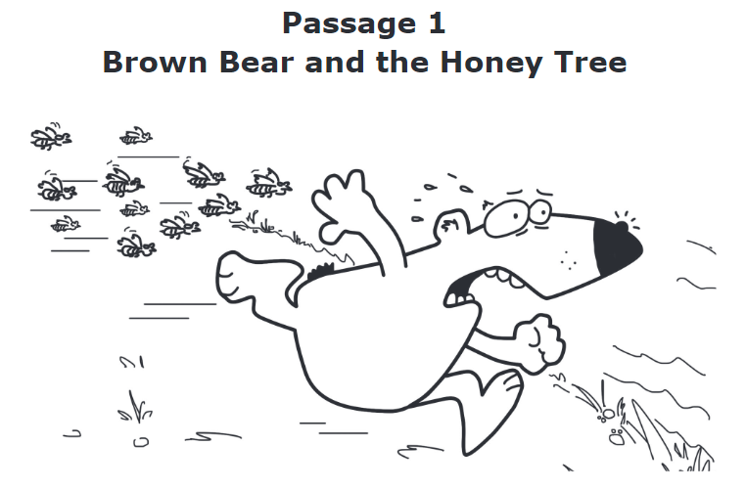  How does the illustration help the reader understand Brown Bear as described in paragraph 6?  - The illustration shows that Brown Bear is furious.  - The illustration shows that Brown Bear is nervous.  - The illustration shows that Brown Bear is excited.  - The illustration shows that Brown Bear is terrified.
L.3.4 |  | What does the word furious mean as it is used in the following text?  Bear reached the river just in time. The furious bees flew angrily overhead. Bear was forced to swim across and down the river.  - angry  - foolish  - hungry  - worried
Passage # 2
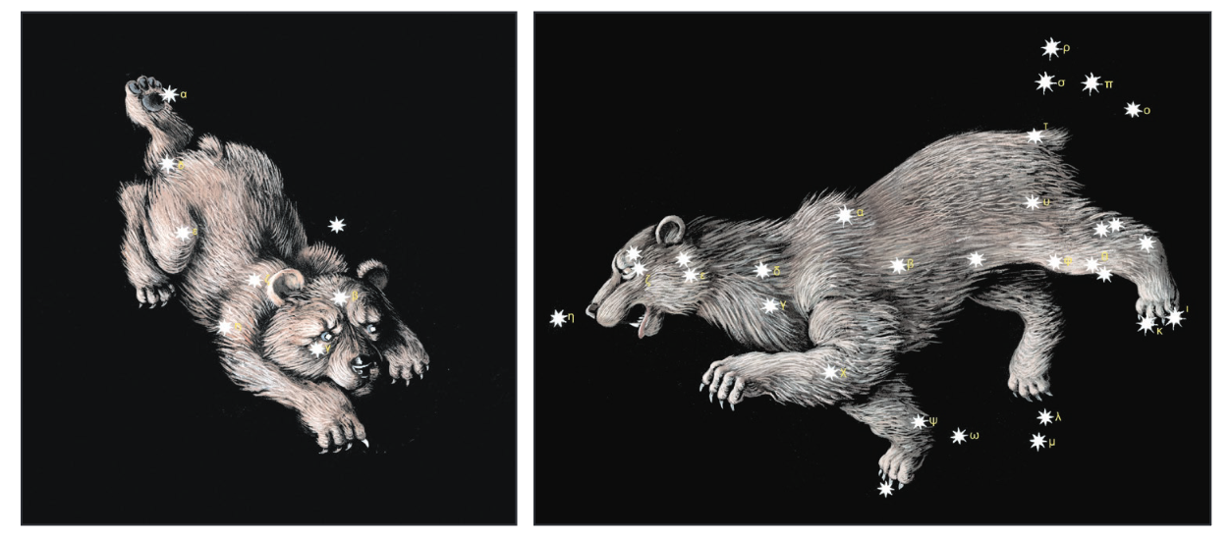
Little Bear Big Bear

“I want to be a star,” Little Bear would often say.
He said it to everyone and said it every day.
“I want to be a star,” he said, “that shines like a light.”
“So very happy,” he said, “and so very bright.”
5 But Raven soon grew tired of Little Bear’s cries
And threw the little baby bear into the night sky.
Little Bear joined the stars and should have been so glad,
But instead he became lonely, and very, very sad.
And down on Earth his mother cried night and day.
10 Her beautiful little cub was now so far away.
“I want to be a star,” she moaned, “together with my son.”
“I must be with him,” she cried, “he is my dear loved one.”
Now Raven soon grew tired of both bears being blue
And threw Little Bear’s mother into the sky, too.
15 Big Bear and Little Bear took their places side by side.
They were so pleased together to lighten up the sky.
So now when you look up into the night sky above,
You see Little Bear and Big Bear united by their love.
Together, forever, they light up the dark night.
20 So very happy they are, and so very bright
Standard |  | Question
RL.3.3 |  | The following item has two parts. Answer Part A and then answer Part B.  Part A  In the passage Little Bear Big Bear, what does Little Bear do that causes Raven to act?  - He complains every day.  - He becomes a group of stars.  - He loves his mother dearly.  - He shines happily at night.  Part B  Which lines from the poem best support the answer to Part A?  - “‘I want to be a star,’ he said, ‘that shines like a light.’ / ‘So very happy,’  he said, ‘and so very bright.’”  - “But Raven soon grew tired of Little Bear’s cries / And threw the little baby  bear into the night sky.”  - “And down on Earth his mother cried night and day. / Her beautiful little  cub was now so far away.”  - “‘I want to be a star,’ she moaned, ‘together with my son.’ / ‘I must be  with him,’ she cried, ‘he is my dear loved one.’”
RL.3.6 |  | The following item has two parts. Answer Part A and then answer Part B.  Part A  Select the word best describes Raven’s perspective when he threw Little Bear into the Night Sky?  - Annoyed  - Angry  - Helpful  - Considerate  Part B  Which example from passage 2 supports why Raven threw Little Bear into the Night Sky?  - He said it to everyone and said it every day.  - “I want to be a star,” he said, “that shines like a light.”  - But Raven soon grew tired of Little Bear’s cries  - Little Bear joined the stars and should have been so glad,
RL.3.7 |  | 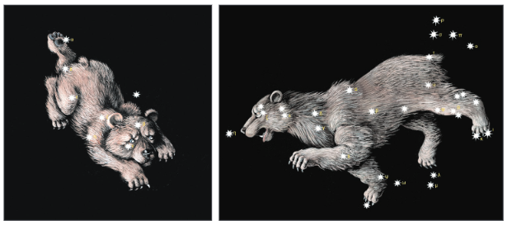  What detail from the story is best described in the illustrations?  - “I want to be a star, Little Bear would often say.  He said it to everyone and said it everyday.”  - “So no when you look up into the night sky above,  You see Little Bear and Big Bear united by their love.”  - “Her little cub was now so far away.  ‘I want to be a star,’ she moaned, ‘together with my son.’ ”  - Now Raven soon grew tired of both bears being blue  And threw Little Bear’s mother into the shy, too.”
Passage # 3
Alligator Alley

1 Alligators live everywhere in Florida. They are so common that there’s
a road named “Alligator Alley.” It is in southern Florida. It runs east–west
across the state in Everglades National Park. This area is mostly grassy,
wet swampland.
2 Before the road was built, there was no easy route from one coast of
Florida to the other. People thought a road would help drivers get places
faster. It would also help farmers take their crops to market. But not
everyone wanted the road. Many thought it would be useless. It crossed
miles and miles of swamp. People joked that only gators would ever use
the road.
3 There were other worries, too. Everglades National Park is home to
abundant wildlife, including birds, deer, snakes, and Florida panthers.
These big cats are an endangered species. During the 1960s, there were
fewer than twenty panthers in Florida. People were concerned about a
new road. It could destroy animals’ homes. And animals could be harmed
by cars on the road.
4 People in favor of the road won out. The eighty-mile road was built in
the late 1960s. The name “Alligator Alley” stuck and became its official
name. The road was not planned well. It was just two lanes. There were
many accidents between cars and wildlife.
5 In the 1980s, the road was redesigned. It was also made safer. It was
widened to four lanes with a safety barrier in the middle. Parts of the
road were raised so that water could flow under it. Wildlife could also
pass underneath. Fences were built along the road, too. The fences kept
animals off the road. They also kept cars from accidentally driving into
the swamp.
6 Today, maps show the road as Interstate 75. But people still call it
Alligator Alley. There are many rest areas and lookout points along the
road. People can stop and look for alligators and other wildlife. Even
though some people thought the road would be useless, many drivers
now use it to get across Florida.

Standard |  | Question
RI.3.2 |  | The following item has two parts. Answer Part A and then answer Part B.  Part A  What is the central idea of Passage 3?  - Alligator Alley is a road through Everglades National Park, which is  mostly swampland.  - Alligator Alley is a road that has made driving in Florida easier, but in the  past it caused problems.  - The best way to make roads safe is to build them with at least four lanes  and a safety barrier in the middle.  - There are so many alligators in Florida that a road called Alligator Alley  was named after them.  Part B  Which two sentences from the passage best support the answer to Part A?  - “They are so common that there’s a road named ‘Alligator Alley.’”  - “It runs east–west across the state in Everglades National Park.”  - “People thought a road would help drivers get places faster.”  - “There were many accidents between cars and wildlife.”  - “They also kept cars from accidentally driving into the swamp.”
RI.3.3 |  | Passage 3 says that Alligator Alley was redesigned in the 1980s.  What were two effects of the redesign?  - Parts of the road were raised to let wildlife and water pass through.  - The road allowed farmers to take their crops to market.  - Fences were built to keep animals off the road.  - Towns and cities along the route grew rapidly.  - There were many accidents involving cars and animals.
RI.3.3 |  | According to Passage 4, what caused panthers to live in South Florida? Choose all that apply.  - Alligators took over the swamps.  - Many of their habitats were destroyed.  - All of the panthers live in the Florida Panther National Wildlife Refuge.  - Too many were hit by automobiles.
RI.3.6 |  | Select the answer that best demonstrates how the content is presented in passage 3.  - Alligator Alley would help travelers get from one coast to another and get places faster. Many people thought Alligator Alley would be useless and harmful to wildlife.  - Alligator Alley was not planned well as a two lane road. Alligator Alley caused too many accidents between cars and wildlife.  - Alligator Alley was safe for animals because of fences to keep animals off of the road. Part of the road was raised so water and animals could pass underneath.  - Alligator Alley was built to attract more tourists; there are many rest areas and lookout points to observe alligators and other wildlife. Travel through the Everglades National Park destroyed habitats and animals had to relocate, animals were scarce and hard to find.
RI.3.7 |  | 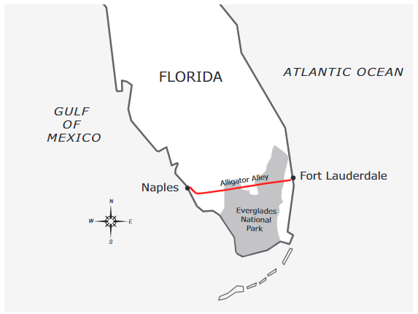  What can the reader learn from the map that is not in the passage?  - Alligator Alley is also called Interstate 75.  - Alligator Alley has four lanes with a barrier in between.  - Alligator Alley runs through Everglades National Park.  - Alligator Alley connects Naples and Fort Lauderdale.
RI.3.9 |  | How does the information from the texts contribute to the overall understanding of the theme or topic? Choose all that apply.  - People were concerned about a new road. It could destroy animals’ homes. And animals could be harmed by cars on the road.  - The eighty- mile road was built in the late 1960s. The name “Alligator Alley” stuck and became its official name.  - Panthers became endangered because they lost their habitats. Forests where they lived were bulldozed to make room for roads and houses.  - The Refuge is preserved land, so no one can build houses, roads or other buildings in it.
Passage # 4
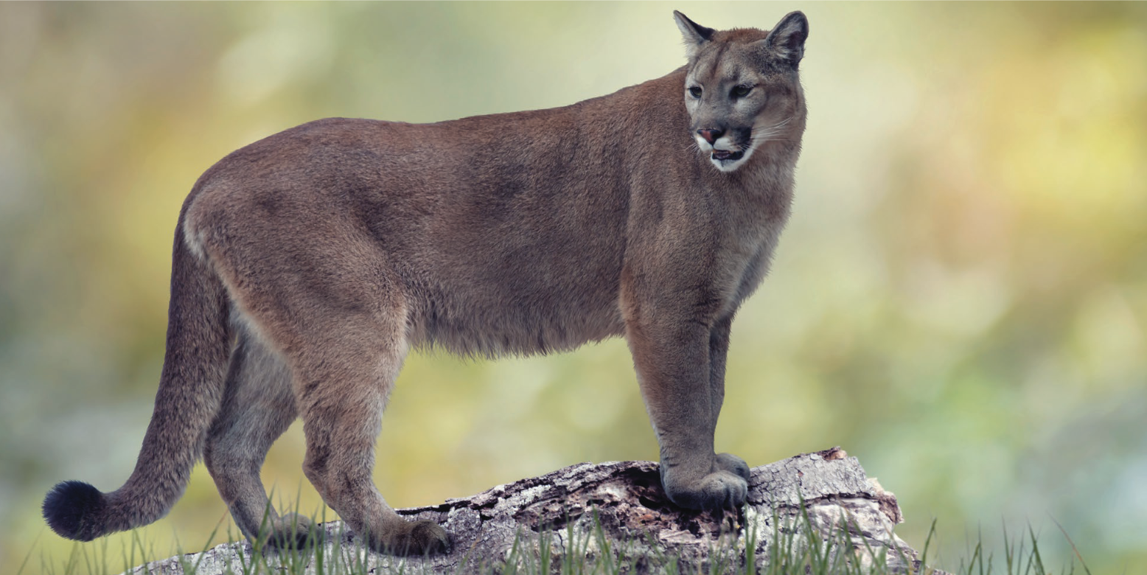
The Florida Panther
National Wildlife Refuge

Florida panthers are found in southern Florida. A male cat can be up to 7 feet long
and weigh 160 pounds. Females are a little smaller and weigh 50 to 115 pounds.
Panthers are tan to brown in color. They hunt and eat smaller animals.

1 Long ago, panthers were found all over the southeastern United
States. Only 120 to 230 of these wild cats are alive today. All of them
live in South Florida. The panthers may have all been lost if it weren’t for
the Florida Panther National Wildlife Refuge. This protected area helped
the panthers survive.
2 The Refuge is preserved land, so no one can build houses, roads, or
other buildings in it. This protects the animals and their homes. The
refuge is run by the U.S. Fish and Wildlife Service, which bought the land
in 1989. People who work there watch over the panthers to keep
them safe.
3 Panthers became endangered because they lost their habitats. Forests
where they lived were bulldozed to make room for roads and houses.
The panthers had to find new places to live. They needed space away
from people and traffic.
4 The Panther Refuge is near Naples, Florida. It is just north of Interstate
75. That road is also known as Alligator Alley. People can visit the refuge.
Two walking trails pass through the park. They allow people to see large
trees, plants, and ponds. Many kinds of birds can be found in the refuge.
Deer, bear, and other mammals live there, too. You may see a panther,
but sightings are not common.
Standard |  | Question
RI.3.2 |  | What is the central idea of Passage 4?  - The Florida Panther National Wildlife Refuge keeps panthers safe.  - Panthers used to live all over the southeastern United States but  now are found only in Florida.  - The Florida Panther National Wildlife Refuge is in southern Florida  near Alligator Alley.  - Panthers are cats that live in the wild, but they are losing their homes.
RI.3.6 |  | Which sentence would the reader most likely agree with after reading the passage “The Florida Panther National Wildlife Refuge?”  - People and traffic have helped panthers relocate to South Florida.  - Research can help scientists know how to protect panthers.  - The National Wildlife Refuge saved the panther species and has helped keep them safe.  - Wild panthers should be caught and kept in a safe place.
RI.3.7 |  | 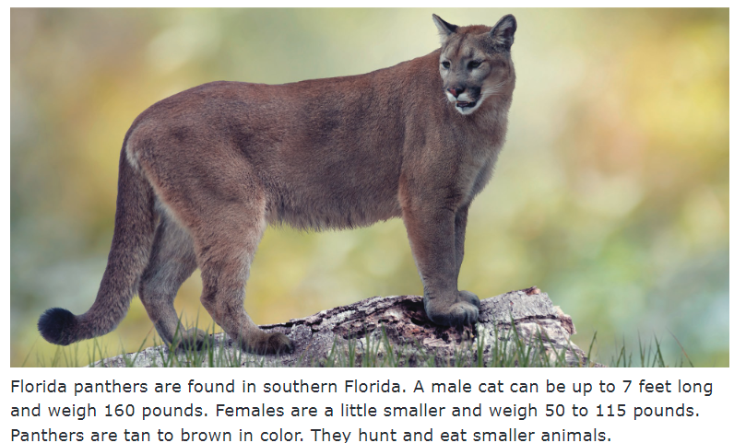  Based on the text, select a caption that would fit the photograph?  - There are only 120 to 130 of these wild cats alive today.  - There are dangers that panthers face all over the Southern United States.  - Panthers eat small animals.  - Panthers live on preserved land where no houses or roads can be built.
L.3.4 |  | What does the word preserved mean as it is used in paragraph 2 of Passage 4?  - open to the public  - without trees or plants  - put into a can or jar  - protected for a purpose
Passage #3 & #4
RI.3.9 |  | What information is discussed in both passages?  - Alligators were considered in development of Interstate 75 and precautions were made to protect alligators.  - The impact of human interaction on animal habitats and the survival of the Florida Panther.  - The National Wildlife relocated the panther after the number of panthers decreased all over the Southern United States.  - Many accidents, on Interstate 75, in Florida have involved cars and animals.
Editing Tasks
There are words or phrases in the passage that are underlined to show they may be incorrect or can be written better. For each underlined word or phrase, choose the correct replacement.

the chicago world fair

The Chicago World’s Fair were held in 1893. Forty-six country took part in the fair.
Some famous people helped design and build the fairgrounds. Main planner being Daniel Burnham. He was in charge of all the building that had to be done. Burnham brought in thousands of workers. It worked night and day for months to open the fair on time.
The Chicago fair was remark for many reasons. It featured the world’s first Ferris wheel. It marked the first time most Americans saw electric light. It also presented a number of new inventions. These included the first moving walkway and the first movie theater.
Standard |  | Question
L.3.1 |  | Replace were held with  - were held (no change)  - are held  - was held  - being held
L.3.1 |  | Replace Main planner being Daniel Burnham. with  - Main planner being Daniel Burnham. (no change)  - The main planner being Daniel Burnham.  - Daniel Burnham, being the main planner.  - The main planner was Daniel Burnham.
L.3.2 |  | Replace the title, the chicago world fair with  - The chicago world fair  - The Chicago World Fair  - THE CHICAGO WORLD FAIR  - the Chicago world fair
L.3.2 |  | Replace remark with  - mark  - remarked  - remarkable  - unmarked

