**Name:** **Date:**

**FCPS English 3 Standard Benchmark 2**

**Read the two selections. Then, choose the best answer to each question.**

**Selection 1: *from* The Yellow Wallpaper**

*by Charlotte Perkins Gilman*

*This excerpt comes from the 1892 short story* “The Yellow Wallpaper.” *The story is about a young woman whose husband, a physician, has taken her to spend the summer relaxing in a rented house after she has exhibited symptoms of depression. She spends much of her time in the home’s nursery, which is decorated with yellow wallpaper.*

*1* I cry at nothing, and cry most of the time.

*2* Of course I don’t when John is here, or anybody else, but when I am alone.

*3* And I am alone a good deal just now. John is kept in town very often by serious cases, and Jennie is good and lets me alone when I want her to.

*4* So I walk a little in the garden or down that lovely lane, sit on the porch under the roses, and lie down up here a good deal.

*5* I’m getting really fond of the room in spite of the wallpaper. Perhaps because of the wallpaper.

*6* It dwells in my mind so!

*7* I lie here on this great immovable bed—it is nailed down, I believe—and follow that pattern about by the hour. It is as good as gymnastics, I assure you. I start, we’ll say, at the bottom, down in the corner over there where it has not been touched, and I determine for the thousandth time that I will follow that pointless pattern to some sort of a conclusion.

*8* I know a little of the principle of design, and I know this thing was not arranged on any laws of radiation, or alternation, or repetition, or symmetry, or anything else that I ever heard of.

*9* It is repeated, of course, by the breadths, but not otherwise.

*10* Looked at in one way each breadth stands alone, the bloated curves and flourishes—a kind of “debased Romanesque” with delirium tremens—go waddling up and down in isolated columns of fatuity.

*11* But, on the other hand, they connect diagonally, and the sprawling outlines run off in great slanting waves of optic horror, like a lot of wallowing seaweeds in full chase.

*12* The whole thing goes horizontally, too, at least it seems so, and I exhaust myself in trying to distinguish the order of its going in that direction.

*13* They have used a horizontal breadth for a frieze, and that adds wonderfully to the confusion.

*14* There is one end of the room where it is almost intact, and there, when the cross-lights fade and the low sun shines directly upon it, I can almost fancy radiation after all,—the interminable grotesques seem to form around a common centre and rush off in headlong plunges of equal distraction.

*15* It makes me tired to follow it. I will take a nap, I guess.

**Selection 2: The Wife**

*by Emily Dickinson*

She rose to his requirement, dropped

The playthings of her life

To take the honorable work

Of woman and of wife.

*5* If aught she missed in her new day

Of amplitude, or awe,

Or first prospective, or the gold

In using wore away,

It lay unmentioned, as the sea

*10* Develops pearl and weed,

But only to himself is known

The fathoms they abide.

**1. Read this passage from “The Yellow Wallpaper.”**

Looked at in one way each breadth stands alone, the bloated curves and flourishes—a kind of “debased Romanesque” with delirium tremens—go waddling up and down in isolated columns of fatuity.

But, on the other hand, they connect diagonally, and the sprawling outlines run off in great slanting waves of optic horror, like a lot of wallowing seaweeds in full chase.

**Which statement best describes the type of diction the author uses in this excerpt to describe the wallpaper?**

1. **The author uses lush yet off-putting sensory language to describe the wallpaper.**
2. The author uses general conversational language to describe the wallpaper.
3. The author uses scientific, intellectual language to describe the wallpaper.
4. The author uses simple, childlike language to describe the wallpaper.

**2. At the time “The Yellow Wallpaper” was written, society largely stereotyped women as weak and inferior to men, and husbands held significant power over their wives. As a result, women’s opinions and experiences were rarely validated within a marriage.**

**Which of the following best expresses a theme in “The Yellow Wallpaper” that reflects the social context in which it was written?**

1. Good marriages should be built on trust and caring.
2. **Men cannot understand the pressures their wives face.**
3. Repressive gender roles in marriage are harmful to women’s mental health.
4. Societal norms around marriage create unrealistic expectations for both men and women.

**3. Read this passage from “The Yellow Wallpaper.”**

I’m getting really fond of the room in spite of the wallpaper. Perhaps because of the wallpaper.

It dwells in my mind so!

I lie here on this great immovable bed—it is nailed down, I believe—and follow that pattern about by the hour. It is as good as gymnastics, I assure you. I start, we’ll say, at the bottom, down in the corner over there where it has not been touched, and I determine for the thousandth time that I will follow that pointless pattern to some sort of a conclusion.

**What makes the author’s syntax in this passage effective?**

1. The arrangement of words and phrases in each sentence suggests the narrator is excited to share her experiences.
2. The arrangement of words and phrases in each sentence emphasizes the narrator’s intelligence and her attention to detail.
3. **The variety in sentence lengths and types, as well as the use of interrupting clauses, reflect the disordered state of the narrator’s mind.**
4. The variety in sentence lengths and types, as well as the use of interrupting clauses, reveal that the narrator is nervous that her husband will never let her out of the room.,

4. **At the time “The Wife” was written in 1896, women, when they married, were generally expected to conform to the lifestyle, desires, and interests of their husbands. Society treated women, in many regards, as second-class citizens.**

**Given this social context, which of the following best expresses a theme in “The Wife”?**

1. **Being seen as a good wife requires burying any negative feelings about marriage.**
2. A woman’s struggles in marriage come from avoiding conflict with her husband.
3. Men never truly understand their wives.
4. It may feel difficult to let go of childish things when one marries, but the result is valuable.

**5. Which of the following statements best compares how women are depicted in “The Yellow Wallpaper” and “The Wife”?**

1. While the story examines women’s oppression, the poem is more focused on a woman’s regrets about making a bad marriage.
2. While the woman in the story is portrayed as shallow and weak, the woman in the poem is shown as having hidden depths.
3. **Both the story and the poem explore how women are harmed by oppressive societal expectations.**
4. Both the story and the poem show that married women can become mentally ill when oppressed.

**6. How does Gilman use setting and description in Selection 1 to develop the narrator’s state of mind?**

1. By describing the wallpaper as a source of comfort and inspiration for the narrator.
2. By depicting the garden and the lane as places of solace and escape from loneliness.
3. **By contrasting the immovable bed with the sprawling and unsettling wallpaper pattern.**
4. By focusing on the narrator's interactions with John and Jennie as a reflection of her emotional state.

**7. Which literary technique is employed in both passages to convey the internal struggles of the narrators?**

1. **Symbolism, through the use of specific objects and settings.**
2. Foreshadowing, through hints about future events in the narrators' lives.
3. Allegory, through the depiction of abstract concepts like honor and duty.
4. Irony, through the contrast between the narrators' thoughts and actions.

**8. How is the narrator characterized in Selection 1?**

1. As resilient and resourceful
2. **As intellectually curious with an artistic sensitivity**
3. As rebellious and defiant against societal norms
4. As content and fulfilled in her domestic role

**9. How does Emily Dickinson’s choice of the phrase “rose to is requirement” in the second passage contribute to the characterization of the wife?**

1. It suggests that the wife is resistant to her husband's demands.
2. **It implies that the wife willingly accepted and fulfilled her husband's expectations.**
3. It conveys a sense of reluctance and hesitation on the part of the wife.
4. It indicates that the wife surpassed her husband's expectations through her actions.

**10. How do the arrangement of stanzas and line breaks contribute to the thematic focus in Selection 3?**

1. By using a consistent rhyme scheme that emphasizes the stability and routine in the wife's life.
2. **By separating the poem into distinct sections that explore different aspects of the wife's role and identity.**
3. By employing enjambment to create a sense of continuity and flow, reflecting the wife's ongoing commitment.
4. By using irregular line lengths to disrupt the poem's rhythm, mirroring the challenges faced by the wife in fulfilling her duties.

**Read the selection, and choose the best answer to each question.**

***from* To the Legislature of New York**

*by Elizabeth Cady Stanton*

*Elizabeth Cady Stanton was an activist who fought for equal rights for women and for the abolition of slavery. The following passage is an excerpt from an 1854 address to the Legislature of New York, in which she argues in favor of women’s voting rights, or suffrage.*

(1) “The thinking minds of all nations call for change. There is a deep-lying struggle in the whole fabric of society; a boundless, grinding collision of the New with the Old.”1

(2) The tyrant, Custom, has been summoned before the bar of Common Sense. His Majesty no longer awes the multitude—his sceptre is broken—his crown is trampled in the dust—the sentence of death is pronounced upon him. All nations, ranks and classes have, in turn, questioned and repudiated his authority; and now, that the monster is chained and caged, timid woman, on tiptoe, comes to look him in the face, and to demand of her brave sires and sons, who have struck stout blows for liberty, if, in this change of dynasty, she, too, shall find relief.

(3) Yes, gentlemen, in republican America, in the nineteenth century, we, the daughters of the revolutionary heroes of '76, demand at your hands the redress of our grievances—a revision of your state constitution—a new code of laws. Permit us then, as briefly as possible, to call your attention to the legal disabilities under which we labor.

(4) 1st. Look at the position of woman as woman. It is not enough for us that by your laws we are permitted to live and breathe, to claim the necessaries of life from our legal protectors—to pay the penalty of our crimes; we demand the full recognition of all our rights as citizens of the Empire State. We are persons; native, free-born citizens; property-holders, tax-payers; yet are we denied the exercise of our right to the elective franchise. We support ourselves, and, in part, your schools, colleges, churches, your poor-houses, jails, prisons, the army, the navy, the whole machinery of government, and yet we have no voice in your councils. We have every qualification required by the constitution, necessary to the legal voter, but the one of sex.

(5) [*Here Stanton points out that there were other groups besides women who were generally not allowed to vote at the time, including African Americans. She notes, however, that members of these other groups were able to vote if they met certain basic requirements. She then contrasts their case with the case of women.*]

(6) [But] we, who have guided great movements of charity, established missions, edited journals, published works on history, economy and statistics; who have governed nations, led armies, filled the professor’s chair, taught philosophy and mathematics to the *savants* of our age, discovered planets, piloted ships across the sea, are denied the most sacred rights of citizens, because, forsooth, we came not into this republic crowned with the dignity of manhood! Woman is theoretically absolved from all allegiance to the laws of the state. Section. 1, Bill of Rights, 2 R.S., 301, says that no authority can, on any pretense whatever, be exercised over the citizens of this state but such as is or shall be derived from, and *granted by, the people of this state*.

(7) Now, gentlemen, we would fain know by what authority you have disfranchised one-half the people of this state? You who have so boldly taken possession of the bulwarks of this republic, show us your credentials, and thus prove your exclusive right to govern, not only yourselves, but us. Judge Hurlburt, who has long occupied a high place at the bar in this state, and who recently retired with honor from the bench of the Supreme Court, in his profound work on human rights, has pronounced your present position rank usurpation. Can it be that here, where are acknowledged no royal blood, no apostolic descent,2 that you, who have declared that all men were created equal—that governments derive their just powers from the consent of the governed—would willingly build up an aristocracy that places the ignorant and vulgar above the educated and refined—the alien and the ditch-digger above the authors and poets of the day—an aristocracy that would raise sons above the mothers that bore them? Would that the men who can sanction a constitution so opposed to the genius of this government, who can enact and execute laws so degrading to womankind, had sprung, Minverva-like,3 from the brains of their fathers, that the matrons of this republic need not blush to own their sons! Woman’s position, under our free institutions, is much lower than under the monarchy of England.

|  |
| --- |

**1. “The thinking minds . . . the New with the Old”** Stanton is quoting from British thinker Thomas Carlyle’s 1829 essay “Signs of the Times,” on social trends of the day.

**2. apostolic descent** the belief that the authority of modern Christian churches has been handed down, generation by generation, from the apostles (original disciples) of Jesus.

**3. Minerva-like** In Greek and Roman mythology, Minerva (called Athena by the Greeks) was said to have been born, fully formed, from the forehead of her father Zeus.

**11. Which of the following best states two central ideas of the passage?**

1. **Women deserve full rights as citizens; men have no authority to take away women’s rights.**
2. Men established the customs of the day; they are responsible for making new laws to solve the problems facing women.
3. Women are important citizens because they pay taxes and own property; women’s accomplishments show they are as intelligent as men.
4. Men have created a constitution that discriminates against women; society in America discriminates against women more than society in England does.

**12. Which choice best explains the development and interaction of the two central ideas identified in Part A?**

1. Stanton praises the “stout blows for liberty” that men have struck (paragraph 2), and she cites legal opinions by a male judge   
   (paragraph 7). These two ideas strengthen and support each other, showing the responsibility men have for the current situation.
2. **Stanton enumerates women’s contributions to prove they deserve the right to vote (paragraph 4). She cites the law and a judge to show that men have no authority to take away this right (paragraphs 6 and 7). The ideas combine to show that women must be given the right to vote.**
3. Stanton calls for “a new code of laws” and a “revision” of the constitution, which was written by men (paragraph 3). She concludes that a woman’s position in America “is much lower than under the monarchy of England” (paragraph 7). These ideas combine to support her argument that the U.S. Constitution is discriminatory and must be revised.
4. Stanton lists public institutions, such as schools and poor-houses, which are partially supported by women’s taxes (paragraph 4). She reminds the audience of women’s achievements in science, philosophy, mathematics, and more (paragraph 6). These two ideas combine to prove that women contribute in the same ways as men, so they are the equals of men.

**13. Consider the following arguments Stanton makes in the speech.**

**1. Stanton reminds her audience that she and many other women are daughters of the revolutionary heroes of ‘76.**

**2. Stanton enumerates women’s many contributions to society, including charity work, publishing, teaching, and governing.**

**3. Stanton argues that disenfranchising women goes against the Bill of Rights, which says that no authority can be exercised over citizens without their consent.**

**4. Stanton cites a former Supreme Court judge’s support for her position and his pronouncement that “your present position [is] rank usurpation.”**

**Which is an example of legal reasoning that supports her claim?**

1. Number 1
2. Number 2
3. **Number 3**
4. Number 4

**14. How does Stanton’s use of rhetorical questions in paragraph 7 contribute to the overall purpose of her speech?**

1. The questions imply that men are not only disenfranchising women—the educated and refined—but also other vulnerable members of society, such as immigrants and working people.
2. The questions point out that there is no clear reason men have this power that women do not, that women also come from royal lineage, and that citizens are living in an aristocracy.
3. **The questions emphasize that men have acted without proper authority, that men are creating a sort of aristocracy, and that the government is governing without the consent of the people.**
4. The questions highlight references to aristocracy’s unjust authority, the influence of royal blood, and the humiliation of women who are rendered subservient to their sons.

**15. How does Stanton’s use of historical details effectively develop her thesis in   
“To the Legislature of New York”?**

1. In paragraph 2, she uses the metaphor of a king as a monster to make the point that women are as courageous as men. In paragraph 6, she lists women’s many accomplishments to develop the point that women are equally hard-working and courageous. These details support her thesis that women should have the right to vote.
2. She uses the example of the Revolutionary War to remind citizens that women have fought alongside men during times of war, and the example of a former Supreme Court judge who supports the cause. These details support her thesis that women should also have the right to vote.
3. **In paragraph 3, she reminds men that women’s fathers fought in the Revolutionary War. In paragraph 4, she lists women’s accomplishments to show the irony that they cannot vote and uses the Bill of Rights to defend women’s right to be part of the legislative process. These details support her thesis that women should have equal rights to men.**
4. In paragraph 2, she uses the metaphor of a king as a monster to make the point that no citizens want a king. She references England’s monarchy in paragraph 7, reminding men they have “no royal blood”, and an aristocracy, to develop the point that Americans want neither of these forms of government. These details support her thesis that women should have the right to vote.

1**6. Which of the following excerpts from Stannton’s speech is an example of the persuasive appeal *pathos*?**

1. **“[W]e demand the full recognition of all our rights as citizens of the Empire State. We are persons; native, free-born citizens; property-holders, tax-payers; yet are we denied the exercise of our right to the elective franchise.”**
2. “We have every qualification required by the constitution, necessary to the legal voter, but the one of sex.”
3. “Woman is theoretically absolved from all allegiance to the laws of the state. Section. 1, Bill of Rights, 2 R.S., 301, says that no authority can, on any pretense whatever, be exercised over the citizens of this state but such as is or shall be derived from, and *granted by, the people of this state*.”
4. “Would that the men who can sanction a constitution so opposed to the genius of this government, who can enact and execute laws so degrading to womankind, had sprung, Minverva-like, from the brains of their fathers, that the matrons of this republic need not blush to own their sons!”

17. **This political cartoon was published in the years before women won the right to vote. Review the cartoon. Consider it alongside Stanton’s “To the Legislature of New York.” What do the two taken together suggest about the challenges women faced in their fight for voting rights?**

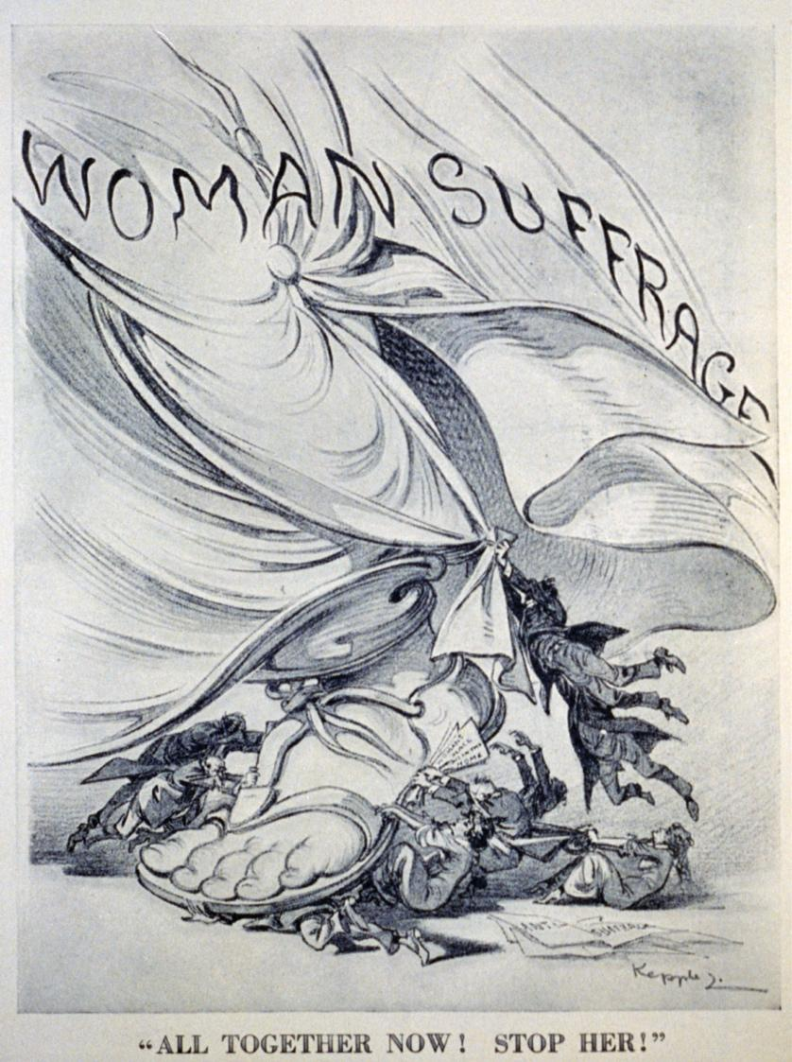

1. **They suggest that although there were many who opposed women’s right to vote and tried to stop the movement, in the end it was an unstoppable force that would be successful.**
2. The political cartoon illustrates a historical example where men have traditionally exerted control over women by keeping them from voting, while the speech suggests women had the power to make change.
3. Both pieces suggest that women’s fight for the right to vote would be a very a long one, with many naysayers and protestors refusing to back down.
4. The political cartoon suggests that some women were traitors to the cause, while the speech implies that men and boys were the only ones fighting against women’s suffrage.

**18. How does Elizabeth Cady Stanton establish a logical progression of ideas in the passage?**

1. By beginning with a historical context and ending with a call to action for women's rights.
2. By alternating between arguments for women's suffrage and criticisms of the legal system.
3. By presenting grievances against the government and then proposing solutions for reform.
4. By starting with personal reflections and concluding with a comparison to the monarchy of England.

**19. How does the artist’s depiction of the Greek sandal in the political cartoon reinforce the message in Stanton’s speech?**

1. **The sandal references Minerva, and symbolizes the ancient traditions of democracy and equality, echoing Stanton’s call for women’s rights within the context of historical precedent.**
2. The sandal represents a barrier to progress, highlighting Stanton’s argument that outdated customs and laws restrict women’s ability to participate fully in society.
3. The sandal is depicted as a symbol of authority and power, illustrating Stanton’s assertion that women should challenge and overcome male-dominated institutions.
4. The sandal signifies a call to action, urging women to step forward and assert their rights as equal citizens, consistent with Stanton’s plea for legal reform.

**20. Which statement reflects the most accurate evaluation of the sufficiency of Stanton’s argument in the speech?**

1. Stanton presents a compelling case by providing historical examples of women's contributions to society, but fails to address the economic implications of granting women the right to vote.
2. **Stanton effectively argues for women's suffrage by highlighting the injustices faced by women under current laws and demonstrating the parallels with other disenfranchised groups.**
3. Stanton's argument lacks sufficiency because she primarily relies on emotional appeals rather than presenting concrete evidence of the benefits of women's participation in governance.
4. Stanton’s speech is insufficient in addressing the legal complexities of amending the Constitution to grant women the right to vote, focusing instead on general principles of equality.

**21. How does Elizabeth Cady Stanton's speech address the theme of equality as it relates to historical and contemporary social structures?**

1. By contrasting the legal rights of women in America with those in England during the monarchy, Stanton highlights the evolution of gender equality.
2. **By discussing the legal disabilities faced by women in the context of a democratic republic, Stanton critiques the gap between ideals of equality and practical implementation.**
3. By referencing the Bill of Rights and other legal documents, Stanton underscores the foundational principles of democracy and their application to gender equality.
4. By advocating for women's suffrage, Stanton explores how historical precedents of civil rights movements inform contemporary debates on equality.

**22. Why is Elizabeth Cady Stanton's speech historically significant?**

1. Because it directly led to the passage of the 19th Amendment, granting women the right to vote in the United States.
2. **Because it challenged prevailing societal norms and legal barriers by advocating for women's rights and suffrage during a time of widespread gender inequality.**
3. Because it was delivered at the Seneca Falls Convention, marking the beginning of the women's suffrage movement in the United States.
4. Because it was the first public address to explicitly argue for women's equality under the law, influencing subsequent civil rights movements globally.