**FCPS English 4 Standards Benchmark 1**

**Read the selection, and choose the best answer to each question.**

**Selection 1: from The *Epic of Gilgamesh***

**POETRY:***Selection 1 is an excerpt from The Epic of Gilgamesh, an epic poem from Sumeria, an ancient civilization of the Middle East. The hero, Gilgamesh, the king of the city-state Uruk, is part human and part divine. When his best friend Enkidu dies, Gilgamesh searches for Utnapishtim, survivor of a greatflood, in order to learn how to escape death. In this excerpt, Utnapishtim sets a challenge for Gilgamesh.*

When Gilgamesh at last finds Utnapishtim,

he cries out to him,

“I searched the world,

tramped over every mountain,

5 descended into every valley,

and sailed across every sea.

I feel every footfall of the journey,

my muscles are throbbing.

Pains keep me awake.

10 I have found Urshanabi the ferryman,

and I have forded the river of death.”

Utnapishtim replies to him,

“Who is Gilgamesh that the gods should gather on your behalf

and grant you the immortal life that you seek?

15 Yet will I set you a challenge: Guard against sleep for six days and seven nights.”

Yet even as Gilgamesh crouches, on his guard against slumber,

sleep, like a strand of sheep’s wool wafting in the breeze, comes to rest upon

him.

Utnapishtim speaks to his wife,

“Behold the mighty warrior now, he who seeks to defeat merciless death

20 has fallen captive to gentle sleep.”

The wife of Utnapishtim beseeches him,

“Wake the poor man now, he who is in turmoil,

so that he may again go home,

his heart at ease, with his mind at ease.”

25 Utnapishtim says to her,

“No mortal man is trustworthy.

Beware, for Gilgamesh will try to trick you.”

Thus he instructs her,

“Every morning bake one loaf of bread, and place it next to his head,

30 and carve a mark for each day that Gilgamesh dreams.”

So every morning she bakes a loaf of bread,

and places it next to his head,

and carves a mark for each day that Gilgamesh dreams.

When Utnapishtim brushes against Gilgamesh, he awakens and says,

35 “Scarcely had you brushed against me when I awoke.”

Utnapishtim replies,

“Regard how many loaves of bread are here,

one for each day you have slumbered.

The bread of your first day is like stone,

40 the bread of your second day is like animal hide,

the bread of your third day is like mud,

the bread of your fourth day is moldy,

the bread of your fifth day is damp,

the bread of your sixth day is soft,

45 the bread of your seventh day is fresh.”

Then speaks Gilgamesh,

“O Utnapishtim, what more can I do,

what hope of victory have I now?

I who sought to conquer my most fearsome enemy, death,

50 the ruler of mortal man and beast?

Already I feel my defeat,

how death makes of me its battlefield and its victory prize.”

**Selection 2: from Gilgamesh, a Graphic Novel**

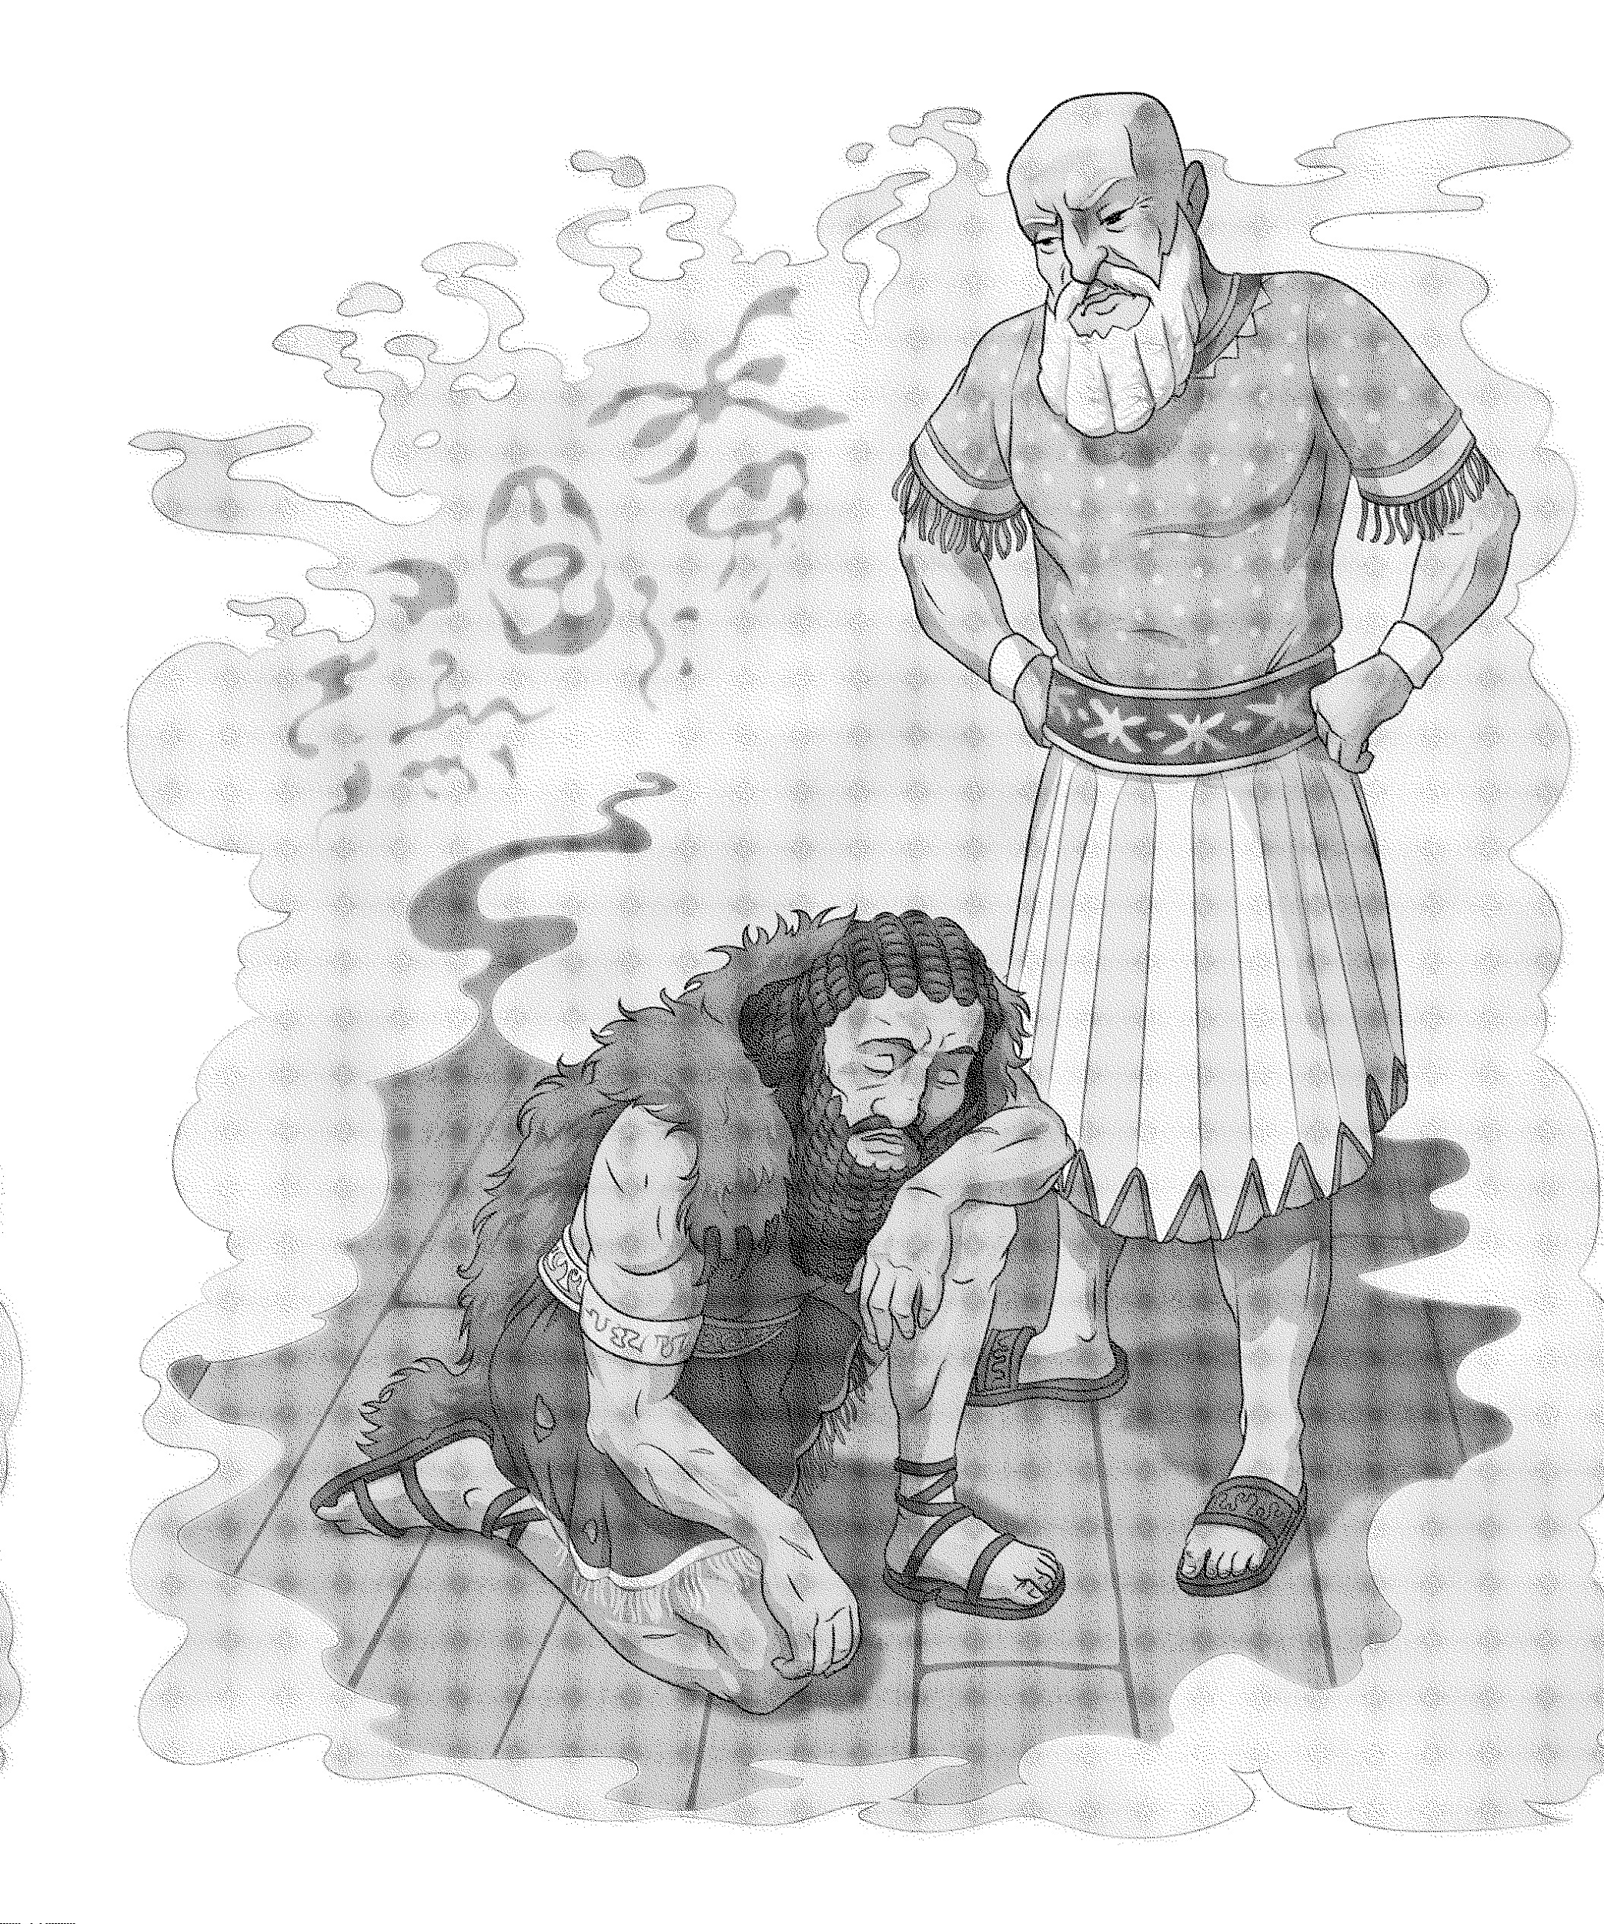

**1. Which of the following best compares the portrayal of Utnapishtim in selections 1**

**and 2?**

1. In both the image and the text, Utnapishtim feels sorry for Gilgamesh as the hero sleeps.
2. **In both the image and the text, Utnapishtim seems sternly critical of Gilgamesh’s weakness.**
3. In the text, but not the image, Utnapishtim feels sadly disappointed by Gilgamesh’s sleep.
4. In the image but not the text, Utnapishtim tries to encourage Gilgamesh to stay awake.

**2. Which of the following best describes the artist’s use of composition in Selection 2?**

1. By depicting Utnapishtim standing over Gilgamesh, the artist emphasizes Utnapishtim’s anger and Gilgamesh’s submission.
2. **By depicting Utnapishtim standing over Gilgamesh, the artist emphasizes Utnapishtim’s authority and Gilgamesh’s failure.**
3. By creating a misty, indeterminate background, the artist emphasizes Utnapishtim’s ignorance and Gilgamesh’s mysterious nature.
4. By creating a misty, indeterminate background, the artist emphasizes Utnapishtim’s power and Gilgamesh’s hunger for immortality.

**3. How does Utnapishtim's interaction with Gilgamesh characterize Utnapishtim, and**

**what do these interactions suggest about his perspective on immortality?**

1. **Utnapishtim is characterized as wise and somewhat cynical, recognizing the futility of Gilgamesh's quest for immortality and using the challenge to teach him a lesson about human limitations.**
2. Utnapishtim is portrayed as compassionate and hopeful, believing that all humans, including Gilgamesh, deserve a chance at immortality if they prove their worth.
3. Utnapishtim is depicted as indifferent and disinterested, showing no concern for Gilgamesh's quest and viewing it as a futile endeavor.
4. Utnapishtim is shown as envious and competitive, seeking to undermine Gilgamesh’s efforts to achieve what he himself possesses.

**4. Which line from the passage best supports your answer to Question 3?**

1. "I searched the world, tramped over every mountain, descended into every valley, and sailed across every sea."
2. **"Who is Gilgamesh that the gods should gather on your behalf and grant you the immortal life that you seek?"**
3. "Wake the poor man now, he who is in turmoil, so that he may again go home, his heart at ease, with his mind at ease."
4. "Regard how many loaves of bread are here, one for each day you have slumbered. The bread of your first day is like stone, the bread of your second day is like animal hide."

**5. What is the outcome of Utnapishtim’s challenge to Gilgamesh?**

1. Utnapishtim challenges Gilgamesh to solve a riddle, and Gilgamesh solves it easily.
2. Utnapishtim challenges Gilgamesh to climb a mountain, but Gilgamesh gives up halfway.
3. **Utnapishtim challenges Gilgamesh to stay awake for six days and seven nights, but Gilgamesh falls asleep.**
4. Utnapishtim challenges Gilgamesh to cross a river, and Gilgamesh successfully completes the task.

**6.** **What does the outcome of Utnapishtim’s challenge reveal about Gilgamesh’s**

**character?**

1. It shows that Gilgamesh is overconfident in his abilities, demonstrating his hubris and lack of self-awareness.
2. It indicates that Gilgamesh is inherently lazy and lacks the discipline needed to achieve his goals.
3. **It reveals Gilgamesh's deep-seated fear of death and his realization of his own limitations as a mortal being.**
4. It highlights Gilgamesh's indifference towards challenges, showing that he is uninterested in proving his worth.

**Selection 3: A Strange Mirror: The World of the Fable**

1 Fables are short, fictional stories that often include animals that act like humans. The animals in fables have conversations, make mistakes, trick each other, take risks, and learn lessons—just like people. Through their animal characters, fables are generally meant to teach a lesson for humanity, sometimes expressed explicitly in a moral, or pithy concluding statement. It may be that the use of non-human characters frees the fabulist from the fear of too directly discomforting—or even insulting—readers. The form has certainly endured, transforming itself over the centuries from a repository of schoolroom lessons in character to a vehicle of biting political observation.

2 Some of the earliest instances of the fable appear in the five-part Panchatantra, a collection of interwoven animal stories from India from the third and fourth centuries BCE. Penned in Sanskrit by Vishnu Sharma, these comical fables were written to teach life lessons to the sons of the Hindu royalty. The animal characters try to outwit each other by trickery and deceit, but in the end learn lessons about friendship, family, prudence, and other concepts.

3 About 600 of the best-known fables today are attributed to an enslaved man in ancient Greece named Aesop who lived from about 620 to 560 BCE. In Aesop’s fables, the animal characters are defined, simply and completely, by the basic human characteristic each emblematizes. The ant in “The Grasshopper and the Ant” is relentlessly industrious; the fox in “The Fox and the Crow” is cocky and clever—and character is destiny. The ant, diligently storing food for the winter, is guaranteed to survive another year; the thriftless grasshopper is doomed to perish in the winter cold. The clever fox inevitably outsmarts the naïve crow. In no instance can the character surpass itself or its destiny; in every instance, there is an easy, practical lesson intended for readers.

4 Centuries afterward, the French poet Jean de La Fontaine (1621–1695) retold some of Aesop’s tales in Fables, a collection of 239 poems. But where Aesop is largely remembered for practical life lessons such as “Slow and steady wins the race,” La Fontaine arguably expands the fable’s moral scope to include critiques of political realities and social injustice. In fables comparing public leaders to flies feasting on a dying animal or likening warring nations to quarreling thieves, La Fontaine brings fable closer to the domain of political satire.

5 This maturing of the fable—its ascent from the humble schoolroom to the political forum—is perhaps consummated in George Orwell’s Animal Farm, published in 1945. While the work has the form of a full-length novel, critics often compare it to a fable because of its use of animal characters to make a point about human affairs. The barnyard animals in Orwell’s tale enact a tragic allegory of the history of the Communist revolution in Russia, descending from their righteous uprising against an oppressive farmer to an evil dictatorship by the pigs who led them.

6 Far as Orwell’s bitter vision of history may be from Aesop and his simple, timeless morals, both hold up the world of animals as a mirror to humanity. In this strange, but strangely familiar, mirror world, a fallible humanity can behold its saddest flaws—and perhaps be moved to correct them.

**7. Which sentence from the text provides the best support for the thesis, “The fable has evolved over time and remains a respected and relevant genre”?**

1. “Fables are short, fictional stories that often include animals that act like

humans.” (paragraph 1)

1. “In Aesop’s fables, the animal characters are defined, simply and

completely, by the basic human characteristic each emblematizes.”

(paragraph 3)

1. **“This maturing of the fable—its ascent from the humble schoolroom to the political forum—is perhaps consummated in George Orwell’s Animal Farm, published in 1945.” (paragraph 5)**
2. “In this strange, but strangely familiar, mirror world, a fallible humanity

can behold its saddest flaws—and perhaps be moved to correct them.”

(paragraph 6)

**8. Which of the following expresses a central idea from the text?**

1. Fables found their most mature form in George Orwell’s Animal Farm.
2. Fables written for children are less complex than those written for adults.
3. **Fables have a range of purposes, from a simple moral to biting political critique.**
4. Fables have developed over time, from simplistic moral tales into sharp political critiques.

**9. Which of the following most clearly identifies the main idea in paragraph 2?**

1. Some of the earliest fables were written by Vishnu Sharma for Hindu royalty, to teach them about life lessons in family, friendship, and other concepts.
2. The earliest of known fables, the Panchatantra is a collection featuring animals trying to outsmart each other using wit and deception.
3. The Indian fable Panchatantra is the earliest example of a fable, forming the basis for the political commentaries of later fables such as Animal Farm.
4. **The Panchatantra, Indian fables written between the fourth and fifth centuries for Hindu royalty, helped establish the framework and example for how fables are known today.**

**10. How does the evidence support your answer to Question 9?**

1. **Evidence: “Some of the earliest instances of the fable…written to teach life lessons…the animal character…learn human lessons.”**

**Support: This highlights that the Panchatantra is the earliest example of the fable, with characteristics similar to the ones we are familiar with today.**

1. Evidence: “interwoven animal fables…comical fables were written to teach life lessons…animal characters try to outwit each other.”

Support: This highlights that Panchatantra’s animal characters and humor mirror characters and tone of Animal Farm.

1. Evidence: “a collection of interwoven animal stories…try to outwit each other by trickery and deceit, but in the end learn lessons about friendship, family, prudence, and other concepts”

Support: The characters of the Panchatantra use wit and deception, similar to the characters of other fables written at later times.

1. Evidence: “appear in the five-part Panchatantra…Penned in Sanskrit…in the end learn lessons about friendship, family, prudence, and other concepts”

Support: The life lessons taught by the Panchatantra are the same ones taught by other fables throughout time.

**11. How does the author structure the passage to convey the evolution of fables over time?**

1. By comparing and contrasting the themes of different fables from various cultures.
2. **By providing a chronological overview of notable fabulists and their contributions.**
3. By discussing the moral lessons of fables before exploring their political implications.
4. By focusing on the different animal characters used in fables and their symbolic meanings.

**12. What is the purpose of the detailed descriptions of fables by Aesop, La Fontaine, and Orwell in the passage?**

1. To show how the use of animal characters in fables has remained consistent over time.
2. To illustrate the increasing complexity and scope of the lessons conveyed through fables.
3. To argue that modern fables are superior to ancient ones in terms of literary quality.
4. **To demonstrate the shift from teaching simple life lessons to addressing broader societal issues.**

**13. How does the author use rhetoric to enhance the reader’s understanding of the significance of fables in different historical contexts?**

1. By employing vivid imagery to describe the animal characters in the fables.
2. By using parallel structure to compare the moral lessons of different fables.
3. By quoting directly from the fables to provide concrete examples of their themes.
4. **By using contrasting examples to show how the purpose of fables has shifted over time.**

**14. How does the author support the argument that fables have matured over time to**

**include political and social commentary?**

1. By discussing the enduring popularity of Aesop’s fables.
2. By highlighting the moral lessons in the Panchatantra and Aesop’s fables.
3. **By providing examples of La Fontaine's and Orwell’s works that expand the scope of fables to critique political realities.**
4. By describing the animal characters used in different fables.

**15. Which piece of evidence best supports the idea in Part A?**

1. "Some of the earliest instances of the fable appear in the five-part Panchatantra, a collection of interwoven animal stories from India from the third and fourth centuries BCE."
2. "About 600 of the best-known fables today are attributed to an enslaved man in ancient Greece named Aesop who lived from about 620 to 560 BCE."
3. **"La Fontaine arguably expands the fable’s moral scope to include critiques of political realities and social injustice."**
4. "The barnyard animals in Orwell’s tale enact a tragic allegory of the history of the Communist revolution in Russia.