**Fayette County Public Schools**

**3rd Grade Social Studies**

**Benchmark Assessment**

**Fall 2024**

**3.C.CP.1. Explain the basic purposes and functions of differing governing bodies in the world.**

Use the graphic below to answer Questions 1-2

| **Who Rules?** | | | |
| --- | --- | --- | --- |
| **NONE** | **ONE** | **FEW** | **ALL** |
| **Anarchy** | **Monarchy**  **Dictatorship** | **Oligarchy** | **Democracy** |

1. Both a monarchy and a dictatorship are ruled by a single person. Which of the following is the biggest difference between these forms of government?
2. Power in a monarchy is always passed down through a ruling family.
3. Power in a dictatorship is always passed down through a ruling family.
4. People vote in a monarchy, not in a dictatorship.
5. People vote in a dictatorship, not a monarchy.

2. Which of the following is the BEST definition of a democracy?

1. A system where one leader makes all the decisions.
2. A system where people vote to choose their leaders and make decisions together.
3. A system where only a few people make decisions for everyone.
4. A system where decisions are made by religious views.

3. Which of the following IS NOT an example of the purpose of government?

1. It defends the country from outside enemies
2. It keeps order within the country
3. It provides goods and services for the people.
4. It controls all aspects of citizen’s lives.

**3.C.RR.1 Examine how the government maintains order, keeps people safe, and makes and enforces rules and laws in diverse world communities.**

4. Which of the following is one way a government maintains order?

1. By passing laws
2. By paying taxes
3. Through schools
4. Through businesses

5. Which of the following is the best example of how the government keeps people safe?

1. The Department of Interior protects the national park system.
2. The Mint makes cash and coins.
3. The National Weather Service issues watches and warnings in severe weather.
4. The Transportation Department monitors ships coming into harbors for trade.

6. In an **oligarchy,** who makes the laws?

1. A single ruler with absolute power
2. A small group of people
3. All citizens
4. A king or queen

**3.C.CV.1 Compare civic virtues and democratic principles within a variety of diverse world communities.**

7. Which of the following is an example of a civic virtue?

1. Holding a canned food drive in your school
2. Having a pep rally at school
3. Watching educational videos on YouTube
4. Leaving trash on the ground when you walk by.

8. Which of the following is true about citizens that live in a country with a dictatorship?

1. They have as many freedoms and exercise rights like people in a democracy.
2. They have the right to come together and protest the government without punishment.
3. They have fair elections to select the leaders they want to lead them.
4. They do not have the right to vote freely or protest the government.

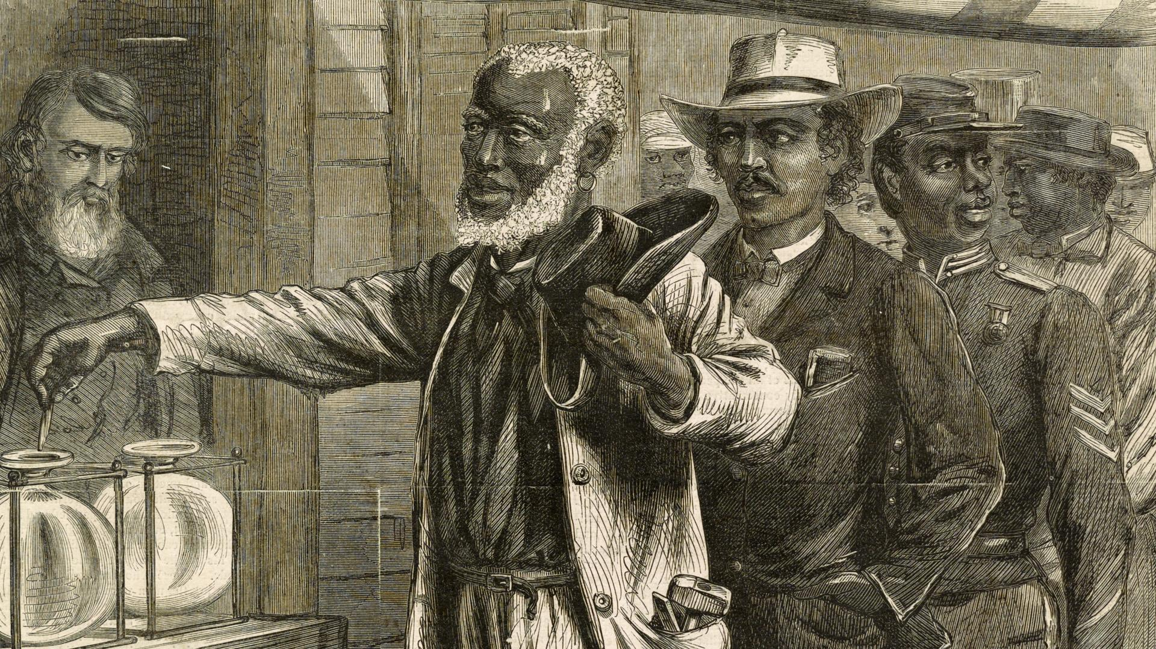

9. After the Civil War in the United States, slavery ended. The men who were freed slaves were then given rights to vote, own land, and collect paychecks for their work. Which of the following best describes what happened from this action?

1. People had fewer rights and privileges.
2. Rights of people were expanded to include the freed slaves as citizens.
3. The freed slaves were still not considered citizens.
4. People that had rights before had them taken away.

**3.C.PR.1 Explain how processes, rules, and laws influence how individuals are governed and how diverse world communities address problems.**

10. How do laws influence individuals in a democratic society?

1. Laws only apply to some people and not others.
2. Laws help protect the rights of all people and ensure fairness.
3. Laws are made to make life difficult for everyone.
4. Laws are always changing and are hard to follow.

11. In Saudi Arabia, a king appoints a Consultative Council of advisors. The council can suggest new laws or change old ones. However, the king is considered the head of the lawmaking branch. Most people in Saudi Arabia have no say in government. (adapted from Savvas myWorld)

Which of the following best describes the government of Saudi Arabia?

1. The king has the final say in what laws are passed.
2. The Council has the real power in laws that are passed.
3. Citizens and the Council work together to suggest laws to the king.
4. The citizens can vote on laws they want to pass.

12. China has a Communist government. In a Communist country, individual people do not own land or businesses. Instead, the government owns them. The Communist Party controls China’s government. The Chinese President leads the Communist Party. The Party controls the National People’s Congress, which makes China’s laws. (Adapted from Savvas myWorld)

Which of the following best describes the government of China?

1. People have had a lot of success owning their own businesses.
2. People have a lot of choices during elections of which party they want to vote for.
3. The Communist Party controls the government and almost all parts of life in China.
4. The President of China does not have much power.