**Fayette County Public Schools**

**4th Grade Social Studies**

**Benchmark Assessment**

**Spring 2025**

**4.G.HI.1 Explain how cultural, economic, environmental characteristics affect the interactions of people, goods, and ideas from European Exploration to the Thirteen Colonies.**

Read the following passage to answer Question 1.

| Long before the first European settlers set foot on this land, Native Americans like the *Wampanoag* tribe had already been farming for thousands of years! However, they didn’t have perfect farmland. They had to develop ways to bring water to fields, control floods, and level the land to make it better to farm. These methods paved the way for crops like corn, beans, and squash, which were introduced to European settlers when they arrived.   * Adapted from *Celebrating National Native American Heritage Month: Indigenous Farming Techniques.* Second Harvest Food Bank of Middle Tennessee (2023) |
| --- |

1. The *Wampanoag* tribe of New England are most known in history for helping the Puritan settlers from England. Based on the above passage, which of the following is most likely a way the tribe helped settlers?
2. They helped settlers build their houses.
3. They introduced settlers to animals like the horse.
4. They introduced new crops and ways to farm.
5. They taught them how to fight in battles.

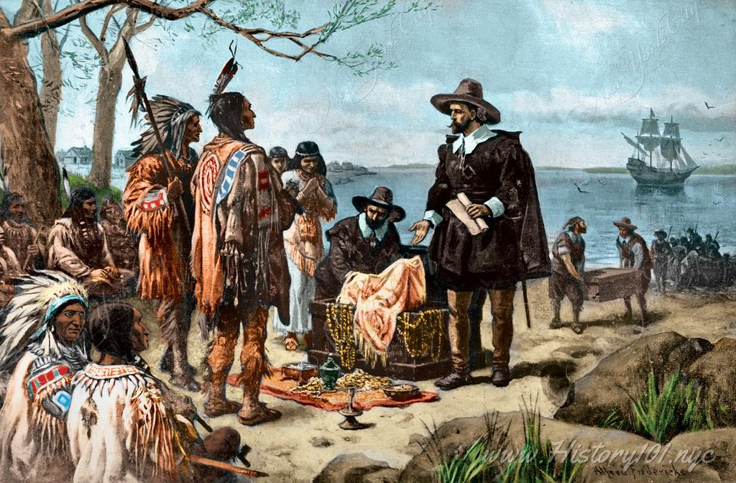

2. The painting above represents the legend of Dutch settlers purchasing the island of Manhattan, which is now New York City. What kind of interaction does this show?

1. It shows how the Dutch directly impacted the environment by building a city.
2. It shows an economic interaction through trade.
3. It shows how both Native Americans and Europeans developed transportation.
4. It shows an exchange of ideas for farming.

Use the map to answer Questions 3-4

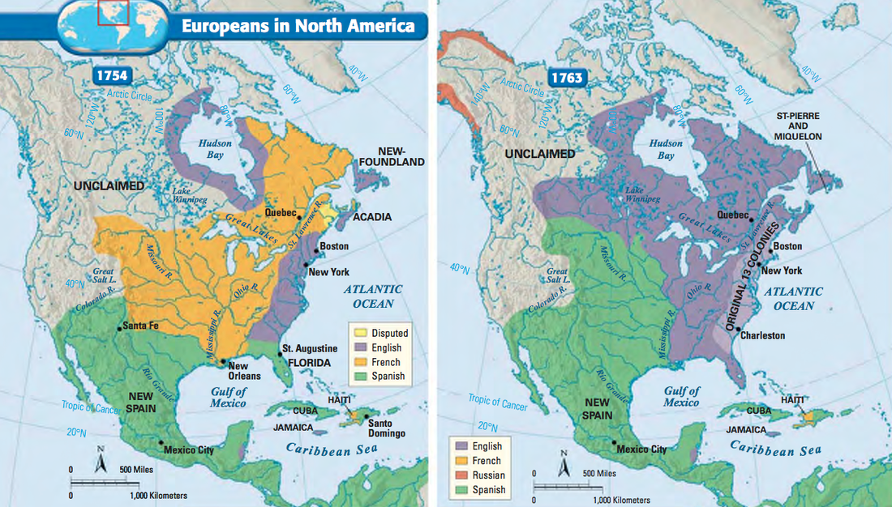

3. The map above shows how European countries had claims in North America. The left shows how the continent looked in 1754, and the right shows nine years later, in 1763. Which of the following best describes what happened as groups claimed land during that time?

1. The French lost almost all of their land claims.
2. The British lost a lot of land.
3. The Spanish lost a lot of land.
4. The Russians lost almost all of their land claims.

**4.H.CH.1 Describe how migration and settlement impacted diverse groups of people as they encountered one another from European Exploration to the Thirteen Colonies.**

4. Using the map, which of the following is true as a result of European settlers interacting together?

1. Russian settlers had land in 1754, but retreated to Alaska by 1763.
2. The English and the Spanish gained land that was once claimed by France.
3. Native American empires grew across the western part of the continent.
4. The English settlers lost Florida from the Spanish by 1763.

| Both France and England wanted to claim the land around the Great Lakes and the Ohio RIver Valley. The French wanted the land to continue hunting and fur trapping. The English wanted the land to expand farmland and settlement. |
| --- |

5. Given the information above and the map of changes in settlement, which of the following is most likely to happen as a result of England and France wanting the same area of land?

1. They would easily be able to meet and come up with a solution to share the land and resources.
2. They would decide it best not to settle and expand their settlements.
3. They would both negotiate through Native American allies and trade deals.
4. They would come into conflict and go to war over the land they both want.

Use the map below to answer Question 6.

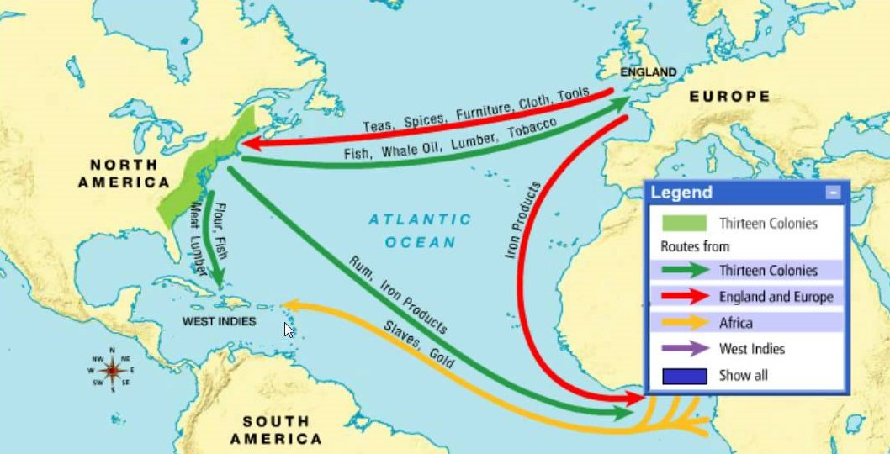

6. Which of the following best describes how interactions between Europeans, Native Americans, and Africa impacted people in all three regions?

1. It opened up a trade network across the Atlantic Ocean where people and goods were moved across different places.
2. The spread of new ideas and goods were limited and people did not interact.
3. Governments had little control over the people and goods that moved from place to place.
4. People in Europe and Africa did not benefit from the expanding trade from North America.

**4.G.HE.1 Analyze how geographic features created challenges and opportunities for the development of Colonial America.**

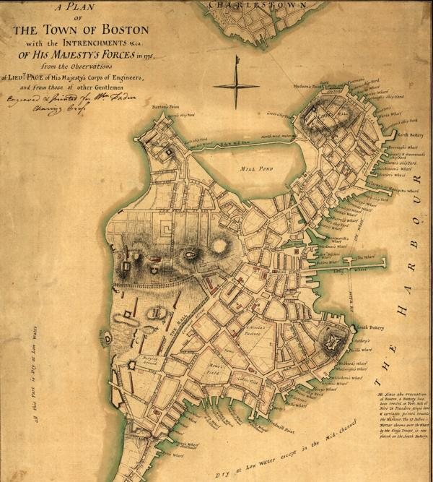

7. This map shows an early plan for the city of Boston. What natural feature would be the biggest benefit for the city to grow?

1. The construction of Mill Pond to make the city beautiful.
2. The way the streets wind around natural barriers.
3. The closeness to The Harbour for ships to move people and ship goods.
4. The fact that Charlestown is across the water to the north.

8. Because the New England colonies had rocky soil and terrain, farming was difficult and many farms that did exist were very small. Because of this, what did most settlers in New England need to do?

1. Focus on other skills like shipbuilding, fishing, and trading.
2. Focus only on crops that would thrive with fertile soil.
3. Design cities around farms that could be developed.
4. Try to grow crops in areas that would not thrive.

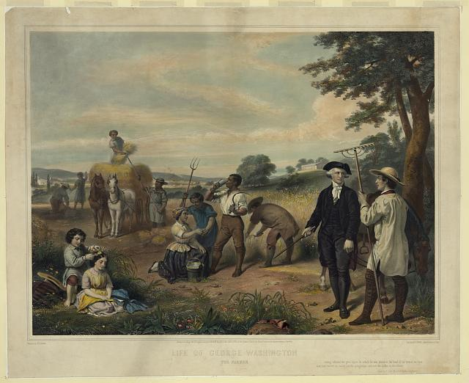

9. The painting above shows George Washington as a farmer. Washington’s farm, Mount Vernon, is located in Virginia, a Southern Colony. Land was very fertile in the South and large farms like Washington’s were called plantations. What can you conclude from this picture about farm life the Southern Colonies?

1. Animals and farm tools were rarely used on farms in the Southern Colonies.
2. Farms in the South required many people to work, including slaves.
3. Very few people had a role in working on Southern farms.
4. Southern farms were not a major part of the economy.

**4.E.IC.1 Describe and evaluate the relationship between resource availability, opportunity costs, migration and settlement.**

10. A large plantation in colonial South Carolina could plant fields of rice, cotton, or tobacco as cash crops for trade. The owner decides he’s going to plant a field of rice and a field of cotton that can be harvested and shipped back to England in exchange for profit. What would be the **opportunity cost** of him choosing to plant rice and cotton?

1. He gives up the opportunity to plant and profit from tobacco.
2. He knows he won’t make as much profit from rice than cotton.
3. He gives up the opportunity to plant as much cotton as rice.
4. He plans for a loss in profit by deciding not to plant tobacco.

11. How did settlement patterns in the colonies change over time due to resource availability and migration?

1. Settlement patterns remained the same throughout the colonization era.
2. Settlement patterns shifted as people moved to areas with better resources.
3. Settlement patterns were determined only by who the leader of an area was.
4. Settlement patterns were not affected by resources available to people.

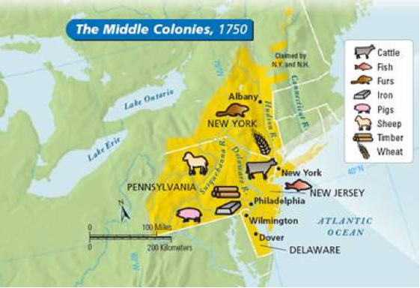

12. The map above shows resources available in the Middle Colonies in 1750. Which of the following could be found in New York?

1. Iron and Pigs
2. Cattle and Sheep
3. Timber and Fish
4. Furs and Wheat