**Fayette County Public Schools**

**4th Grade Social Studies**

**Benchmark Assessment**

**Fall 2024**

**4.G.GR.1 Analyze how location and regional landforms affect human settlement, movement, and use of various national resources, using maps, photos, and other geographic representations.**

Use the map below to answer Questions 1 & 2. (Map from Tree of Life Jamestown)

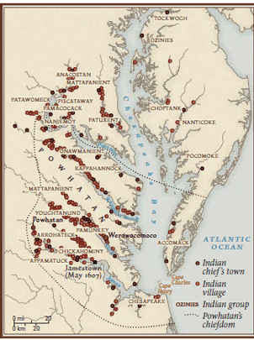

1. According to the map, which geographic feature influenced where indigenous people (Indians) settled in Virginia?
2. Mountains
3. Rivers
4. Deserts
5. Lakes

2. Based on the information gathered from the map, what is the most likely reason indigenous people settled along these features?

1. Availability of fresh water and routes to trade.
2. The temperate climate of the region.
3. The abundance of flat land for construction.
4. The closeness to mountains for outdoor activities.

3. How does the presence of natural barriers like mountains impact human movement and settlement patterns?

1. Natural barriers encourage exploration and trade
2. Natural barriers are challenging for communication and cultural exchange
3. Natural barriers have no effect on human settlements
4. Natural barriers create ideal conditions for agriculture

**4.G.HI.1 Explain how cultural, economic, and environmental characteristics affect the interactions of people, goods, and ideas from European Exploration to the Thirteen Colonies**

4. Which environmental characteristic played a crucial role in shaping interactions between European settlers and Native American tribes?

1. The availability of fertile land for farming.
2. The lack of resources that led to conflicts.
3. The presence of vast mountain ranges that hindered communication.
4. The absence of water bodies for transportation.

5. How did cultural characteristics impact the exchange of ideas between European explorers and Native Americans?

1. Both groups shared similar religious beliefs, leading to peaceful interactions.
2. Cultural differences often caused misunderstandings and conflicts.
3. There was no exchange of ideas between the two groups.
4. Native Americans adopted European culture entirely.

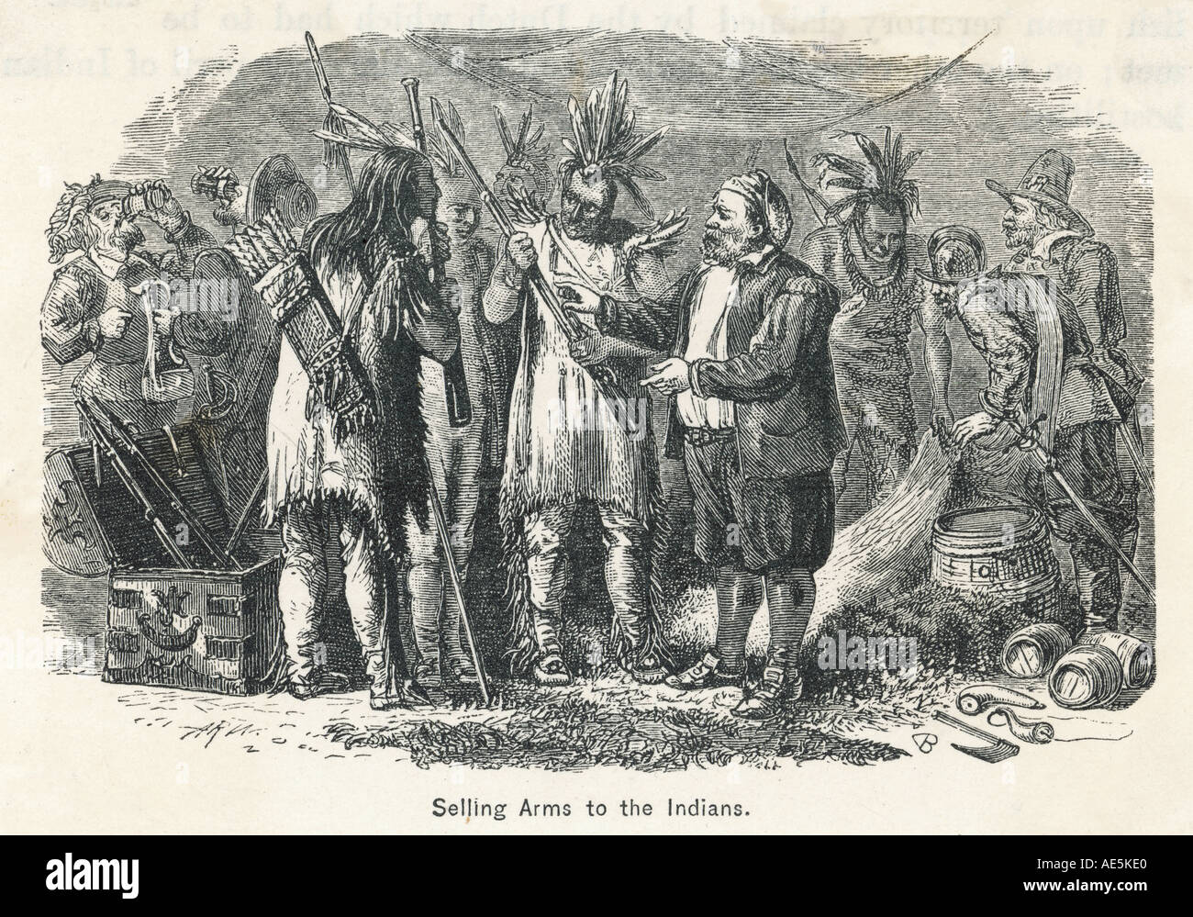

6. What was a significant impact of European exploration on the interactions of people, goods, and ideas as Europeans began to settle alongside indigenous people?

1. More advanced technology was introduced, leading to improved trade.
2. The settlers fully embraced indigenous customs.
3. Trade decreased between Europe and the Americas.
4. Settlers refused to interact with indigenous people.

**4.H.CO.1 Explain examples of conflict and collaboration among various groups of people from European Exploration to the Thirteen Colonies as they encountered one another.**

7. Which of the following gives the best example of a **conflict** between the First Americans and European settlers?

1. A peaceful trading agreement between settlers and tribes.
2. Shared farming practices between settlers and tribes.
3. Cultural and technological exchanges between settlers and tribes.
4. A battle over land and resources between settlers and tribes.

8. Which of the following gives the best example of **collaboration** between the First Americans and European settlers?

1. The spread of disease among European settlers to the First Americans.
2. The exchange of goods and ideas.
3. The establishment of permanent settlements by both groups on the same land.
4. The decline of the populations of indigenous tribes.

9. How did the arrival of Europeans change the way of life for indigenous people?

1. They built more ships.
2. They began to live in cities alongside the settlers.
3. They had to adapt to new people, culture, ideas, and diseases introduced to them.
4. They completely abandoned the customs they held for generations.