**Fayette County Public Schools**

**5th Grade Social Studies**

**Benchmark Assessment**

**Spring 2025**

**5.H.CO.1 Analyze the role conflict and collaboration played in the founding of the United States.**

| Before the American Revolution ended, people saw problems with the Articles of Confederation. This document made it hard for Congress to collect taxes because it could only ask states to give money, and they often didn’t. Congress wanted to change this but needed all 13 states to agree. Twelve states agreed, but Rhode Island did not, stopping the change. This showed another problem: all states had to agree to any changes, and most important decisions needed nine states to agree. Many times, not enough states were present to make decisions. Congress could make treaties with other countries, but it couldn’t enforce them, making other countries doubt their value. Congress also couldn’t control trade between states or with other countries, leading to disputes and unfair rules. |
| --- |

1. What was required for any changes to be made to the Articles of Confederation?
2. Approval from the President.
3. Approval from all 13 states.
4. Approval from at least 9 states.
5. Approval from Congress alone.

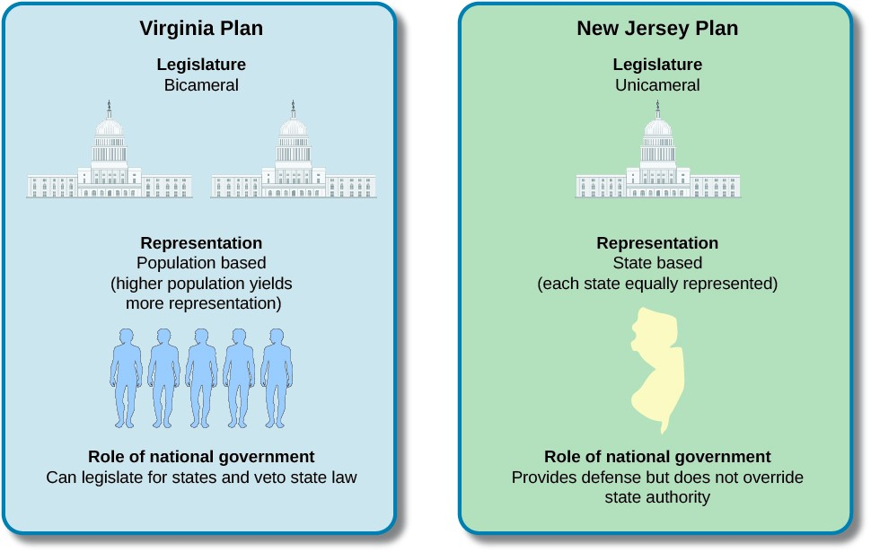

2. Given the graphic above, why would small states be against the Virginia Plan?

1. Small states felt representation by population was unfair.
2. Small states did not like the national government to have power.
3. Small states were against a unicameral legislature.
4. Small states felt all states should have their own defense.

|  | Roger Sherman was a politician and judge from Connecticut. He is best known for creating the Connecticut Compromise, which helped solve a big disagreement between the states while making the United States Constitution.  In the summer of 1787, leaders met in Philadelphia to make rules for a stronger central government. They got stuck on how states should vote in the legislature. Sherman suggested a solution he had used before. His plan was to have two houses in the legislature: one (the House of Representatives) where the number of representatives is based on the state’s population, and another (the Senate) where each state has the same number of representatives. Sherman's idea was accepted on July 16, 1787, by a vote of five states to four. This compromise saved the meeting and helped solve other problems. |
| --- | --- |

3. What does Roger Sherman’s plan for the legislature include?

1. One house where each state has equal votes.
2. Two houses: one based on population and one with equal votes for each state.
3. A President that makes all important decisions.
4. Establishing the capital in Philadelphia.

**5.H.CE.1 Analyze the causes of the American Revolution and the effects individuals and groups had on the conflict.**

Use the timeline below to answer Questions 4-6.

**Seven Events That Enraged Colonists and Led to the American Revolution** (adapted from History Channel)

| **Stamp Act (March 1765)** | To help pay off war debt, the British Parliament passed the Stamp Act, taxing many things in the colonies for the first time. The colonists were angry and rioted, so the tax was never collected. Benjamin Franklin convinced the British to cancel the tax, making the colonists think they could resist British rules. |
| --- | --- |
| **Townshend Acts (June-July 1767)** | Parliament tried to tax goods imported from Great Britain and set up customs officers to stop smuggling. In response, Americans boycotted these goods and harassed the customs officers. The British sent troops to Boston, which made the colonists even angrier. |
| **The Boston Massacre (March 1770)** | Tensions in Boston erupted when a disagreement led to 200 colonists surrounding seven British soldiers. The soldiers fired into the crowd, killing three men, including Crispus Attucks, and wounding two others. This event, known as the Boston Massacre, was used as propaganda by the colonists, especially after Paul Revere's engraving showed the British as the attackers. |
| **Boston Tea Party (December 1773)** | The British withdrew their forces from Boston and repealed many taxes, but kept the tax on tea and passed the Tea Act to help the struggling British East India Company. This angered Americans, who wanted to trade freely. The Sons of Liberty, disguised as Mohawks, boarded three ships and dumped 92,000 pounds of tea into Boston Harbor to protest. They made sure not to harm the crew or ships, but this act of defiance greatly angered the British government. |
| **Coercive Acts (March- June 1774)** | In response to the Boston Tea Party, the British government passed harsh laws. These laws closed Boston Harbor until payment was made for the destroyed tea, and replaced Massachusetts' elected council with one picked by the British. Town meetings were banned without approval, and British officials accused of serious crimes could be tried in other colonies or in Britain, not Massachusetts. The Quartering Act allowed British soldiers to stay in towns, with the colonists paying for their food and housing, which later became a grievance listed in the Declaration of Independence. |
| **Lexington & Concord (April 1775)** | British General Thomas Gage led soldiers to Lexington to capture colonial leaders and seize gunpowder. American spies, including riders like Paul Revere, warned the colonists, who prepared to fight. At Lexington, 77 American militiamen faced the British, and shots were exchanged, resulting in seven American deaths. The British continued to Concord but were harassed by militia on their way back to Boston. This battle showed the British that the colonists were serious about independence, marking the start of the Revolutionary War. |
| **British Attacks on Coastal Towns (October 1775- January 1776)** | British attacks on Falmouth, Massachusetts, and Norfolk, Virginia, shocked the colonies and unified them against a common enemy. The brutal destruction of these towns led to a realization that the British would do anything to control them. This brutality, along with the British offering freedom to African Americans who fought for them, stirred fears and pushed colonists toward independence. Leaders used these events to argue for unity and independence, which eventually led to victory. |

4. Why were the colonists angry about the Stamp Act?

1. It raised taxes on essential goods.
2. It was the first time they were taxed by the British Parliament
3. It banned town meetings without approval
4. It replaced Massachusetts’ elected council

5. Why did the British government pass harsh laws after the Boston Tea Party?

1. To punish the colonies for dumping the tea.
2. To unify the colonies against a common enemy.
3. To help the struggling British East India Company.
4. To improve trade relations with the colonies.

6. What did the British actions at Falmouth and Norfolk reveal to the colonists?

1. The British were offering freedom to African Americans
2. The British were seeking peace negotiations.
3. The British were willing to do anything to control the colonies.
4. The British were withdrawing from the colonies.

**5.C.CV.1 Describe the democratic principles of equality before the law, unalienable rights, consent of the governed and right to alter or abolish the government.**

| **The Declaration of Independence states:**  *“…We hold these truths to be self-evident, that all men are created equal, that they are* ***endowed by their Creator*** *with certain* ***unalienable Rights****, that among these are* ***Life, Liberty and the pursuit of Happiness****.--That to secure these rights, Governments are instituted among Men,* ***deriving their just powers from the consent of the governed****, --That whenever any Form of Government becomes destructive of these ends, it is the Right of the People to* ***alter or to abolish it****, and to institute new Government, laying its foundation on such principles and organizing its powers in such form, as to them shall seem most likely to effect their Safety and Happiness…”* |
| --- |

7. Read the above excerpt carefully. What do you think the signers of the Declaration of Independence mean when they say **“unalienable rights?”**

1. These are rights that the government must provide for its citizens.
2. These are rights they say are given by the Creator (God), and being human alone gives them those rights.
3. These are rights that the king must guarantee through the laws and orders he decides to pass.
4. These are rights that will be entrusted to the new President of the United States.

8. What do you think is meant when the Declaration of Independence says “Governments are instituted among Men, deriving their just powers from the **consent of the governed?**”

1. A monarchy is the best method of government.
2. Government power should be dictated by wealthy landowners alone.
3. The best form of government is one where the people have a say in the decisions made.
4. The best form of government has to be divided into three branches of power.

9. According to the Declaration of Independence, when should people exercise their right to **alter or abolish** the government?

1. When the government is destructive in protecting the people’s rights.
2. When the government needs to fund a stronger army for defense
3. When a new President is elected
4. When the Supreme Court views a law as unconstitutional.

**5.H.CH.2 Analyze the impact innovation and human ingenuity had on the development of the United States from Colonization to Constitution.**

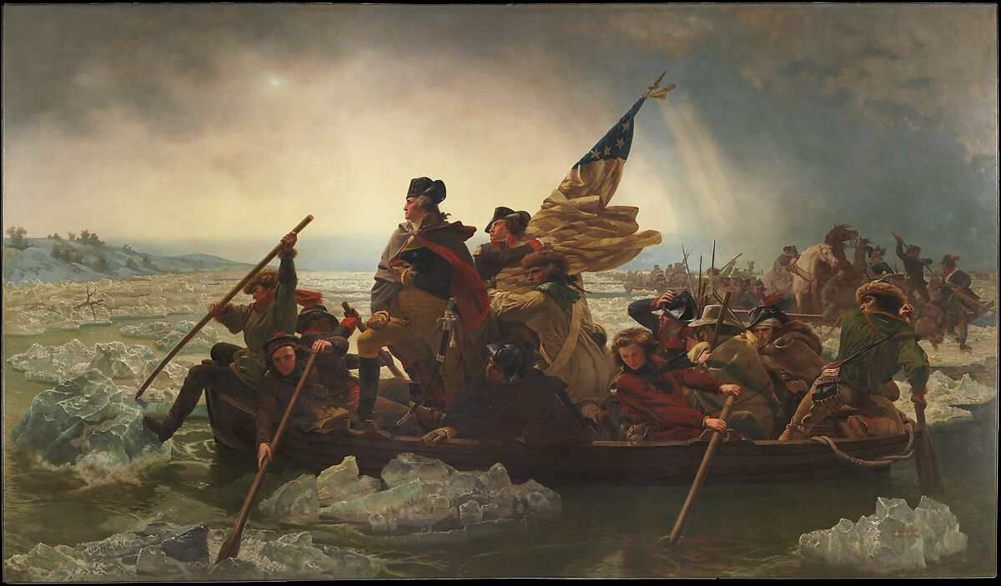On Christmas Day, 1776, George Washington and his army headed across the Delaware River to attack the city of Trenton and drive British and Hessian soldiers out. Washington knew the soldiers would be sleeping in from celebrating the holiday the day before.

10. Which of the following best describes Washington’s strategy at Trenton?

1. The location of Trenton near the Delaware River
2. The element of surprise with enemy soldiers being ill-prepared
3. The use of cannons and gunpowder
4. The sneakiness of hiding in nearby woods

At the start, the Continental army had a big problem: many soldiers weren't trained soldiers. They were farmers or shopkeepers. They didn't have proper military training or enough weapons. Some didn't even have uniforms, except for the officers who could afford them. The army didn't agree on how to fight the better-trained British army. Some officers knew about fighting from past wars, but others got their positions because of who they knew. Because of this, the American army was in trouble, especially since they had to rely on untrained militia too.

11. Why was it so important for the Continental Army (the colonists) to be innovative in their training?

1. Because they had a lot of technology that could be used to defeat the British.
2. Because they could use a lot of their knowledge in farming to apply to battles.
3. Because their leaders were appointed based on people they knew.
4. Because many of the soldiers did not have proper training or weapons.

12. George Washington developed a spy network during the war to gather intelligence against the British and plant false information about the Continental Army’s size and whereabouts. Why do you think this tactic was important for the Continental Army to win the war?

1. It kept communication open between both sides of the war.
2. It gave the Continental Army the upper hand to mislead the British.
3. It decreased the likelihood of Continental victories.
4. It promoted the ideas of gentleman’s warfare, which the British valued.