**Fayette County Public Schools**

**6th Grade Social Studies**

**Benchmark Assessment**

**Fall 2024**

**6.E.ST.2 Examine how new knowledge, technology and specialization increases productivity.**

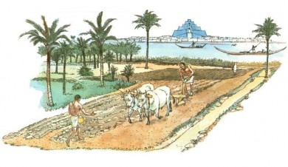

1. Which of the following technological advancements was most significant in allowing early people to create permanent settlements?
2. The invention of the wheel
3. The discovery of fire
4. The Agricultural Revolution
5. The invention of pottery

2. Which of the following is an example of specialization and division of labor that increased productivity for early humans?

1. Everyone in the society hunted for food.
2. With a surplus of food, some people could focus on skills like making pottery.
3. Every member of the society had to craft their own tools.
4. Everyone in the society had to become farmers and grow all their own food.

3. What was the major development of the Agricultural Revolution?

1. The discovery of bronze
2. The invention of writing
3. The invention of the wheel
4. The domestication of plants and animals

**6.E.MI.3 Explain how markets exist whenever there is an exchange of goods and services**.

4. Before the invention of currency (money), societies worked on a system known as bartering. A farmer may trade some of his harvest to a skilled craftsman who made pottery. Which of the following is the best definition of the barter system?

1. Exchanging goods and services without using money.
2. Specializing in a particular kind of work.
3. Developing a currency system using shells and stones.
4. Fighting with neighboring societies for resources.

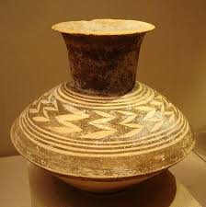

5. How did the development of specialization and the division of labor in early civilizations contribute to the existence of markets?

1. It led to the creation of currency.
2. It reduced the need for trade.
3. It increased the variety of goods available to trade.
4. It discouraged the bartering system.

6. What was one benefit of the existence of markets in early civilizations?

1. It reduced the need for specialization.
2. It increased the need for subsistence farming.
3. It facilitated the exchange of goods and services, leading to economic growth.
4. It discouraged the idea of division of labor.

**6.C.CV.1 Analyze how historical, economic, geographic and cultural characteristics influence social and government structures in River Valley Civilizations and Classical Empires between 3500 BCE and 600 CE.**

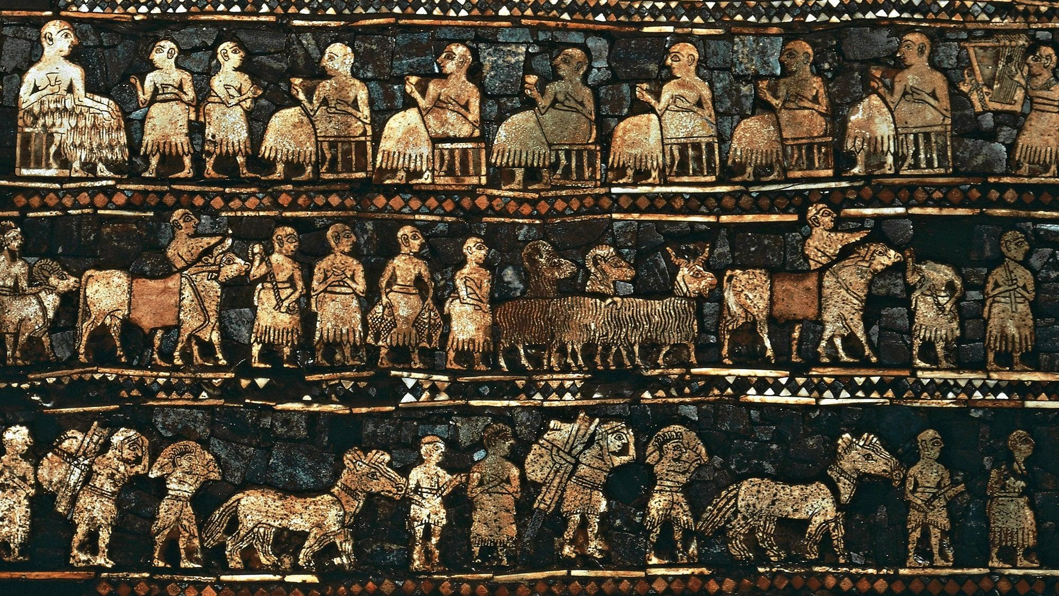

7. The social structure of ancient Mesopotamian civilizations typically consisted of:

1. A strict caste system with little social mobility
2. Equal rights for all citizens regardless of social status
3. A hierarchical system with kings and priests at the top followed by merchants, farmers, and slaves
4. A society without any social distinctions

8. Which of the following best explains why Sumer was classified as the first modern civilization?

1. They had advancements in mathematics, astronomy, architecture, and writing.
2. They were the first group of people to develop farms.
3. They were deeply religious and built ziggurats.
4. They were highly skilled and militaristic, conquering the Assyrians.

The box below shows a small sample of laws from Hammurabi’s Code.

| *Law 1: If a man brings an accusation against another man, charging him with murder, but cannot prove it, the accuser shall be put to death.*  *Law 196: If a man destroys the eye of another man, they shall destroy his eye.*  *Law 199: If a man destroys the eye of a man’s slave or breaks a bone of a man’s slave, he shall pay one-half his price.*  *Law 229: If a builder builds a house for a man and… the house collapses and causes death of the owner of the house, the builder shall be put to dealth.* |
| --- |

9. Why is Hammurabi's Code considered significant in history?

1. It was the first legal code to establish equality among all citizens.
2. It provided guidelines for fair and just treatment of all social classes.
3. It was the first written legal code to address social inequalities and regulate behavior.
4. It emphasized the superiority of the ruling class over commoners.

**6.G.HE.1 Analyze how physical environments shaped the development of River Valley Civilizations and between various Classical Empires between 3500 BCE - 600 CE.**

10. How did the annual flooding of the rivers benefit Mesopotamian agriculture?

1. It deposited fertile silt, enriching the soil for farming.
2. It created barriers to protect crops from harsh winds.
3. It prevented excessive evaporation of water, maintaining soil moisture.
4. It provided natural irrigation systems for efficient water distribution.

11. How did the construction of canals contribute to the agricultural productivity of ancient Mesopotamia?

1. By preventing soil erosion during floods
2. By providing a source of drinking water for livestock
3. By developing irrigation systems to distribute water to fields
4. By draining excess water from flooded areas

12. In addition to agriculture, how did ancient Mesopotamians utilize the Tigris and Euphrates rivers for economic purposes?

1. By harnessing their power to generate electricity
2. By extracting precious metals and minerals from their riverbeds
3. By using them as transportation routes for trade and commerce
4. By building dams to regulate their flow for fishing

**6.G.GR.1 Use maps and other geographic representations, geospatial technologies and spatial thinking to determine similarities and differences among River Valley Civilizations and Classical Empires 3500 BCE-600 CE.**

Use the map below to answer questions 13-15. (Map from World History Encyclopedia)

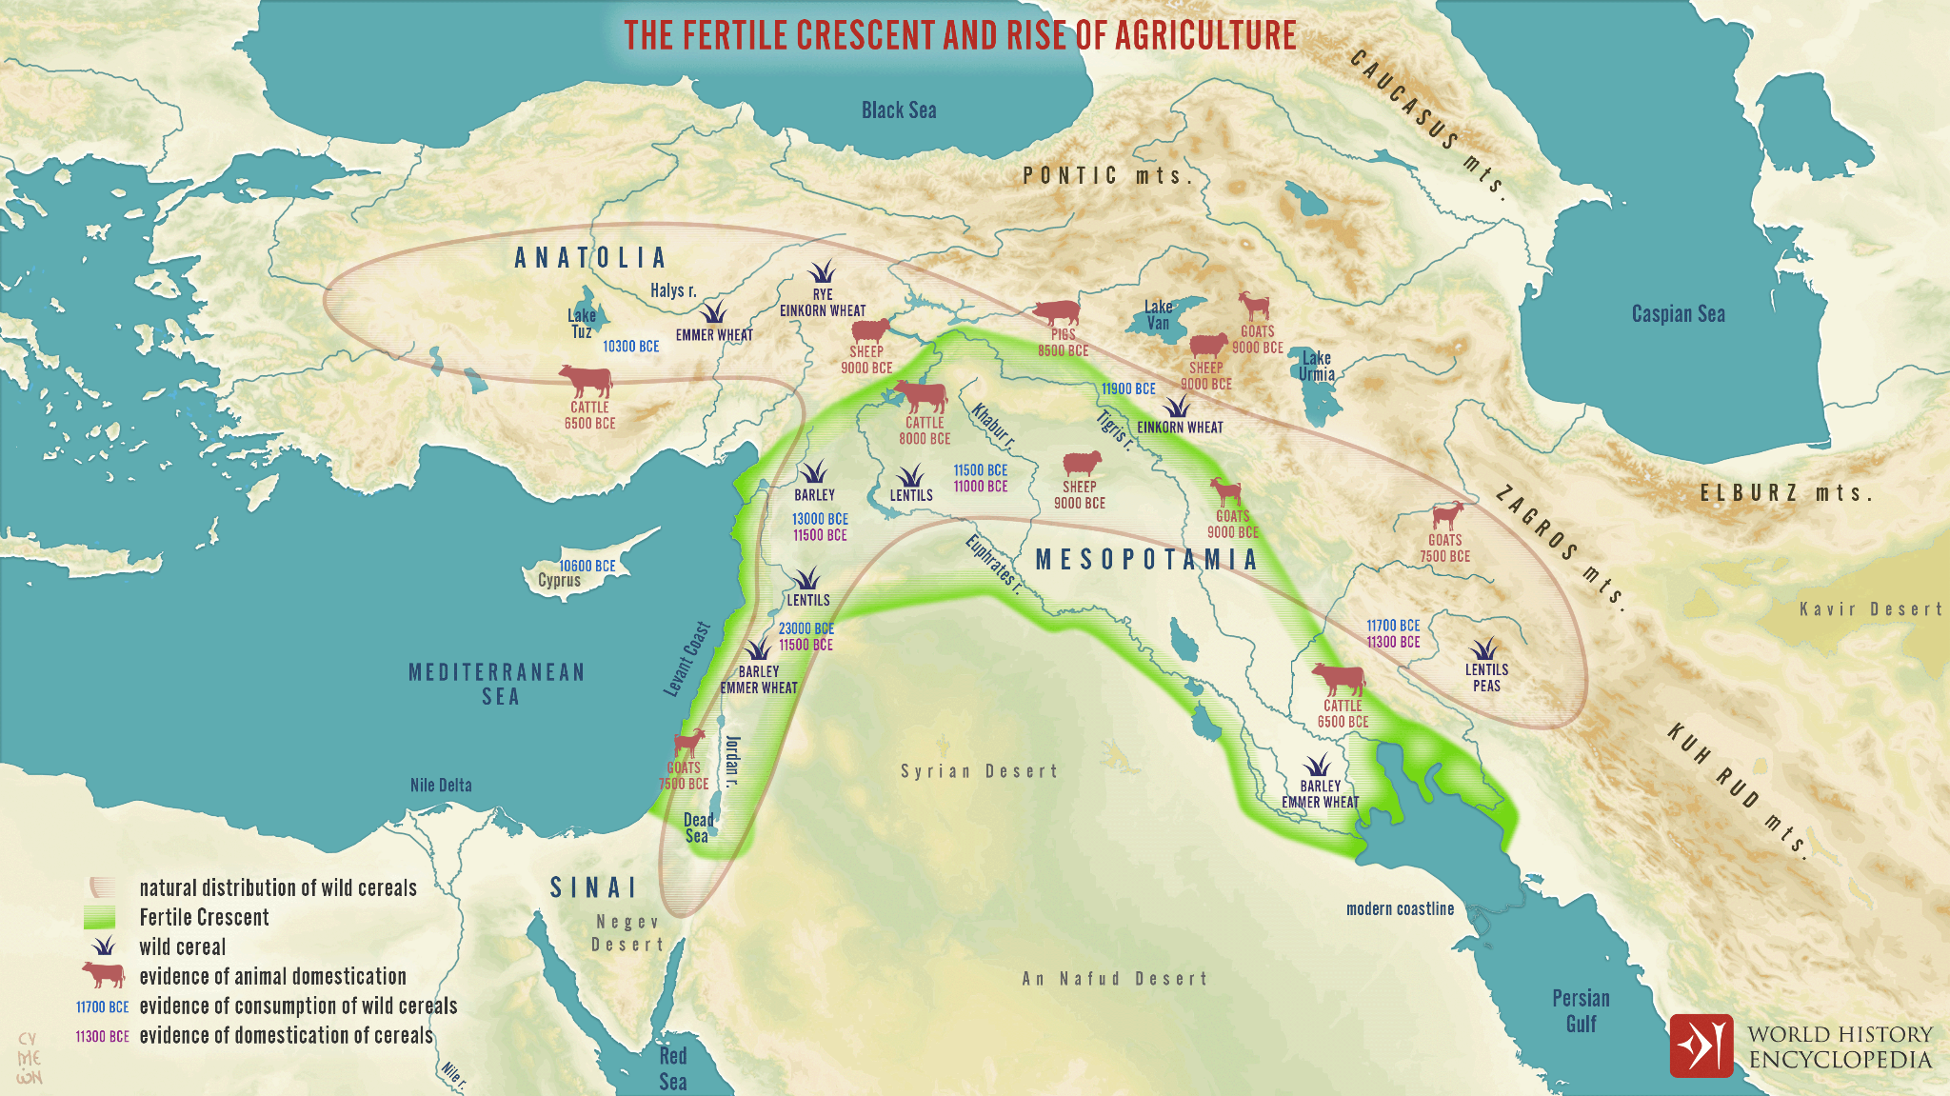

13. According to the map above, which animals in central Mesopotamia was the first to likely be domesticated around 9000 BCE?

1. Cattle and Sheep
2. Sheep and Goats
3. Goats and Cattle
4. Sheep and Chickens

14. According to the map above, what other river can be seen along with the Tigris and Euphrates inside the Fertile Crescent?

1. Khabur River
2. Halys River
3. Nile River
4. Persian River

15. According to the map, which of the following crops would you NOT be able to find inside the labeled Fertile Crescent region?

1. Lentils
2. Emmer Wheat
3. Peas
4. Barley