**Fayette County Public Schools**

**World History**

**Benchmark Assessment**

**Fall 2024**

**HS.WH.CH.2 Explain continuities and changes within the religion, ideology, science and arts of empires and nation-states in multiple global regions between 1300-1750.**

1. What impact did the Trans-Saharan Trade Routes have on the spread of Islamic calligraphy and architecture in West Africa during the 15th century?

a) It led to the development of indigenous African script styles distinct from Arabic calligraphy.

b) It facilitated the construction of mosques and madrasas influenced by Islamic architectural design.

c) It promoted the use of Christian symbols and iconography in African religious art.

d) It resulted in the integration of Chinese motifs and patterns in West African pottery.

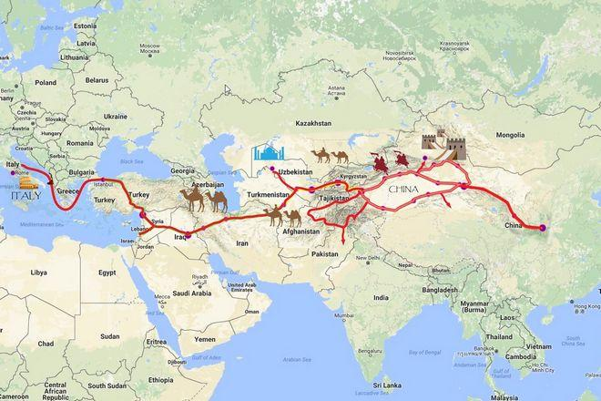

1. What impact did the Silk Road have on the spread of Christianity during the 5th and 6th centuries?

a) It facilitated the translation of the Bible into multiple languages along trade routes.

b) It enabled missionaries to travel to Central Asia and establish Christian communities.

c) It promoted the exchange of religious artifacts and iconography between East and West.

d) It resulted in the integration of Christian motifs and symbols in Buddhist art.

1. Which advancement was a result of cultural diffusion along the Silk Road during the 14th century from the Middle East to Europe and Asia?

a) Development of gunpowder for military use

b) Invention of the printing press for mass communication

c) Introduction of algebra

d) Discovery of the heliocentric model of the solar system by Copernicus

**HS.WH.CE.1 Examine effects of the movement of people, cultures, goods, diseases and technologies through established systems of connection, including the Silk Roads, Trans-Saharan Trade Routes and Indian Ocean Maritime System between 1300-1450.**

1. How did the introduction of gunpowder along the Silk Road impact military technologies during the 14th century?

a) It led to the widespread adoption of crossbows as the primary ranged weapon in European warfare.

b) It resulted in the development of cannons and firearms, revolutionizing siege warfare.

c) It promoted the use of catapults and trebuchets as the preferred siege weapons in Chinese armies.

d) It facilitated the spread of cavalry tactics as mounted archers dominated battlefield strategies.

1. How did the exchange of silk textiles along the Indian Ocean Maritime System impact Chinese economies during the 15th century?

a) It led to the devaluation of Chinese currency as silk became more widely available in global markets.

b) It resulted in the specialization of Chinese silk production in luxury fabrics for export.

c) It promoted the adoption of Indian weaving techniques in Chinese silk workshops.

d) It facilitated the migration of Indian merchants to Chinese port cities to control silk trade routes.

1. How did the introduction of papermaking techniques along the Silk Road impact literacy rates during the 12th century?

a) It led to a decline in literacy as paper was expensive and inaccessible to the majority of the population.

b) It resulted in the proliferation of written texts and increased access to education for the general population.

c) It promoted the use of parchment and vellum as superior writing materials in religious and scholarly circles.

d) It facilitated the spread of oral traditions as written texts became less reliable for preserving knowledge.

**HS.WH.CE.4 Analyze causes and effects of political revolutions in multiple global regions from 1750-present.**

1. How did the ideas of the Enlightenment and Revolution in the United States influence the French Revolution?

a) By advocating for the divine right of kings and absolute monarchy

b) By promoting the idea of social hierarchy and feudalism

c) By inspiring notions of popular sovereignty and individual rights

d) By encouraging adherence to traditional religious doctrines

1. What was a key cause of the Central American Revolutions in the early 19th century?

a) The influence of French revolutionary ideas on indigenous populations

b) Economic exploitation and political marginalization by Spanish colonial authorities

c) The implementation of democratic reforms by Spanish monarchs

d) Cultural assimilation and integration of indigenous communities into colonial society

1. How did the French Revolution influence the Haitian Revolution?

a) It provided military support to the enslaved Africans in Haiti

b) It inspired ideas of liberty, equality, and fraternity among the enslaved population

c) It imposed economic sanctions on Haiti, leading to further unrest

d) It had no direct impact on the Haitian Revolution

**HS.WH.CE.5 Analyze the political, social and economic causes and effects of early industrialization in Europe and North America between 1750-1850.**

1. How did early industrialization contribute to environmental changes?

a) It promoted sustainable development practices and the conservation of natural resources

b) It resulted in pollution, deforestation, and the degradation of ecosystems

c) It had no significant impact on the environment as industrial processes were clean and efficient

d) It led to the preservation of wilderness areas and the protection of biodiversity

1. How did urbanization contribute to the growth of early industrial cities in Europe and North America?

a) It led to the decentralization of economic activities and the dispersal of population

b) It resulted in the decline of urban centers as people moved back to rural areas for employment

c) It promoted the concentration of factories, workers, and markets in urban areas

d) It had no significant impact on population distribution or urban development

1. What was a social effect of early industrialization in Europe and North America?

a) The emergence of a wealthy merchant class and the decline of the aristocracy

b) The strengthening of traditional artisan guilds and craft production

c) The promotion of social equality and the eradication of class distinctions

d) The preservation of rural communities and the continuation of agrarian lifestyles