5th Grade Standard Benchmark Assessment 2
Standards:
RL.5.2  RL.5.3  RL.5.5  RL.5.9 | RI.5.2  RI.5.3  RI.5.5  RI.5.8  RI.5.9 |  |  | L.5.1  L.5.2  L.5.4
Passage # 1
The Bicycle Revolution
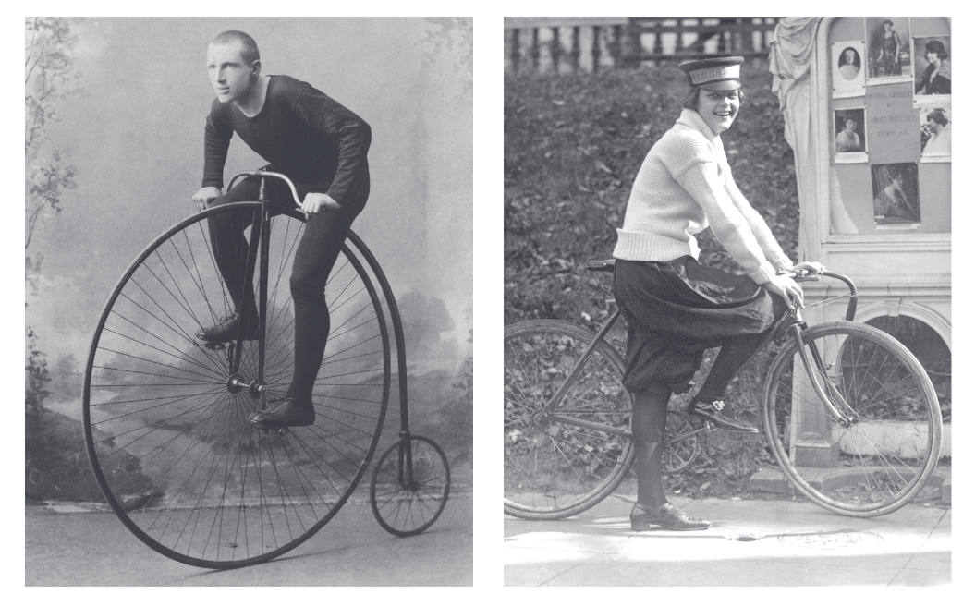
1 One of the earliest bicycles was called “the bone shaker.” It was invented in 1855. With a wooden frame and iron tires, it literally shook its rider, sometimes violently. By 1890, changes in bicycle design resulted in “the safety bicycle.” This model, which looked much like today’s modern bike, began to change America.

2 The safety bicycle had wheels of equal size and pedals mounted on a chain. It had light steel parts and inflatable tires. These improvements resulted in a lightweight bike that was comfortable to ride. Unlike the horse, it needed little care. Now for a modest price, people could afford to go almost anywhere.

3 Manufacturers working to satisfy popular demand for bicycles developed new ideas for producing them. The most important of these was mass production. Instead of making each bike individually, different parts of the factories produced separate parts of the bicycles. The parts were then put together in an assembly line.

4 Besides revolutionizing the production process, manufacturers also developed new ideas for marketing and selling bikes to the public. These included advertising different models to different types of people and setting nationwide prices.

5 Many professions began using bicycles to improve their businesses. Bikes were more efficient for mail delivery than horses or walking. Using bicycles saved time and effort. A stretcher strapped between two bikes became a makeshift ambulance. In 1894, a California rail strike stopped mail delivery. So a bike shop owner started a messenger service with six riders delivering mail.

6 The bicycle also caused social change. Mass production lowered prices, which made bikes affordable not just to the middle class but to factory workers, too. People who had only dreamed of more mobility could now travel. They could meet with others and seek new opportunities. They founded bike clubs, choirs, and book groups.

7 Bicycles were especially important to women. In the nineteenth century, women who did not have to work in factories were largely confined to the home. The bicycle made women more independent. This contributed to a growing women’s movement that included the fight for women’s right to vote. As women’s rights leader Susan B. Anthony said in 1896 about the bicycle, “I think it has done more to emancipate women than anything else in the world.”
8 Women’s use of the bicycle also affected fashion. Riding a bike in layers of petticoats and heavy skirts was almost impossible. Women cyclists began wearing bloomers—baggy pants with elastic at the knees. The “bloomer craze” led to new thinking about restrictive women’s clothing. Designers began creating styles that allowed freedom of movement. This offended some people who did not like the new fashions. Like many of the changes prompted by the bicycle, they were here to stay.
Standard |  |  | Question
RI.5.2 #1  1 pt. |  |  | In “The Bicycle Revolution”, what is the central idea of paragraphs 3-4?  - Manufacturers worked hard to meet the demand for bicycles.  - The bicycle sparked new ideas in production and marketing.  - Bicycles were mass-produced in factory assembly lines.  - Bicycle manufacturers decided to set nationwide prices.
RI.5.3 #2  1 pt. |  |  | According to “The Bicycle Revolution”, how did the wide availability of bicycles affect America?  - Manufacturers stopped producing bikes referred to as “bone shakers.”  - People started using bicycles to improve businesses and their lives.  - Bicycles became lightweight and easy to ride.  - Bicycles were put together on assembly lines.
RI.5.8 #3  2 pts. |  |  | In paragraph 6 of “The Bicycle Revolution”, the author states: “The bicycle also caused social change.” What explicit evidence supports this claim? Select two answers.  - “One of the earliest bicycles was called ‘the bone shaker.’”  - “Now for a modest price, people could afford to go almost anywhere.”  - “By 1890, changes in bicycle design resulted in ‘the safety bicycle.’”  - “Unlike the horse, it needed little care.”  - “The bicycle made women more independent.”  - “These improvements resulted in a lightweight bike that was comfortable to ride.”
L.5.4 #4  1 pt. |  |  | In “The Bicycle Revolution”, what is the meaning of the word efficient as it is used in paragraph 5?  - popular in certain social groups  - easy for many people to afford  - using the least time and effort  - designed for use by women
Passage # 2
How TV Changed America
1 By the early twentieth century, sound could be sent via telegraph, telephone, and radio. Inventors were confident they could discover a way to send pictures, too. Some of the first inventions were mechanical. These required people to turn a cardboard wheel to view a sequence of pictures. In 1939, a fully electronic television was introduced at the World’s Fair in New York. Soon, television became one of the most powerful forces in American society.

2 The first TV sets cost around $500. Because the average household income was only about $1,300 a year, TVs remained a luxury. Most programs were special broadcasts of sports or political events. As America entered the 1940s, television began sweeping across the nation. As the decade began, however, so did World War II. To prepare for war, American factories stopped manufacturing TVs so they could produce radios, weapons, airplanes, and radar systems instead. People could not buy new TV sets in those years, but television still flourished as a communications medium. When the United States entered the war in 1941, so did television.

3 Newsreels brought war reports into people’s living rooms. Television did more than spread the news; it also rallied public opinion. The government used TV to promote campaigns like buying war bonds to support the war effort. Advertisers also created the format for the modern TV commercial. After World War II ended, television manufacturing boomed.

4 The 1950s is known as television’s Golden Age. During this decade, almost two-thirds of American households owned a TV. People no longer gathered around their radios. Instead, they sat together in their living rooms to watch TV. Broadcasters produced comedies such as I Love Lucy. They developed a variety of programs like The Ed Sullivan Show and westerns like Bonanza. Television also began to revolutionize American politics. Candidates running for office had to change the way they campaigned on TV, which meant fewer long, informative speeches. When Dwight Eisenhower ran for president in 1952, his staff began the practice of writing catchy “sound bites” for their candidate.

5 In the 1960s, television allowed an entire nation to witness the social changes and conflicts of a new era. Millions became excited about space travel as spectators watched astronauts land on the moon and space capsules splash down in the ocean. Americans also watched the Vietnam War, the first war to be televised, bringing images of conflict into people’s homes. Many people reacted by protesting U.S. participation in the war. Those protests were televised, too.

6 Since the 1960s, many things about television have changed, from video games to movies on demand to watching shows on a cell phone. Television’s influence on society is well established, and it will certainly affect generations to come.
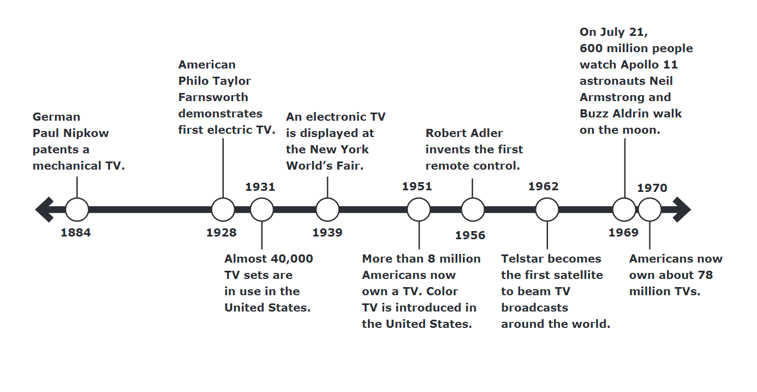

Standard |  |  | Question
RI.5.2 #5  2 pts. |  |  | Select two central ideas best supported by the evidence in “How TV Changed America”.  - In the 1950s, Dwight Eisenhower appeared on television as a candidate and used “sound bites”.  - By the 1950s, TV introduced a variety of programs that changed how most people got their information and entertainment.  - In the 1960s, people watched images from the Vietnam War on their televisions.  - Starting in the 1940s, television became the most important American invention since the radio.  - Most people couldn’t afford a television in the 1940s, but by the 1950s televisions became common in most American households.  - Television programming was limited in the 1940s, but by the 1950s, broadcasters produced better programs.
RI.5.8 #6  Part A - 1 pt  Part B - 1 pt |  |  | The following item has two parts. Answer Part A and then answer Part B.  Part A  What reason did the author give, in “How TV Changed America”, to support the claim that “Television also began to revolutionize American Politics”?  - “When Dwight Eisenhower ran for president in 1952, his staff began the practice of writing catchy “sound bites” for their candidate.”  - “The government used TV to promote campaigns like buying war bonds to support the war effort.”  - “In the 1960s, television allowed an entire nation to witness the social changes and conflicts of a new era.”  - “Candidates running for office had to change the way they campaigned on TV, which meant fewer long, informative speeches.”  Part B  What evidence does the author give to support the reason in part A?  - “When Dwight Eisenhower ran for president in 1952, his staff began  the practice of writing catchy “sound bites” for their candidate.”  - “Candidates running for office had to change the way they campaigned on TV, which meant fewer long, informative speeches.”  - “In the 1960s, television allowed an entire nation to witness the social changes and conflicts of a new era.”  - “Millions became excited about space travel as spectators watched astronauts land on the moon and space capsules splash down in the ocean.”
RI.5.3 #7  Part A - 1 pt  Part B - 1 pt |  |  | The following has two parts. Answer Part A and then Answer Part B.  Part A  According to “How TV Changed America”, how did television change after World War II?  - Television remained a luxury item owned by the very wealthy.  - Production of new televisions stopped.  - New and innovative television programs were developed.  - Broadcasters created the modern television commercial format.  Part B  Which sentence from the passage best supports the answer to Part A?  - “In 1939, a fully electronic television was introduced at the World’s Fair in New York.”  - “As America entered the 1940’s, television began sweeping across the nation.”  - “They developed variety programs like The Ed Sullivan Show and westerns like Bonanza”.  - “Most programs were special broadcasts of sports or political events.”
RI.5.5 #8  1 pt. |  |  | Compare the events in Passages 1 and 2.  - Both explain problems and solutions.  - Both compare America to other countries.  - Both tell about events in chronological order.  - Both present information in order of importance.
RI.5.5 #9  1 pt. |  |  | Which paragraph from the two texts includes a cause-and-effect structure?  - One of the earliest bicycles was called “the bone shaker.” It was invented in 1855. With a wooden frame and iron tires, it literally shook its rider, sometimes violently. By 1890, changes in bicycle design resulted in “the safety bicycle.” This model, which looked much like today’s modern bike, began to change America.  - Besides revolutionizing the production process, manufacturers also developed new ideas for marketing and selling bikes to the public. These included advertising different models to different types of people and setting nationwide prices.  - Newsreels brought war reports into people’s living rooms. Television did more than spread the news; it also rallied public opinion. The government used TV to promote campaigns like buying war bonds to support the war effort. Advertisers also created the format for the modern TV commercial. After World War II ended, television manufacturing boomed.  - All of the above
RI.5.9 #10  1 pt. |  |  | What topic is explored in both passages?  - Changes in women’s clothing led to important changes in American politics and culture.  - In the past century, television has recorded some of America’s most important events.  - The United States has invented the most important machines in world history.  - Changes in technology have improved American life in several important ways.
RI5.9 #11  2 pts. |  |  | Which two examples show how each invention impacted communication?  A. Bicycles improved mail delivery  B. Bicycles led to the development of the assembly line  C. Televisions broadcasted war news into homes  D. Televisions replaced newspapers for all communication
L.5.4 #12  1 pt. |  |  | Based on its Latin root, what is the meaning of the word spectators as it is used in “How TV Changed America” paragraph 5?  - builders  - viewers  - protestors  - astronauts
Passage #3
The Horseless Carriage
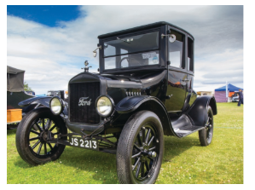
1 Shirley and her family lived in a white wooden house on Beal Street in Hyde Park, Michigan. They bought the house two years earlier, in 1913. Behind their house was a red barn where their horse, Mason, lived. On Sundays, the whole family crowded into a buggy that hitched to Mason’s harness. Mason and the buggy carried them to church and afterward, if the weather was sunny and warm, to the nearby park for a picnic. Shirley loved these Sunday outings almost as much as she loved Mason, who had been part of their family for as long as she could recall. She fed him apples and carrots every morning before school and kissed his nose every afternoon when she got home.

2 Shirley was barely awake one Saturday morning when she heard a sound like a sick horse coughing and sneezing. When she jumped out of bed and looked out the window, she blinked twice to be sure that what she saw was real. A black metal box with four big rubber tires sat in the dirt driveway spewing steam and smoke. Shirley had seen these horseless carriages at the park, but she had never been this close to one. She ran downstairs and out the back door, where her brother, James, was already outside, quite out of breath.

3 “Is it ours?” James asked hopefully as their father stood beside the noisy thing with his boot on one of the wheels.

4 “Yes, it is, son,” answered their father proudly. He worked on the assembly line at the factory that made these cars.

5 Their father explained that Mr. Ford wanted every person who worked in his factory to be able to own a Model T, so he offered his workers a special low price and several years to pay it off, interest-free. Shirley could see her reflection in the shiny black metal as she reached out to touch the word “Ford” written in silver on the front of the car.

6 “Let’s go for a ride,” exclaimed James, already scrambling into the seat, still in his pajamas.

7 “Let’s all go,” said their father, reaching for his daughter’s hand. But Shirley hesitated. The Model T frightened her, and she didn’t like the noise it made. It smelled bad, and the front of it steamed like a dragon catching its breath. Mama had come out of the house and didn’t look at all surprised to see the new car.

8 “What’s wrong, honey?” Mama asked, noticing Shirley’s frown as she dried her hands on her apron. “There’s nothing to be afraid of. I think the car will make our lives easier and much more fun.”

9 “But what about Mason?” Shirley asked.

10 “Don’t worry,” her mother said softly, giving her a hug, “we’ll use both.”

11 But Shirley could see the future, and what she saw were machines that would guzzle gasoline instead of hay.
RL.5.3 #13  1 pt. |  |  | In “The Horseless Carriage”, how are James and Shirley different?  - Shirley thinks the new car is beautiful, but James is afraid of it.  - James is excited about the new car, but Shirley is not.  - James thinks the car looks like a dragon, but Shirley disagrees.  - Shirley cares about Mason more than anyone else in her family.
RL.5.5 #14  1 pt. |  |  | In “The Horseless Carriage”, how does paragraph 1 fit into the rest of the story?  - It presents a short history of the Model T Ford.  - It tells a story about James and his horse, Mason.  - It sets up a conflict between the children and their parents.  - It gives background information about the family and their horse.
RL.5.2 #15  1 pt. |  |  | What sentence reflects the theme of “The Horseless Carriage”?  - Machines are always better than animals.  - Parents should always consult with their children.  - Working in a factory can be harmful and dangerous.  - New inventions sometimes replace things people love.
Passage # 4
If I Only Had a Bike
If I only had a bike, I would cruise all over town.
I would pump my way up all the hills
and then I would glide down.
I could have a paper route and deliver all the news,
5 and earn some spending cash to buy whatever stuff I choose.

If I only had a bike, you know, I could really shine.
I could ride it to the store and back in only half the time.
I could ride it to the pool to get the cooling off I’m needing.
I could ride it to the library and spend all summer reading.

10 But bikes cost lots of money, and I don’t have a lot.
A wishful imagination is the only bike I’ve got.
So I cross my fingers that a bike will magically appear
in our garage or driveway in some future day and year.

And then, we see a yard sale as we are driving through,
15 I spot a bike my own size, my favorite color, too.
I beg my mom to stop, and so she parks along the street,
and I run over to that bike and climb onto its seat.

“How much?” I asked the man, and he begins to grin.
“For you, it costs a dollar.” My mom is smiling then.
20 “Your birthday’s coming up,” she says, reaching into her purse.
It was the greatest gift in the entire universe.

If I only had a bike, I thought, and now, I really do.
It’s got scratches and a little rust, but to me it is brand new.
A summer full of happiness to ride instead of hike:
25 wheels instead of feet . . . thanks to my new bike.

Standard |  |  | Question
RL.5.2 #16  1 pt. |  |  | Which sentence reflects the theme of the poem?  - If you want a bike, just ask one of your parents.  - If you wish for something long enough, you might get it.  - If you want to make money, a yard sale is a good thing to do.  - If you want to spend the summer reading, you must own a bike.
RL.5.3 #17  1 pt. |  |  | How would you describe the character at the beginning of the passage and at the end of the passage?  - Sad, Excited  - Excited, Excited  - Sad, Hopeful  - Hopeful, Excited
RL.5.5 #18  1 pt. |  |  | How are the first three stanzas of the poem different from the last three stanzas?  - The first three stanzas are about wishing; the last three stanzas tell how the wish is fulfilled.  - The first three stanzas are told by a child; the last three stanzas are told by a mother.  - The first three stanzas are about a paper route; the last three stanzas are about a yard sale.  - The first three stanzas happen in the past; the last three stanzas happen in the future.
RL.5.9 #19  Each line is worth .5 - making this question worth 2.5 points. |  |  | Read each phrase in the chart. Decide whether the phrase describes “The Horseless Carriage,” “If I Only Had a Bike,” or both passages. Fill in the bubble in the correct box beside each phrase.  Phrase “The Horseless Carriage” “If I Only Had a Bike” Both Passages  Explains how a family  affords a new car  Happens more than a  hundred years ago  Shows how a person  feels about an object  Tells a story with a  happy ending  Is told from a child’s  first-person point of  view  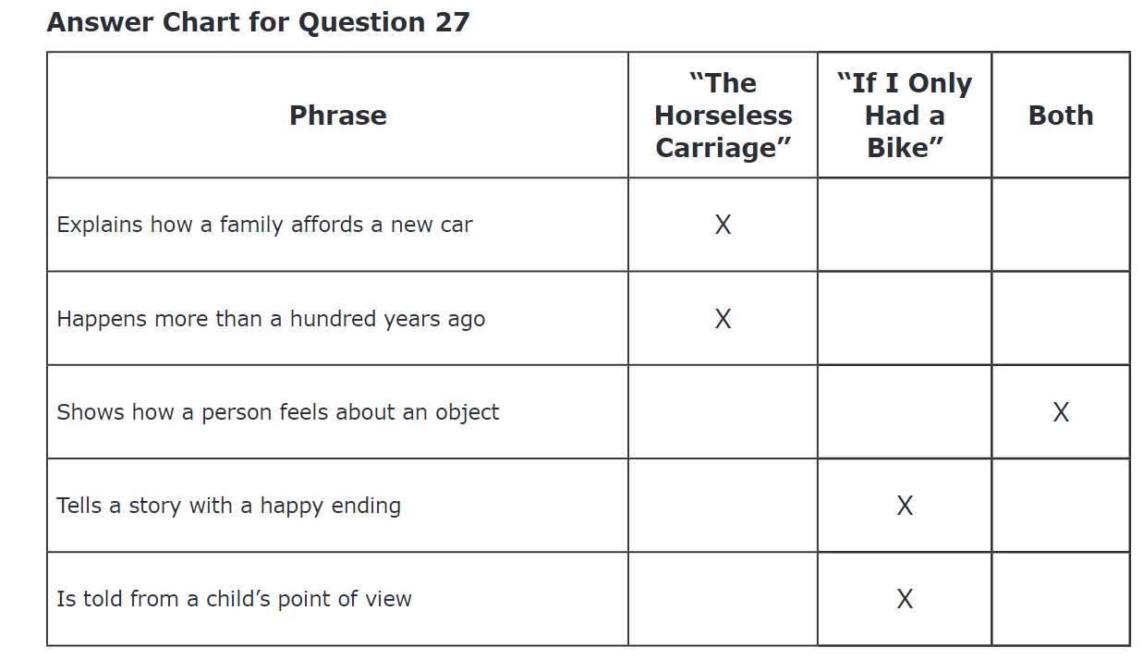
RL.5.9 #20  1 pt. |  |  | What information is found in passages 3 and 4?  - Both stories talk about changes in getting around: one is about getting a bike, and the other is about a family getting a new car.  - Both stories talk about when a family gets a new mode of transportation.  - Both stories use bikes to get around town.  - Both stories have characters that are sad when they change to the different mode of transportation.
Editing and Mechanics
Read the following passage, and then answer the following question.

The day my family got its first computer is one (1) of the best days of my life. It was in 1998, I think, when I was in fifth grade. Our dad brought home a big cardboard box wrapped in a dark green bag. He set it in the living room. Gathered us all around. Then we got to draw straws to see who would have the opportunity to open the bag. When I got the long straw, I yelled, “Hooray!” (2) When I opened the box, everyone let out a yell. We set it up right away. By dinnertime: we were (3) searching the Internet and using email. Having a computer changes (4) their lives. It made homework easier to do and opened up a whole new world to us. It was sort of neat.

L.5.1 #21  1 pt. |  |  | What is the best choice for the underlined phrase 1?  - no change  - was one  - will be one  - is going to be
L.5.2 #22  1 pt. |  |  | What is the best choice for the underlined phrase 2?  - no change  - I yelled Hooray!  - I yelled Hooray.  - I yelled, “Hooray”
L.5.2 #23  1 pt. |  |  | What is the best choice for the underlined phrase 3?  - no change  - By dinnertime. We were  - By dinnertime, we were  - By dinnertime; we were
L.5.1 #24  1 pt. |  |  | What is the best choice for the underlined phrase 4?  - change  - changing  - changed  - will change

RI5.9 - NOT INCLUDED IN THE ONLINE ASSESSMENT:

Compare and contrast the topics found in The Bicycle Revolution and How TV Changed America. Use details from both texts to support your answer.

Exemplar Response:

When comparing the topics of the bicycle revolution in The Bicycle Revolution and the impact of television in How TV Changed America, it is evident that both inventions brought significant societal changes, however, in different ways. The bicycle revolution, starting in the 19th century, enabled greater mobility and independence, especially for women, leading to social movements like women's rights. On the other hand, television, emerging in the 20th century, became a powerful medium for news dissemination, entertainment, and shaping public opinion, notably during significant events like World War II. While bicycles led to practical innovations in transportation and fashion, television influenced political campaigns and cultural norms. These texts highlight how technological advancements have shaped American society across different time periods.
Non-Exemplary Response:
The bicycle and television are discussed in both texts. The bicycle was invented in 1855 and changed things for people. With wooden and iron parts, it was hard to ride. Later, they made better bikes. They began using bikes for mail and even ambulance services. Many people liked the bikes. On the other hand, the TV was created with sound and then pictures in the 1930s. It became powerful because people watched it a lot during World War II. They also watched programs and commercials. TV kept changing over the years, making an impact on society.

5th Interium Assessment for March.pdf

https://navigator.fcps.net/storage/6622/Cfx1YEpuEOxqvMMQ97NIiTSVT6XSj8-metaNXRoIEdyYWRlIEVMQSBRdWVzdGlvbiBTdGVtcyBGaW5hbC5wZGY=-.pdf

https://instantaccess.benchmarkuniverse.com/?#/library/X98407

https://ky.mypearsonsupport.com/resources/released-items/Grade%205%20Reading%20Released%20Items.pdf

https://ky.mypearsonsupport.com/resources/released-items/Grade%205%20Editing%20and%20Mechanics%20Released%20Items.pdf

