**Fayette County Public Schools**

**6th Grade Social Studies**

**Benchmark Assessment**

**Spring 2025 (Egypt, India, China)**

**6.G.GR.1 Use maps and other geographic representations, geospatial technologies and spatial thinking to determine similarities and differences among River Valley Civilizations and Classical Empires 3500 BCE-600 CE.**

Use the maps below to answer Questions 1-3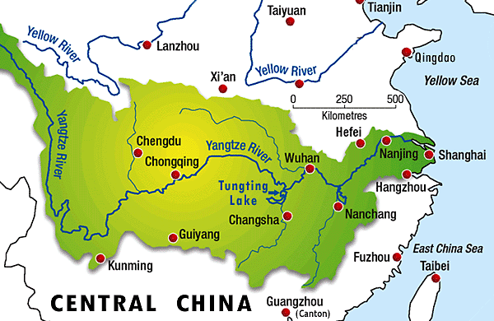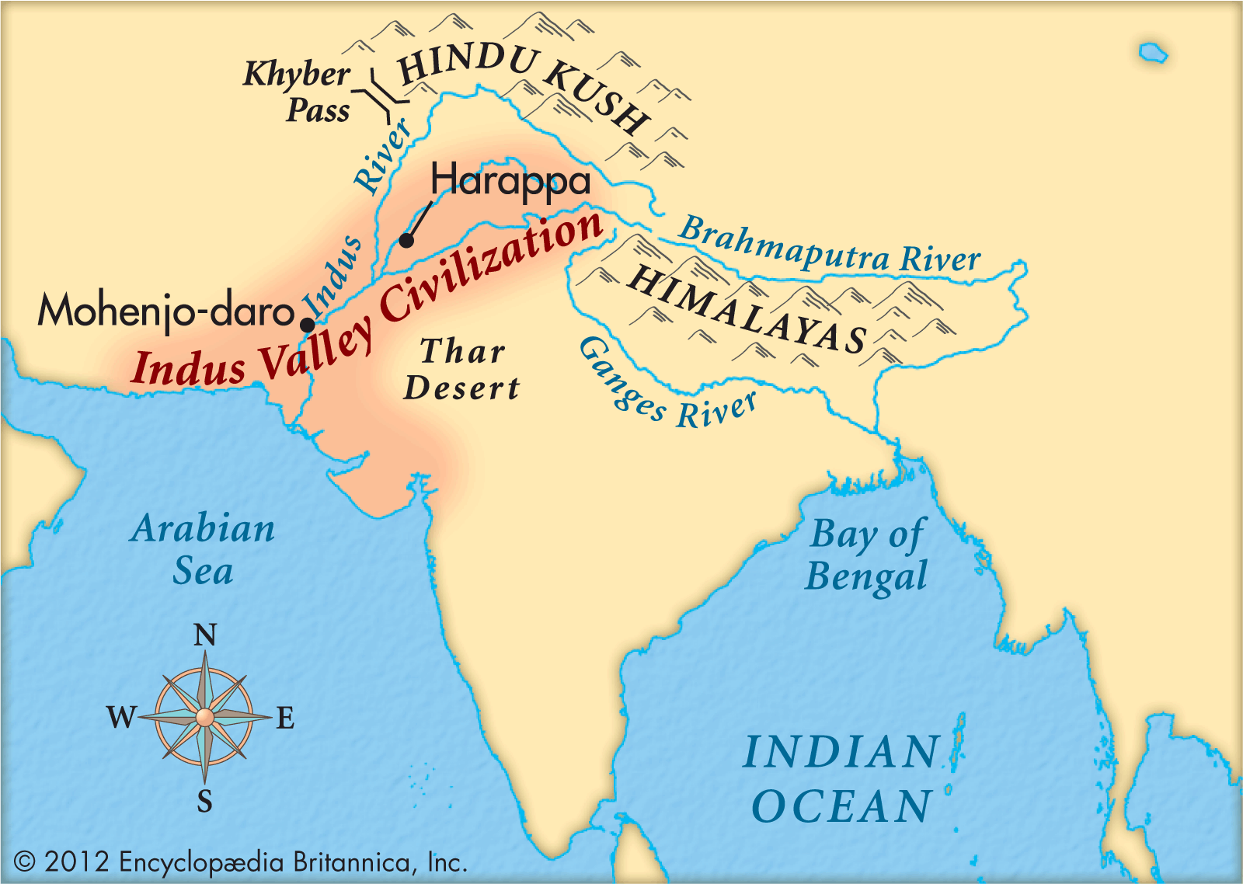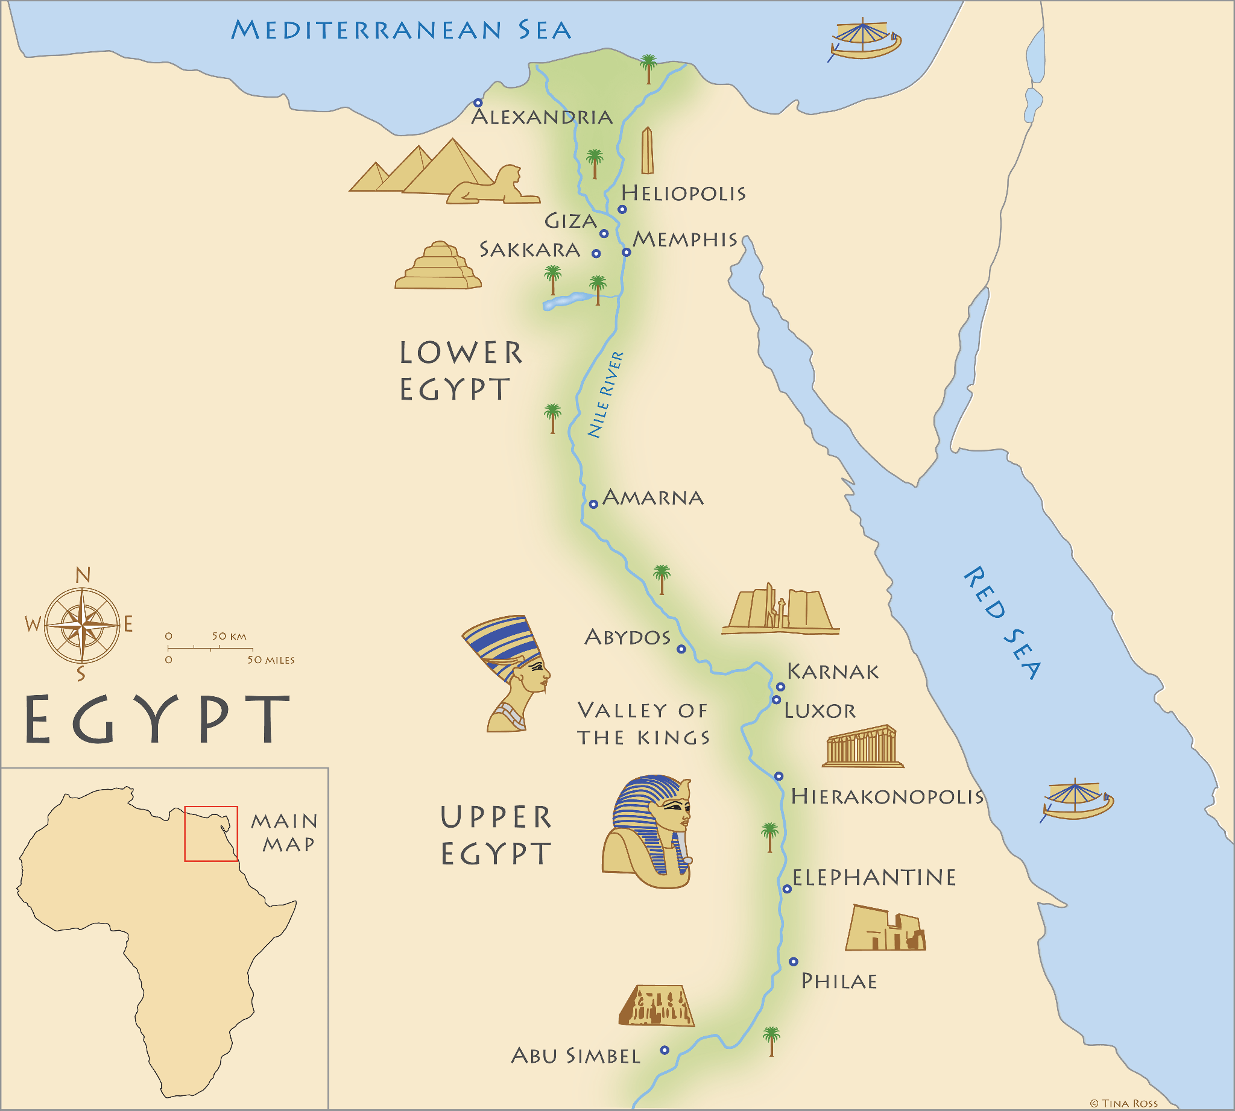

1. Which of the following is true of ancient civilizations of Egypt, India, and China?
2. They all settled in mountainous regions to protect from invaders.
3. They were all unorganized territories lacking social structures.
4. They all settled in and around river valleys.
5. They were all unable to establish communities along rivers.

2. Because of the similar geographic features of the three civilizations, what can you conclude is true?

1. Deserts were important expanses of land easy to establish trade routes.
2. Rivers were central for farming, transportation, and trade.
3. Mountains in each region were important to promote travel to areas.
4. It was difficult to establish trade between communities in each region because of rivers.

3. Aside from a common geographic feature across these civilizations, which of the following is also true among Egypt, India, and China?

1. They all benefited from natural barriers for protection like deserts and/or mountains.
2. They all had trouble navigating and controlling the rivers through their regions.
3. They all resisted using the seas and oceans for economic activity.
4. They all followed monotheistic religions.

**6.G.HE.1 Analyze how physical environments shaped the development of River Valley Civilizations and between various Classical Empires between 3500 BCE-600 CE.**

At its peak, the Indus Valley Civilization may have had a population of over five million people. The Indus cities are noted for their **urban planning**, a technical and political process concerned with the use of land and design of the urban environment. They are also noted for their baked brick houses, elaborate drainage systems, water supply systems, and clusters of large, nonresidential buildings. (From Khan Academy)

4. Which of the following best demonstrates how the Indus River Valley Civilization impacted the environment?

1. They were skilled with carrying out political processes for construction projects.
2. They were unable to find stable resources suitable for building nonresidential areas.
3. Their cities were poorly designed, but followed the flow of rivers.
4. Their cities were well planned and they developed drainage and water systems.

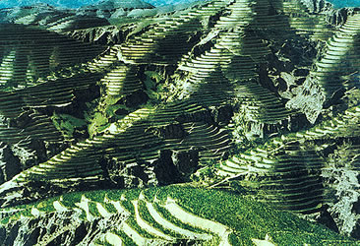

5. This picture shows terraces in mountainous areas in China. What was the purpose of the Chinese to impact their land in this way?

1. To make it easier to travel across the mountains.
2. To level the land to make it easier to farm.
3. To promote snow melt during the winter season.
4. To provide additional defense from invading armies.

6. Which of the following best demonstrates how the construction of the pyramids in Egypt was connected to environmental interaction?

1. Bricks were made of mined rock found in the region.
2. Scaffolds and ramps were built to put the rocks into place.
3. The work was done with slave labor.
4. It would take years to complete one pyramid.

**6.H.CO.2 Analyze the impact trade networks had on interactions among various human societies between 3500 BCE-600 CE.**

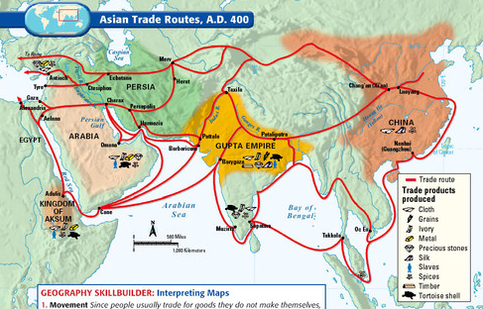

Central Asian nomads told people from India in the Gupta Empire about the Silk Roads, a network of trade routes. People in the region saw an opportunity to make money by acting as middlemen, helping other traders. They built trading stations along the Silk Roads. By sea, traders from India used routes around the Persian Gulf and Arabian Sea to bring goods to Rome and Southeast Asia. They imported African gold and ivory and exported cotton cloth, rice, and wheat. When trade with Rome decreased, trade with China and Southeast Asia grew. Increased trade led to more banking, with bankers lending money to merchants. Merchants from India living abroad spread Indian culture, influencing places like Java, Cambodia, and Thailand. Religions like Hinduism and Buddhism also spread to new regions due to trade and traveling monks.

7. In what way did trade networks centered around India impact **goods** exchanged across Europe, Asia, and Africa?

1. Banking increased in the region and people moved from a barter system to making currency.
2. The sea routes of the Persian Gulf and Arabian Sea were more important than the land routes.
3. They had to shift focus from Rome and the west to China and the east as civilizations declined.
4. They imported gold and ivory from Africa and exported cotton, cloth, rice, and wheat across the region.

8. In what way did trade networks centered around India impact **ideas** exchanged across Europe, Asia, and Africa?

1. Merchants spread Indian culture, spreading religions like Hinduism and Buddhism.
2. Early people in the region felt it best to serve as middlemen in trade negotiations.
3. They built trading stations along the area that would later be known as the Silk Road.
4. Bankers in India would be able to lend money to merchants.

9. What conclusion can you draw about the relationship between trade in this region and cultural exchange?

1. Trade had little to no impact on cultural exchange.
2. Trade encouraged the spread of cultures and traditions between different regions.
3. Trade made it difficult for cultures to interact.
4. Trade only impacted these civilizations economically, not culturally.