**Fayette County Public Schools**

**World History**

**Benchmark Assessment**

**Spring 2025 (Imperialism & World Wars)**

**HS.WH.CO.2 Analyze examples of conflict created by global expansionist policies and actions between 1750-1945 across global regions.**

1. What was a primary motivation behind European imperialist expansion in Africa and Asia during the late 19th and early 20th centuries?

* A. Spreading democratic ideals
* B. Establishing religious missions
* C. Acquiring natural resources and markets
* D. Promoting cultural diversity

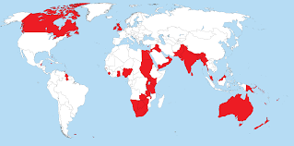

On the map, areas controlled by the British Empire at its height are highlighted in red.

1. Why was it often said during the early 20th Century “The sun never sets on the British Empire?”

* A. Land controlled by Britain around the world was so expansive that there was always a location that experienced daytime.
* B. The observatory at Greenwich, England was influential in astronomical advancements at the time.
* C. The British Empire was limited to a vast expanse of the Northern Hemisphere.
* D. The diversity of people the British ruled over contributed to a drastic rise in Christian practices and principles.

1. What was a significant consequence of European imperialism in Africa and Asia during the late 19th and early 20th centuries?

* A. The spread of democracy and human rights
* B. The promotion of economic equality and social justice
* C. The exploitation of indigenous peoples and resources
* D. The preservation of cultural diversity and autonomy

**HS.WH.CE.7 Examine the ways non-industrialized nations attempted to combat the rising power of European Imperialism between 1750-1900.**

| **Ethiopia Maintains Independence at Adwa** (from History.com)  When the fighting broke out on March 1, 1896, the Italians and their African auxiliaries quickly found themselves disorganized, highly outnumbered, and exposed in inhospitable terrain. By day’s end, they were in full retreat, leaving behind their artillery and roughly 3,000 prisoners. King Melenik outsmarted and outflanked the Italians in every aspect. Many women contributed to the victory, serving as water distributors, medical care providers, prison guards, and morale boosters. Queen Taytu herself commanded her own personal army. |
| --- |

1. Which of the following best describes the benefits the Ethiopians had over the Italians at Adwa?

* A. The Italians retreated leaving artillery and prisoners behind.
* B. Ethiopian strategy and the contributions of women were essential.
* C. Ethiopian inexperience with inhospitable terrain gave Italians advantage.
* D. Ethiopian men served as water distributors, medical providers, and guards.

| **Zulu Resistance at Isandlwana, South Africa** (from British National Army Museum)  On 22 January 1879, British Lieutenant-General Lord Chelmsford established a temporary camp for his column near Isandlwana, but neglected to strengthen its defense by encircling his wagons. After receiving intelligence reports that part of the Zulu army was nearby, he led part of his force out to find them.  Over 20,000 Zulus, the main part of leader Cetshwayo's army, then launched a surprise attack on Chelmsford's poorly fortified camp. Fighting in an over-extended line and too far from their ammunition, the British were swamped by sheer weight of numbers. The majority of their 1,700 troops were killed. Supplies and ammunition were also seized.  The Zulus earned their greatest victory of the war and Chelmsford was left no choice but to retreat. The Victorian public was shocked by the news that 'spear-wielding savages' had defeated their army. |
| --- |

1. According to the passage, which of the following contributed to the Zulu victory at Isandlwana, holding off the British forces?

* A. A surprise attack on a poorly fortified British camp.
* B. Knowledge of the terrain of South Africa.
* C. More sophisticated weapons against the British.
* D. The encircling of British wagons in the camp.

| **Wassoulou Empire Resists the French** (from African Resistance to Colonialism, World History Project)  In West Africa, many states and independent societies resisted colonialism. The Mandinka state was led by Muslim leader Samori Ture. Samori did not inherit a kingdom. So, he created one. It was the Wassoulou Empire. He had an army of 30,000 to 40,000 men.  The French first began to push into his territory in 1881. Samori attempted to negotiate. He also used a strategy to balance the British and the French against each other. Unfortunately, his weapons were less advanced. His forces were defeated in several battles. He agreed to a treaty with the French that gave them some territory in return for peace. However, the French military broke this treaty. This encouraged Samori’s people to rebel. In 1892, the French army and Samori’s army fought in a battle, but Samori was defeated. | |
| --- | --- |

1. According to the passage, which best describes Samori’s approach to resist the French invasion of the Wassoulou Empire?

* A. He quickly developed more advanced weapons.
* B. His military quickly became experts in guerilla warfare.
* C. He attempted to achieve peace through negotiations and diplomacy.
* D. He willingly and eagerly surrendered all lands to France.

**HS.G.HI.1 Analyze how the forces of cooperation and conflict within and among people, nations and empires influence the division and control of Earth’s surface and resources.**

| **The Berlin West Africa Conference of 1884** (from Britannica)  Berlin West Africa Conference, a series of negotiations (Nov. 15, 1884–Feb. 26, 1885) at Berlin, in which the major European nations met to decide all questions connected with the Congo River basin in Central Africa.  The conference, proposed by Portugal in pursuance of its special claim to control of the Congo estuary, was necessitated by the jealousy and suspicion with which the great European powers viewed one another’s attempts at colonial expansion in Africa. The general act of the Conference of Berlin declared the Congo River basin to be neutral (a fact that in no way deterred the Allies from extending the war into that area in World War I); guaranteed freedom for trade and shipping for all states in the basin; forbade slave trading; and rejected Portugal’s claims to the Congo River estuary—thereby making possible the founding of the independent Congo Free State, to which Great Britain, France, and Germany had already agreed in principle. |
| --- |

1. What was the primary purpose of the Berlin West Africa Conference of 1884?

* A. To establish a peace treaty between European nations
* B. To determine the control or neutrality of the Congo River basin
* C. To negotiate trade agreements with Asian countries
* D. To discuss the industrial revolution's impact on Europe

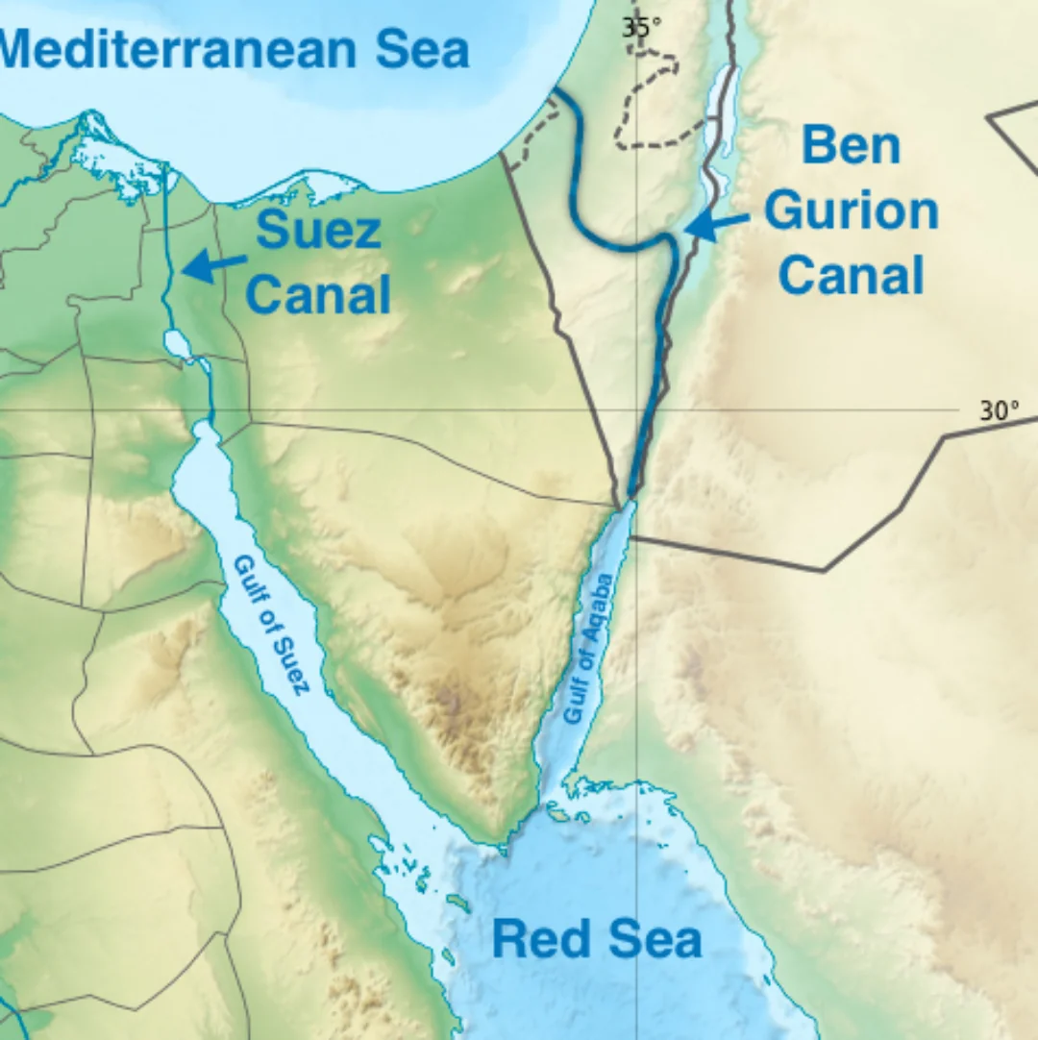

1. How did the construction of the Suez Canal influence imperial interests in Egypt during the 19th century?

* A. It decreased European interest in Egypt
* B. It made Egypt a strategic link for trade and military routes
* C. It isolated Egypt from European influence
* D. It led to the colonization of Egypt by the United States

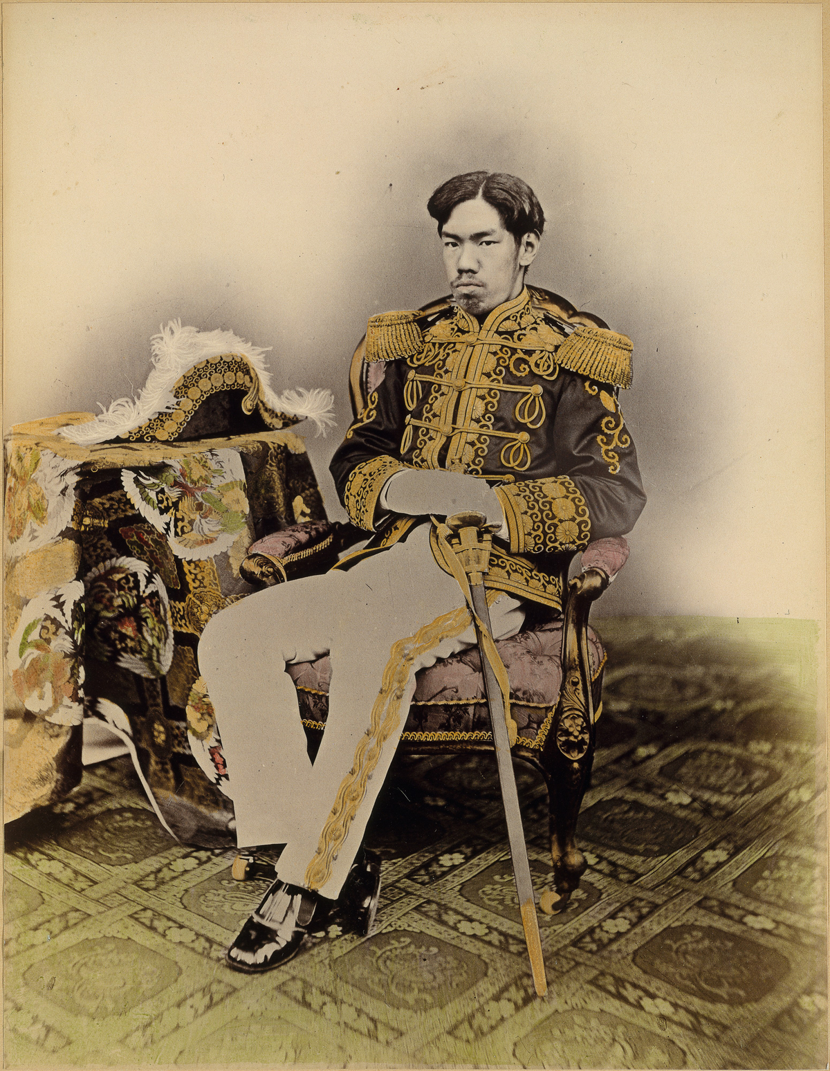

1. The Meiji Restoration in Japan led to which of the following outcomes in the late 19th and early 20th centuries?

* A. Japan's isolation from the rest of the world
* B. The westernization, industrialization, and militarization of Japan
* C. The colonization of Japan by European powers
* D. The establishment of a communist government in Japan

**HS.WH.CE.8 Determine the causes of the World Wars and their global effects between 1900-1945.**

1. The Treaty of Versailles imposed harsh penalties on Germany after World War I. Which of the following was a consequence that contributed to the rise of World War II?

* A. Germany gained new territories in Africa
* B. Germany was allowed to expand its military
* C. Germany faced economic hardship and national humiliation
* D. Germany formed a close alliance with the United States

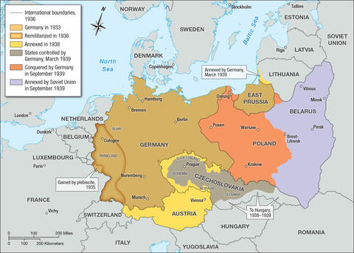

1. Which ideology did Adolf Hitler promote as part of his vision for German empire-building?

* A. Socialism through the expansion of worker’s rights
* B. Democracy through the notion of racial purity
* C. Fascism and the concept of Lebensraum (living space)
* D. Communism and the crafting of the Final Solution

1. The policy of **appeasement** is most closely associated with which pre-World War II event?

* A. The bombing of Pearl Harbor
* B. The Munich Agreement allowing Germany to annex the Sudetenland
* C. The signing of the Non-Aggression Pact between Germany and the Soviet Union
* D. The attack on Ethiopia by Italy

**HS.WH.CH.4 Analyze the connections between industrialization and the development of total war between 1900-1950.**

1. What was the impact of the conversion of **assembly-line** factories in Allied countries during World War II?

* A. By promoting diplomatic negotiations
* B. By increasing the production capacity for weapons and ammunition
* C. By reducing the number of military conflicts
* D. By improving agricultural techniques

1. How did the introduction of **tanks** in World War I revolutionize military strategies?

* A. Tanks could move quickly and provide a breakthrough in static trench lines
* B. Tanks were used mainly for transporting supplies
* C. Tanks were ineffective and rarely used
* D. Tanks replaced infantry soldiers completely

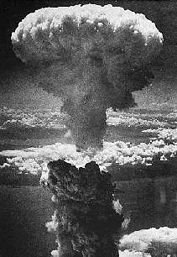

1. How did the use of the atomic bomb in World War II demonstrate the connection between industrialization and total war?

* A. It showed that industrialization had no impact on warfare
* B. It exemplified the peak of industrial capability to create devastating weapons
* C. Industrialization was used mainly for agricultural purposes
* D. Industrialization had no significant impact on the outcome of the war