**Fayette County Public Schools**

**U.S. History**

**Benchmark Assessment**

**Spring 2025 (Boom & Bust, WWII, Cold War)**

**HS.UH.CH.1 Examine the ways diverse groups viewed themselves and contributed to the identity of the United States in the world from 1877-present.**

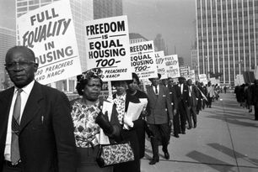

1. Which of the following demonstrates advocacy for African American visibility and activism in the 1920s and 30s?

* A. The establishment of sharecropping farms in the American South.
* B. The establishment of organizations like the National Association for the Advancement of Colored People (NAACP)
* C. The establishment of literacy tests and poll taxes for voter registration and eligibility.
* D. The implementation of President Woodrow Wilson’s Fourteen Points.

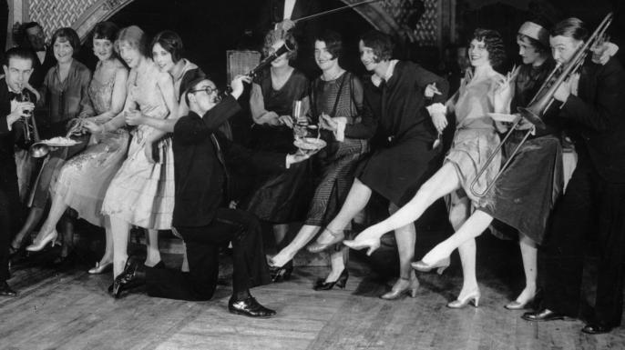

1. Which of the following best describes **cultural impacts** and changes among American culture during the Roaring Twenties?

* A. The strict obedience to the prohibition of alcoholic consumption and sales.
* B. A rise in attendance of religious institutions and instilling traditional family values.
* C. A divestment in the stock markets at-large, which culminated in the events of Black Friday, 1929.
* D. A challenge to social norms and advocacy for women’s rights and artistic experimentation through jazz music and surrealist art.

| **Source:** From “Another School Year Begins” which reported on the new additions and future plans for the American Indian Institute. Taken from the Presbyterian Historical Society. Philadelphia, PA. 2024.  Organization and Purpose:  Founded in 1915 by Rev. Henry Roe Cloud and Mrs. Walter C. Roe, the American Indian Institute has as its aim the training of a native Christian leadership for the Indians of America. Feeling that the United States government was unable for many reasons to more than partially care for the Indian, the founders of this school banded together in order to provide a way of carrying on the work where it had been left off by the government, inculcate into the young Indian some of those virtues and character-building essentials which would make him a “four-square” citizen, equally balanced spiritually, mentally, morally and physically, and able to think clearly and meet any emergency or problem. Through the efforts of Mr. Cloud, himself a Winnebago Indian and a graduate of Yale University, this vision has been fruitful, and the four classes which have been graduated from this institution have already provided twelve students in institutions of higher learning.  Location:  Wichita is well adapted to be the seat of the American Indian Institute, and the location of the school just at the outskirts of the city proper gives it the additional advantages of the country, with the proximity and facilities of metropolitanism. Wichita is served by six large main-line railroads and one Interurban, thus making it easy of access from all parts of the United States. Many of the principal Indian reservations are within a short radius and all are within easy traveling distance. The city itself is a large agricultural and stock-raising center, making for wholesomeness and health. |
| --- |

1. Which of the following BEST describes the academic successes of the American Indian Institute?
2. The Institute, founded by a Winnebago Indian, was developed out of a feeling the United States government was unable to partially care for the Indian.
3. The Institute, with its beautiful campus on the outskirts of Wichita, Kansas, has a strong focus on physical fitness and athletic training, preparing students for a healthy lifestyle.
4. The Institute, located in a city with excellent transportation links, offers a unique blend of urban and rural experiences, providing students with a well-rounded education.
5. The Institute, founded by Rev. Henry Roe Cloud, a Winnebago Indian and Yale graduate, has a strong academic program that has already sent 12 students to institutions of higher learning.

**HS.UH.CE.3 Explain the political, social and economic causes and effects of economic boom and bust cycles between 1877-1945**.

The Great Depression, a period of severe economic hardship that began in 1929, led to widespread unemployment and social unrest. In 1933, newly elected President Franklin D. Roosevelt's New Deal initiative aimed to address these challenges through a series of federal programs.

During the First Hundred Days (March-June 1933), Roosevelt implemented several key measures. These included the Emergency Banking Act to stabilize the banking system, the National Industrial Recovery Act to promote industrial recovery and worker rights, and the Agricultural Adjustment Act to provide relief to farmers. Additionally, the Tennessee Valley Authority was established to develop the Tennessee River region through flood control, hydroelectric power, and navigation improvements.

However, the Great Depression persisted, and Roosevelt launched the Second New Deal in 1935. This phase included the Works Progress Administration (WPA) to create jobs, the Social Security Act to establish social safety nets, and the National Labor Relations Act to protect workers' rights. Despite these efforts, the economy remained fragile, and unemployment remained high until the onset of World War II.

4. What impact did the Great Depression have on the role of government in the economy, leading to increased federal intervention and regulation?

* A. It prompted a return to laissez-faire economic policies
* B. It resulted in the dismantling of social welfare programs
* C. It led to the expansion of government programs and the establishment of new regulatory agencies
* D. It encouraged privatization and deregulation of industries

The Smoot-Hawley Tariff Act of 1930 was a law that increased import duties on agricultural and manufactured goods to protect American businesses and farmers. The law was named after its sponsors, Senator Reed Smoot of Utah and Representative Willis Hawley of Oregon. President Herbert Hoover signed the bill into law on June 17, 1930

5. Despite the intention to protect American businesses and farmers, how did the Smoot-Hawley Tariff Act of 1930 actually worsen the economic conditions of the Great Depression?

* A. It reduced government spending on social welfare programs
* B. It increased the price of goods, led to retaliation from other countries, and a decline in international trade
* C. It increased government regulation of financial markets
* D. It provided subsidies to struggling industries, promoting economic recovery

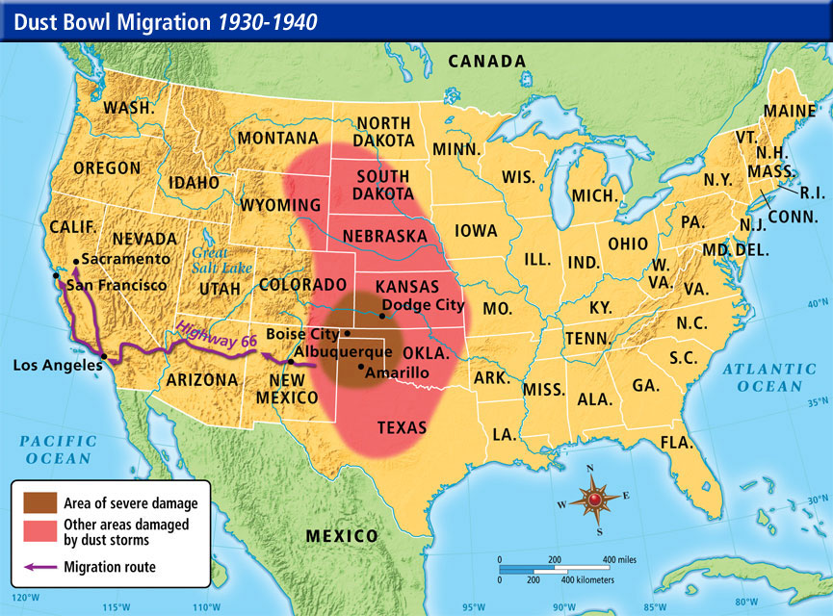

6. What impact did the Dust Bowl have on agricultural communities in the Great Plains during the 1930s?

* A. Increased crop yields and agricultural productivity
* B. Migration of farmers to urban areas in search of employment
* C. Expansion of agricultural land through government subsidies
* D. Adoption of sustainable farming practices to prevent soil erosion

**HS.UH.CO.3 Analyze the role of the United States in global compromises and conflicts between 1890-1945 in the Spanish American War, World War I, the Interwar years and World War II.**

7. HOT TEXT: Which of the highlighted excerpts BEST demonstrates how the United States implemented isolationist policies after World War I?

Americans reeled from the emotional and financial costs of war and began to feel as though joining the war effort was a mistake. In 1918, Wilson articulated fourteen points to help end the war and establish a basis for cooperation, which included freedom of the seas, open economic trade, the evacuation of occupied territories, the liberation of non-Turkish peoples in the Ottoman Empire, and a general collection of nation states to offer members territorial integrity and political independence—setting the stage for what would later become the League of Nations.

What ensued was a radical shift in U.S. foreign policy, which promoted a stance of isolationism that would last until World War II. Warren Harding won the 1920 presidential election on the promise of staying out of global affairs, and by arguing that the United States needed normalcy and a focus on internal problems. Thus, U.S. foreign policy during the 1920s was characterized by the enactment of isolationist policies; for instance, the U.S. opted not to join the burgeoning League of Nations, even though it had been the nation to first propose such international cooperation. Instead, the United States focused on building the domestic economy by supporting business growth, encouraging industrial expansion, imposing tariffs on imported products and limiting immigration. (Norwich University Research Library, *Isolationism and U.S. Foreign Policy After World War I)*

*—--------------------------------------------------------------------------------------------------------------------------*

| **1919** | Rejection of the League of Nations |
| --- | --- |
| **1920s** | Washington Naval Conference: limits to naval armaments, but continued domestic focus on policy |
| **1924** | Immigration Act of 1924 severely limits immigration from Eastern and Southern Europe |
| **1928** | Kellogg-Briand Pact: US signs this pact to renounce war as an instrument of national policy |
| **1930s** | Great Depression strengthens isolationist sentiment |
| **1935** | Neutrality Acts aim to prevent US from being drawn into future European conflicts |
| **1937** | Japan invades Manchuria, concerning some Americans but largely maintaining isolationist stance |
| **1939** | Germany invades Poland, no initial sway in general public opinion on isolationist policies. |
| **1940** | Lend-Lease Act: Though still officially neutral, US begins providing military aid to Britain, marking a shift to support of Allied powers |
| **1941** | Japan attacks Pearl Harbor, Hawaii, forcing the US to officially enter World War II |

8. Which of the following best describes why the United States was forced to end its isolationist policies it had maintained throughout the 1920s and 1930s?

1. The United States had to limit the flow of immigration from Eastern and Southern Europe.
2. The Great Depression forced Americans to look for economic opportunities on a global scale.
3. The attack on Pearl Harbor by Japan forced the United States to officially enter World War II.
4. The Lend-Lease Act ended the official stance of American neutrality by giving initial aid to the British.

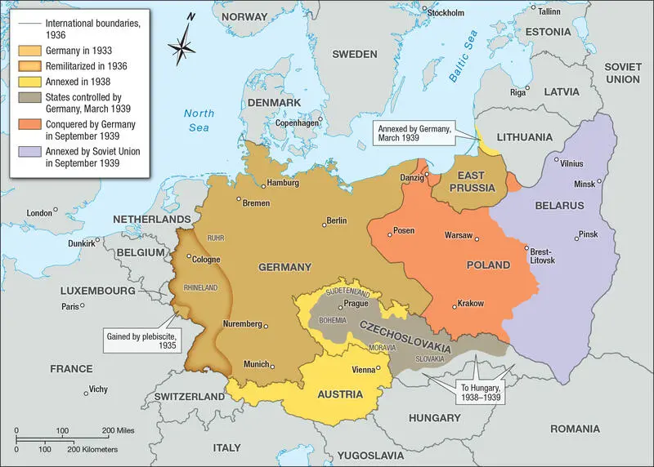

9. The map shows the expansion of Nazi Germany in the late 1930s as a result of Britain and France’s policy of appeasement. How did this policy differ from the United States’ in their approach to the rise of Nazi Germany?

* A. The United States supported German expansionist policies, providing economic aid to Germany.
* B. The United States took a more isolationist approach to avoid involvement in foreign affairs.
* C. The United States took a humanitarian approach, ensuring neighboring countries installed strong democratic governments.
* D. The United States supported the economic developments and policies of Germany as it expanded territory.

**HS.UH.CO.4 Analyze the conflicting ideologies and policies of the United States and Soviet Union and their impact, both domestically and globally, during the Cold War Era between 1945- 1991.**

*"...Since the end of the last world war, I have been the object of lies and propaganda by powerful reactionary groups who, by their influence and by the aid of America's yellow press, have created an unhealthy atmosphere in which liberal-minded individuals can be singled out and persecuted. Under these conditions I find it virtually impossible to continue my motion-picture work, and I have therefore given up my residence in the United States." - actor Charlie Chaplin, after FBI Director J. Edgar Hoover worked to block him from re-entering the United States from London after a film promotion, and being monitored in the U.K. by the British spy agency M15*

10. What impact did the Cold War have on American society and politics during the 1950s, particularly in terms of domestic policies and national security measures?

* A. It led to the expansion of civil rights and social welfare programs
* B. It fueled anticommunist hysteria and the Red Scare, resulting in McCarthyism and the rise of the surveillance state
* C. It promoted international cooperation and diplomacy through the United Nations
* D. It encouraged isolationism and withdrawal from global affairs

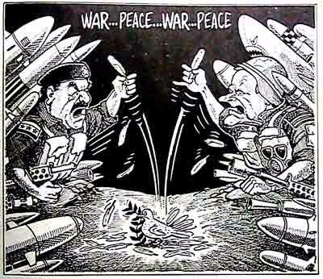

11. Which term describes the policy of strategic military buildup and nuclear deterrence pursued by both the United States and the Soviet Union during the Cold War, aimed at preventing mutual destruction through the threat of overwhelming force?

* A. Arms race
* B. Proxy war
* C. Containment
* D. Detente

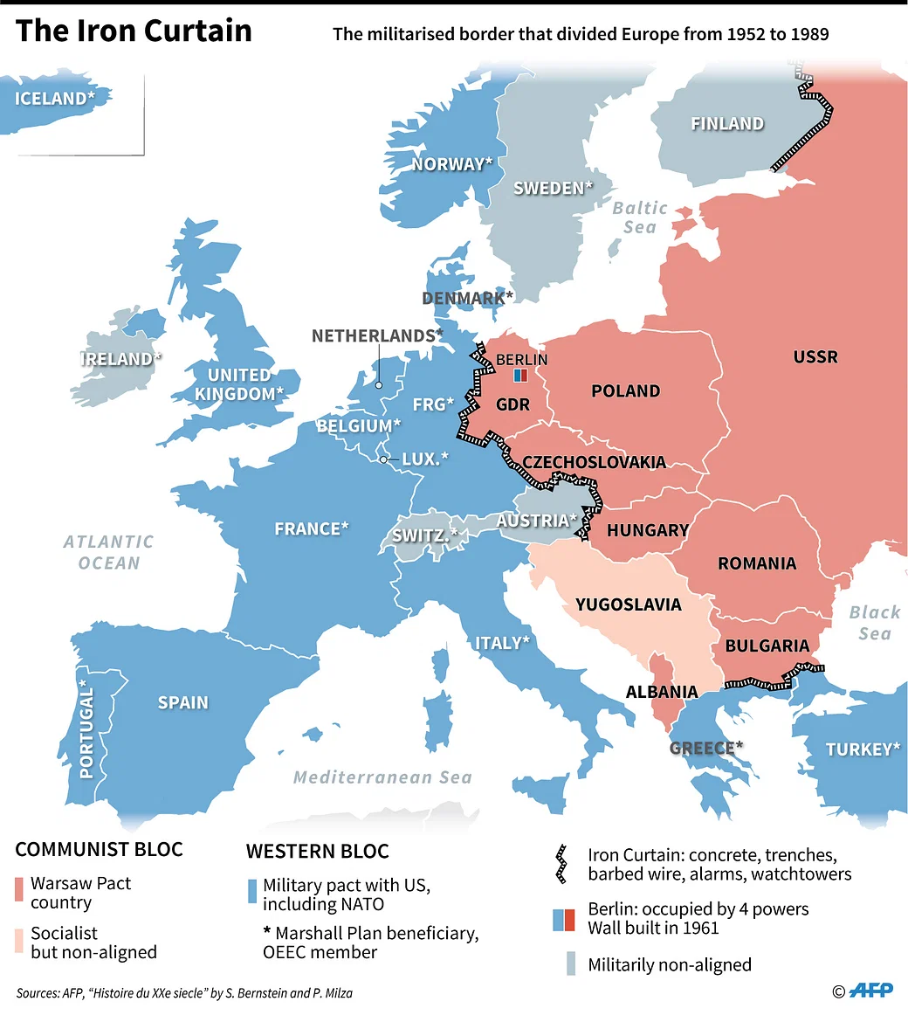

12. What was the primary objective of the policy of **containment**, adopted by the United States during the Cold War, in response to Soviet expansionism?

* A. To promote democracy and human rights worldwide
* B. To prevent the spread of communism beyond its existing borders
* C. To establish economic partnerships with Eastern Bloc countries
* D. To negotiate arms control agreements with the Soviet Union

**HS.UH.CH.5 Analyze the impact of technology and new ideas on American culture from 1877- present.**

13. Which of the following best describes the impact of the radio in the 1920s and 1930s?

* A. It was transformational to entertainment and leisure, particularly through the spread of music, shows, and news broadcasts.
* B. It was transformational to the transportation industry as they were regularly installed in early automobile models.
* C. They were only briefly popular with the development of early televisions, which were immediately widespread in households in the 1930s.
* D. They played a little role in informing the public about local, state, and national affairs on a wide scale.

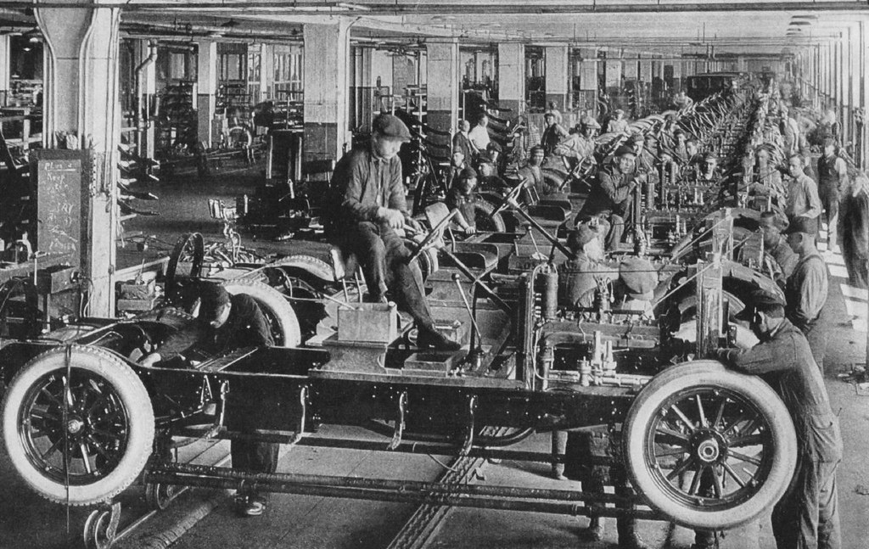

14. What was a significant consequence of the development of mass production techniques, such as the assembly line, in the early 20th century on American industry and consumerism?

* A. The decline of labor unions and worker rights
* B. The rise of monopolies and corporate consolidation
* C. The increase in efficiency and affordability of consumer goods
* D. The expansion of agricultural production and rural economies

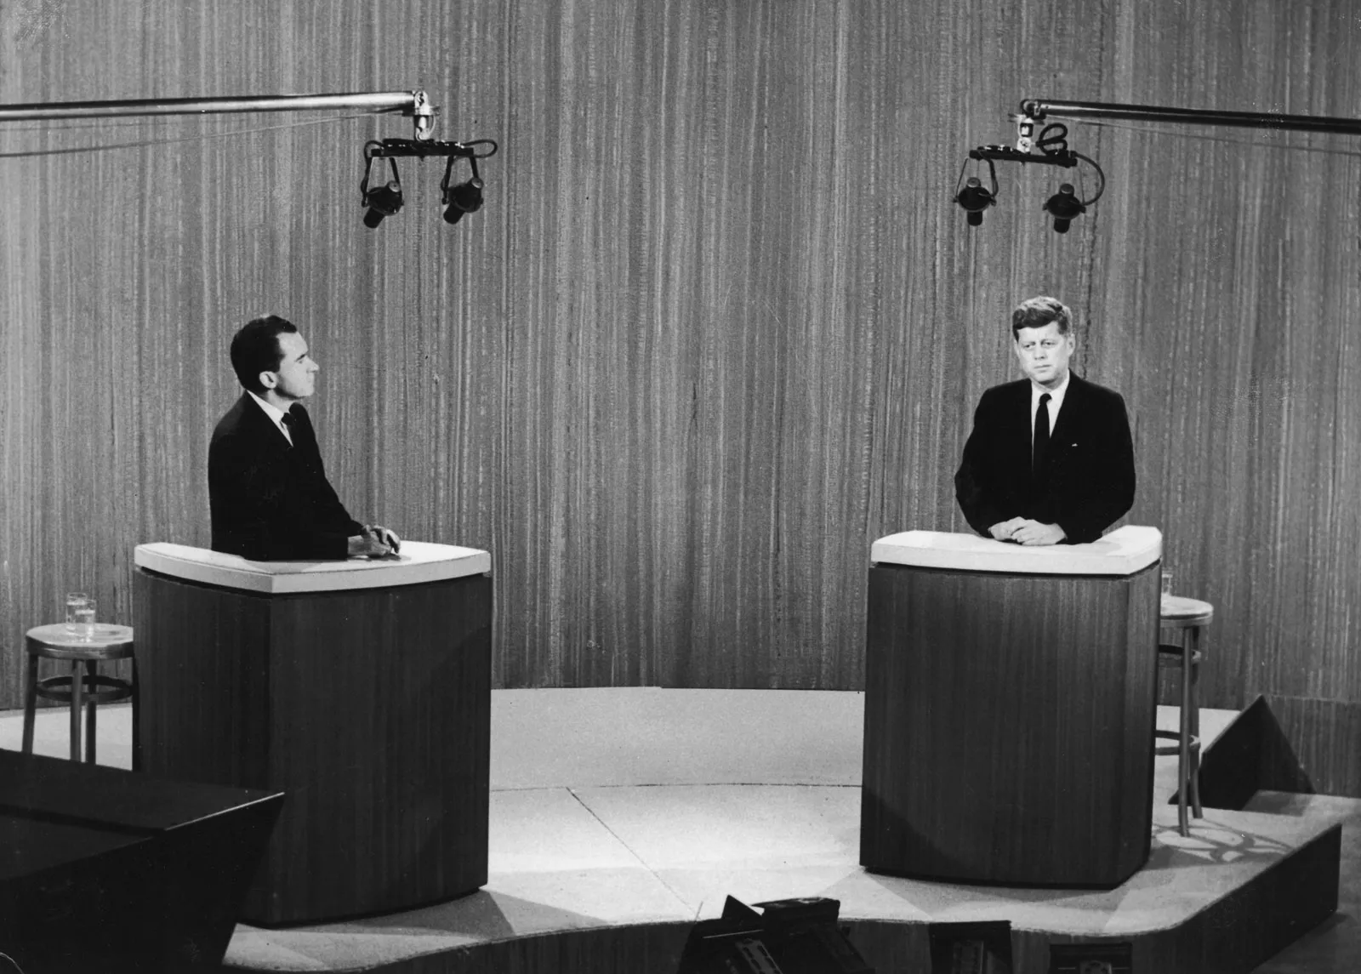

A 1960 Presidential debate between Richard Nixon and John F. Kennedy

15. What was the primary effect of the widespread availability of television in American households, especially during the Elections from the 1950s and 1960s?

* A. The decentralization of media ownership and increased diversity of perspectives
* B. The decline of political engagement and civic participation
* C. The growth of political advertising and campaign strategies
* D. The expansion of public access to government information and transparency