Clarity for Learning
Standard KY.4.NBT.5 Multiply whole numbers
- Up to four-digit numbers by a one-digit number
- Two-digit number by two-digit number
Multiply using strategies based on place value and properties of operations. Illustrate and explain the calculation using equations, rectangular arrays, and area models.
Concepts (Nouns)  whole numbers  digit  strategy  place value  properties of operations  equations  rectangular arrays  area models | Skills (Verbs)  multiply  illustrate  explain
Learning Progressions
Prerequisites:
- Understand multiplication as repeated addition.
- Know how to make an array.
- Multiply one-digit by one-digit numbers.

Grade Level Skills:
- Use hands-on materials (counters, color tiles, or base-10 blocks) to show the multiplication of whole numbers using strategies based on place value.
- Use place value strategies to multiply up to a four-digit number by a one-digit number.
- Use place value strategies to multiply a two-digit number by a two-digit number
- Multiply using properties of operations (Distributive property, Associative property, etc).
- Illustrate and explain multiplication calculations using equations, rectangular arrays, and/or area models.

Clarifications:
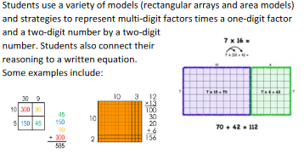

KY.3.NBT.3(KY.3.OA.5, KY.3.MD.7)→ KY.4.NBT.5 →KY.5.NBT.5

Learning Intentions (I am learning to...) | Success Criteria (I know I’m successful when...)
Multiply multi-digit numbers 4-digit by 1-digit and 2-digit by 2-digit. | - I can multiply up to a 4-digit number by a 1-digit number.  - I can multiply two 2-digit numbers.  - I can use place value strategies to solve multiplication problems.  - I can show my thinking by creating rectangular arrays.  - I can show my thinking by creating area models.  - I can write an equation to model a multiplication problem.

